Description:
,663,6629
The Certified Cyber Forensics Threat Analyst (C)CFTA) is an advanced-level, practitioner-focused certification that trains cybersecurity professionals to collect, preserve, and analyze network-based digital evidence in support of cyber incident investigations and threat analysis. Aligned to DoD 8140 / DCWF Work Role 212 (Cyber Defense Forensics Analyst), the C)CFTA prepares candidates for the full lifecycle of a network forensics investigation: from physical and wireless evidence acquisition through protocol-level analysis, NSM toolchain operation, threat intelligence integration, timeline construction, anti-forensics detection, and cloud network forensics. | 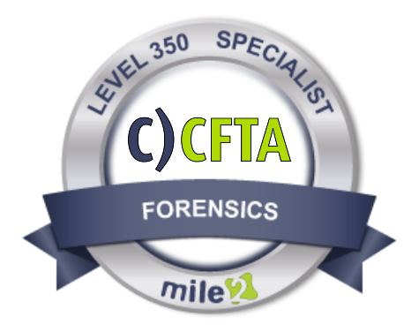
Annual Salary Potential $99,000 AVG/year


Live Class Duration: 5 Days

CEUs: 40

Language: English

Class Formats Available:

- Instructor Led
- Self-Study
- Live Virtual Training

Suggested Prerequisites:

- 2 years networking experience
- 2 years in IT Secuirty
- Working knowledge of TCPIP
Course Information

Lab 01: Network Evidence
Lab 02: Wireshark Fundamentals
Lab 03: Core Protocol Analysis
Lab 04: DNS, SMTP, FTP & Email
Lab 05: NetFlow / IPFIX / sFlow
Lab 06: Zeek (Bro) Log Analysis
Lab 07: Intrusion Detection
Lab 08: Proxy & Web Application
Lab 09: Wireless Network
Lab 10: Malware & C2 Analysis
Lab 11: Advanced Packet Carving
Lab 12: Network Timeline
Lab 13: Anti-Forensics & Evasion
Lab 14: Enterprise Triage with
Lab 15: Cloud Network Forensics

Detailed Outline Below

Module 00: Course Introduction
Module 01: Network Forensics
Module 02: Digital Evidence
Module 03: Network Evidence
Module 04: Wireshark & Traffic
Module 05: Protocol Analysis
Module 06: Protocol Security
Module 07: NetFlow, IPFIX & Zeek
Module 08: NIDS/NIPS, Snort
Module 09: Network Log Forensics
Module 10: Wireless & Cloud
Module 11: Threat Investigation
Module 12: Anti-Forensics

Detailed Outline
Below
Hands-On Labs
Key Course Information
Modules/Lessons

Accreditations
Course FAQ’s
Exam Information

The C)CFTA exam is taken online through Mile2’s Assessment and Certification System (“MACS”), accessible from your mile2.com account. The exam consists of 100 multiple-choice questions with a 2-hour time limit.
A minimum grade of 70% is required for certification.

All Mile2 certifications will be awarded a 3-year expiration date.

There are two requirements to maintain Mile2 certification:

- Pass the most current version of the exam for your respective existing certification
- Earn and submit 20 CEUs per year in your Mile2 account.

Question: Do I have to purchase a course to buy a certification exam?
Answer: No
Question: Do all Mile2 courses map to a role-based career path?
Answer: Yes. You can find the career path and other courses associated with it at www.mile2.com.
Question: Are all courses available as self-study courses?
Answer: Yes. There is however 1 exception. The Red Team vs Blue Team course is only available as a live class.
Question: Are Mile2 courses transferable/shareable?
Answer: No. The course materials, videos, and exams are not meant to be shared or transferred.

- ANAB (ANSI National Accreditation Board) ISO/IEC 17024 Aligned
- DoD 8140 / DCWF Work Role 212 — Cyber Defense Forensics Analyst
- NICE Cybersecurity Workforce Framework (NIST SP 800-181) Mapped
- Approved for DoD 8570 IA Workforce Improvement Program

- Forensic Examiners
- IS Managers
- Network Auditors
- IT Managers

Re-Certification Requirements
Who Should Attend

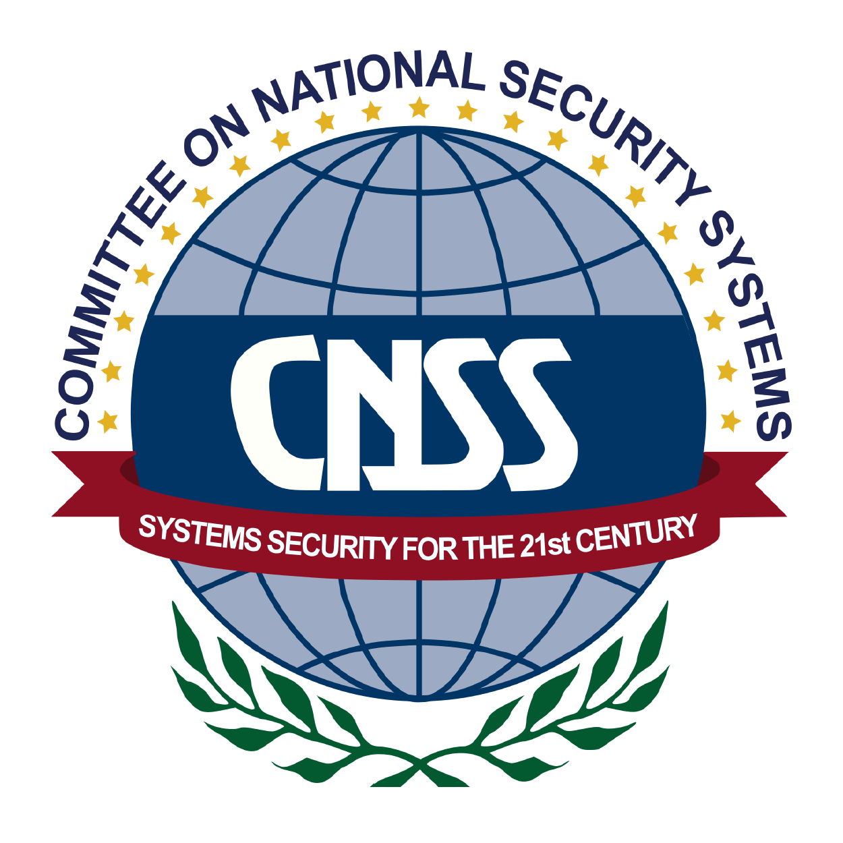
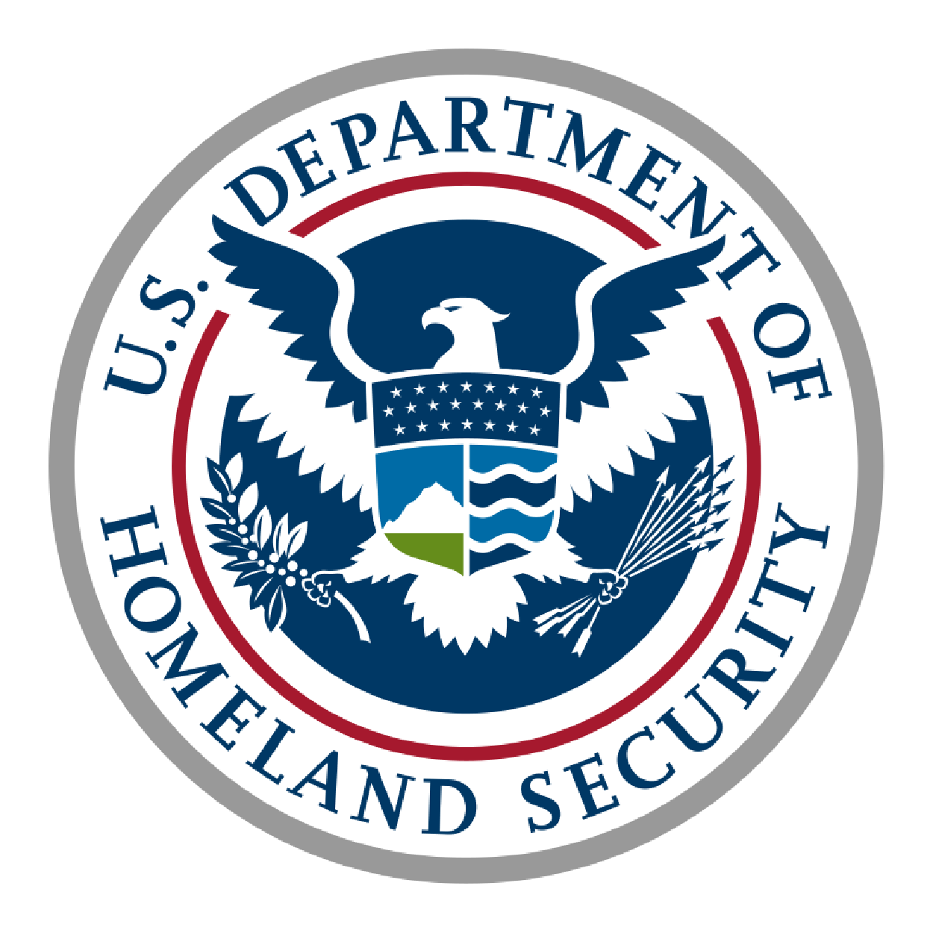
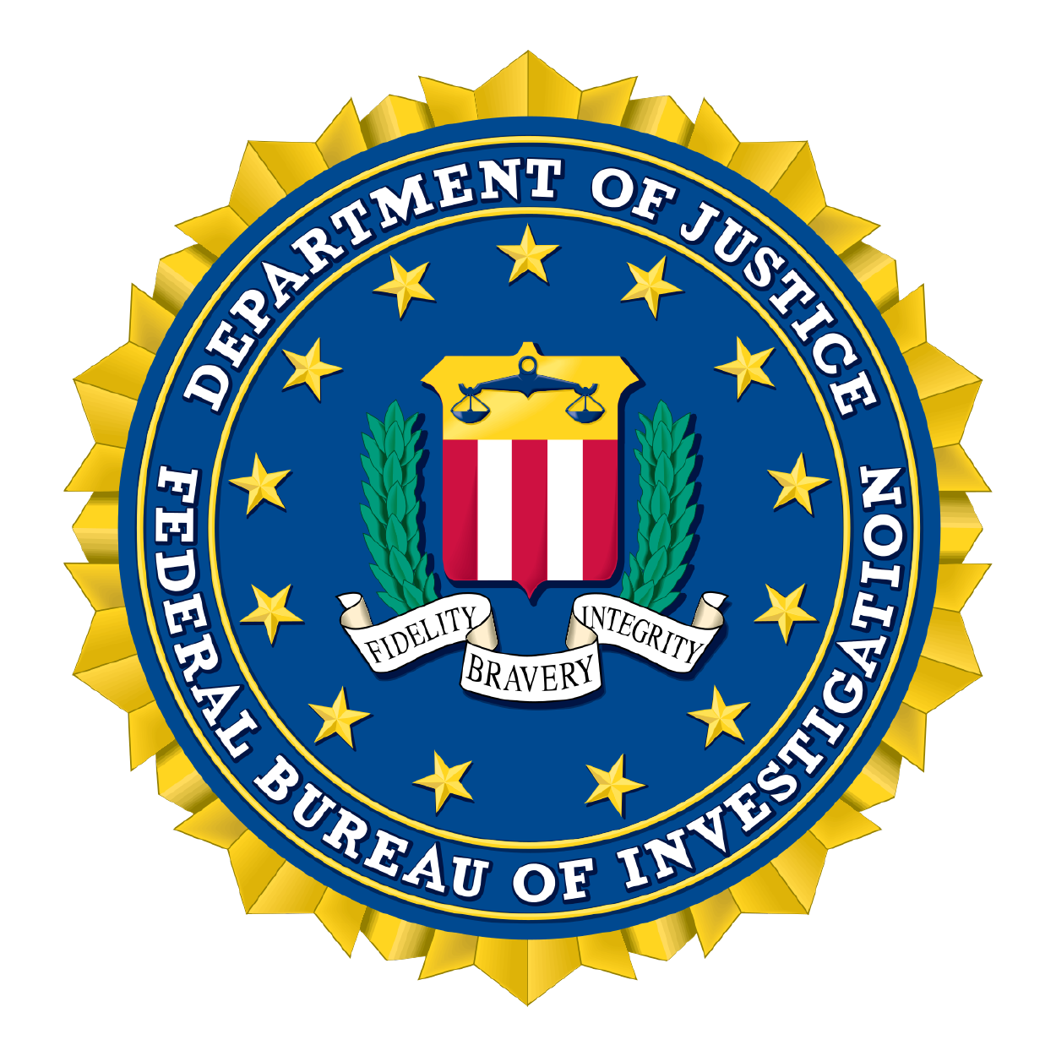
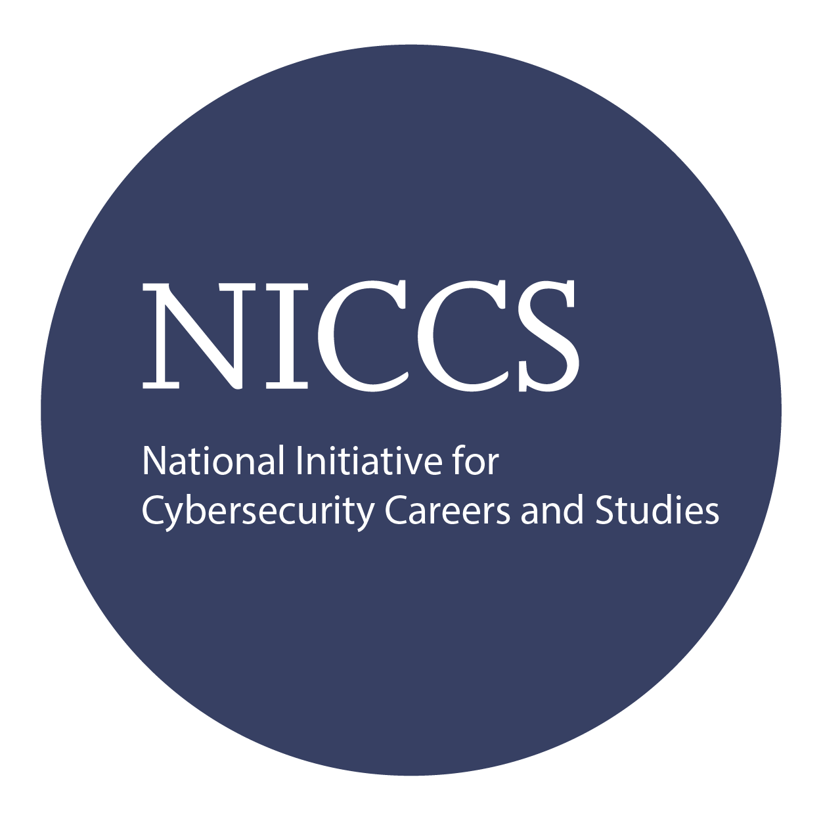

Course and Certification Learning Options
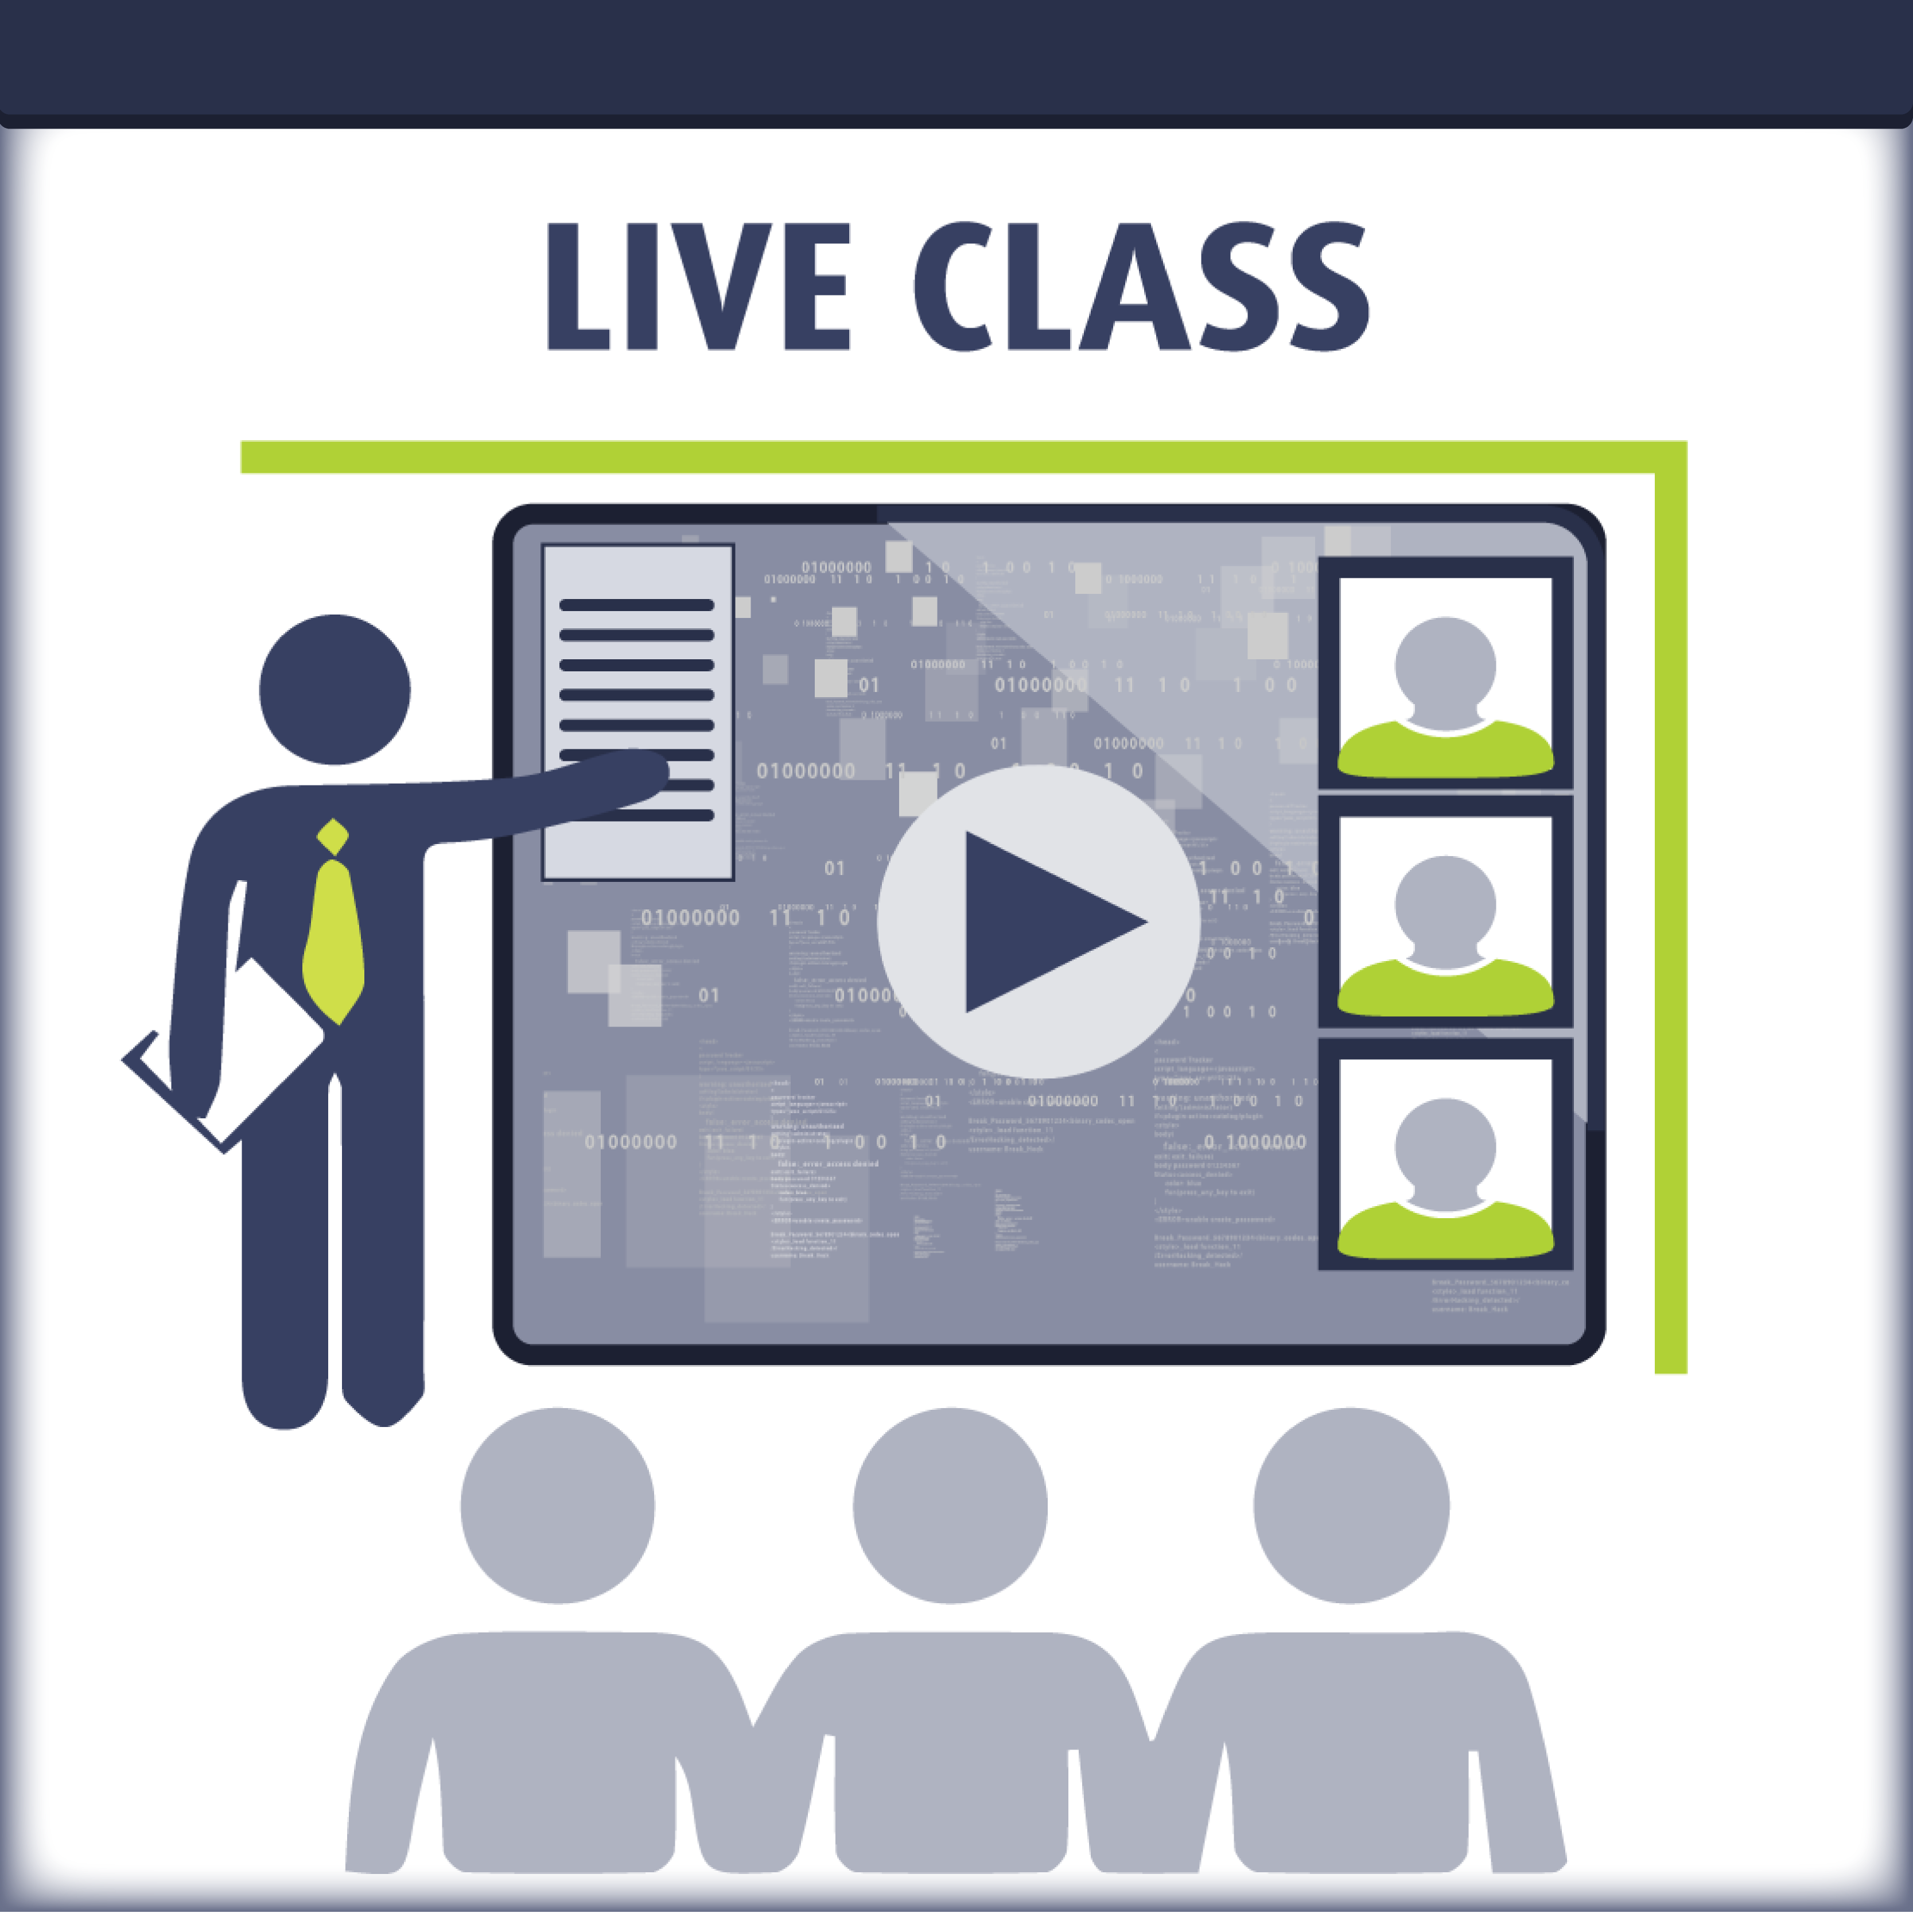
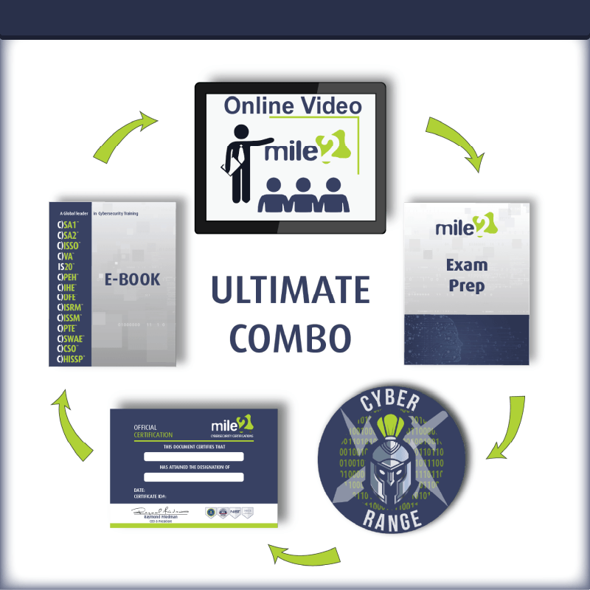
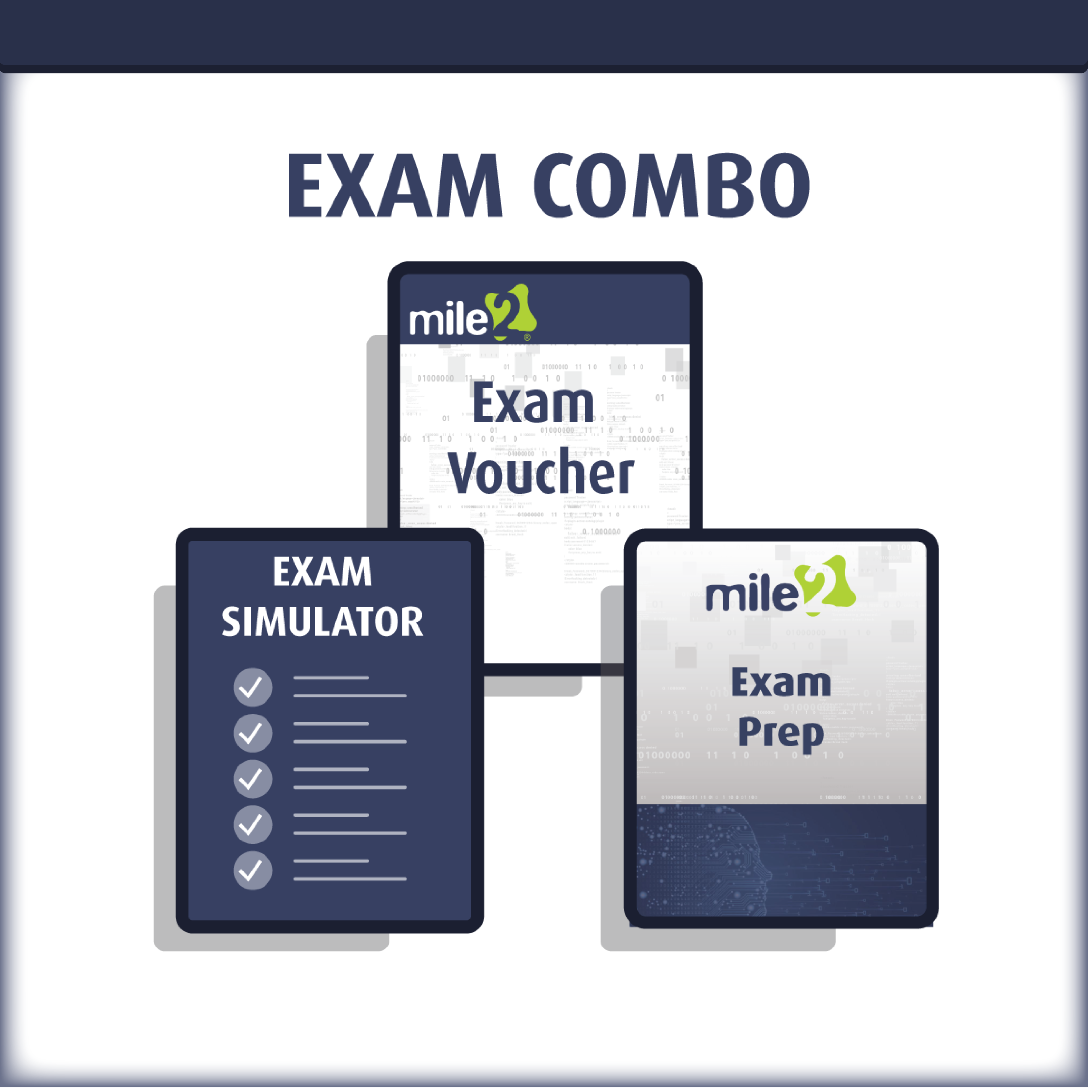

Upon Completion

Upon completion of the C)CFTA program, candidates will be equipped to sit for the C)CFTA certification exam and will possess the practical skills required to perform network-based forensic investigations in enterprise and government environments. Candidates will be able to:

- Acquire, preserve, and maintain chain of custody for network-based digital evidence including PCAPs, flow records, and log exports
- Apply the OSCAR investigative methodology to structure and document network forensics investigations from evidence collection through formal reporting
- Perform deep packet analysis using Wireshark, tshark, and tcpdump — including BPF filtering, protocol dissection, stream reassembly, and object extraction
- Analyze NetFlow, IPFIX, and sFlow records to detect lateral movement, exfiltration, and anomalous behavior
- Deploy and query the Zeek (Bro) NSM framework to produce structured logs for forensic investigation
- Configure and analyze Snort and Suricata for intrusion detection, alert triage, and custom rule development
- Correlate firewall logs, proxy logs, web server logs, and Windows Event Log data across multiple sources into a unified forensic timeline
- Identify and investigate C2 channels, covert tunneling (DNS, ICMP), malware beaconing, ransomware kill chain evidence, and phishing artifacts in packet captures
- Reconstruct network intrusion timelines using SOF-ELK and Timesketch, and detect anti-forensics evasion techniques on the wire
- Conduct enterprise-scale triage using RITA for automated beacon detection across distributed Zeek sensor logs
- Apply wireless network forensics techniques to 802.11 captures including attack detection, rogue AP identification, and WPA handshake analysis
- Analyze cloud network evidence sources including VPC flow logs, CloudTrail, Azure Activity Logs, GCP Audit Logs, and container/Kubernetes network forensics
- Map investigative findings to MITRE ATT&CK techniques and produce structured forensic reports for technical, executive, and legal audiences

Detailed Course Outline

Module 00: Course Introduction

Module 01: Network Forensics Foundations
Section 01: What Is Network Forensics?
Section 02: The Threat Analyst Role & Adversary Landscape
Section 03: Scope & Applicability
Section 04: Tools Overview

Module 02: Digital Evidence & Investigative Methodology
Section 01: Types of Digital Evidence
Section 02: Network Evidence Challenges
Section 03: Evidence Handling & Legal Authority
Section 04: OSCAR Investigative Methodology

Module 03: Network Evidence Sources & Physical Interception
Section 01: Sources of Network-Based Evidence
Section 02: Physical Interception Methods
Section 03: Tcpdump & Capture Management
Section 04: Interception Hardware & Infrastructure
Section 05: Live Acquisition & Chain of Custody

Module 04: Wireshark & Traffic Triage
Section 01: Capture Libraries & BPF Filtering
Section 02: Wireshark, Tshark & Capture Tools
Section 03: Advanced Packet Analysis

Module 05: Protocol Analysis, Session Reconstruction & Packet Carving
Section 01: Protocol Stack as Forensic Evidence
Section 02: Transport, Address & Layer 2 Forensics
Section 03: Session Reconstruction, Carving & TLS Decryption
Section 04: Network Attack Forensics — PCAP-Level Indicators

Module 06: Protocol Security & DNS/Email/FTP Forensics
Section 01: Protocol Security Fundamentals
Section 02: Protocol-Specific Vulnerability Forensics
Section 03: Phishing Investigation

Module 07: NetFlow, IPFIX & Zeek Forensics
Section 01: Flow Records & NetFlow Forensics
Section 02: Zeek (Bro) NSM Framework

Module 08: NIDS/NIPS, Snort & Suricata Forensics
Section 01: NIDS/NIPS Fundamentals & Forensic Context
Section 02: NIDS/NIPS Evidence Acquisition
Section 03: Snort — Architecture, Rules & Forensic Analysis
Section 04: Suricata — Rules, PCAP Analysis & eve.json
Section 05: Suricata vs. Zeek & Rule Tuning for Forensics

Module 09: Network Log Forensics & Proxy Analysis
Section 01: Log Forensics Foundations
Section 02: Firewall, IDS & System Logs
Section 03: Proxy & Web Server Log Analysis

Module 10: Wireless & Cloud Network Forensics
Section 01: Wireless Physical & Link-Layer Fundamentals
Section 02: WEP to WPA3 Evolution & 802.1X
Section 03: Wireless Infrastructure & Forensic Scope
Section 04: 802.11 Standards & Encryption
Section 05: Wireless Evidence Acquisition
Section 06: Wireless Traffic Analysis & Attack Detection
Section 07: Cloud Network Forensics

Module 11: Threat Investigation: C2 & Malware Analysis
Section 01: C2 Channels & Covert Tunneling
Section 02: Malware Network Traffic Analysis
Section 03: Threat Investigation Workflow

Module 12: Timeline, Anti-Forensics & Enterprise Triage
Section 01: Network Intrusion Investigation Framework
Section 02: IIS Log Forensics & Time Correlation
Section 03: Network Timeline Construction
Section 04: Anti-Forensics Detection on the Network
Section 05: Multi-Source Correlation & PCAP Matching
Section 06: Enterprise-Scale Network Triage

Detailed Labs Outline

The C)CFTA program includes 15 hands-on laboratory exercises covering the full investigation lifecycle. Labs are conducted in a preconfigured virtual environment with real-world evidence data including live PCAPs, flow records, Zeek logs, Suricata alerts, proxy logs, and cloud telemetry.

Lab 01: Network Evidence Acquisition
- Capture live network traffic in a controlled investigation environment
- Acquire PCAPs using tcpdump, Wireshark, and Velociraptor
- Handle large captures using file splitting, ring buffers, and capture-time filtering

Lab 02: Wireshark Fundamentals & Traffic Triage
- Navigate Wireshark: IO Graphs, Conversations, Endpoints, and Expert Info panels
- Apply display filters and BPF capture filters for targeted analysis
- Identify normal vs. anomalous traffic patterns in real-world PCAPs
- Export objects (files, images, executables) from packet captures

Lab 03: Core Protocol Analysis — TCP/IP, HTTP/HTTPS
- Deep dive into TCP handshake mechanics, flag anomalies, and session reconstruction
- HTTP request/response analysis for C2 detection and data exfiltration identification
- TLS decryption using session key logs and certificate analysis

Lab 04: DNS, SMTP, FTP & Email Forensics on the Wire
- Detect DNS tunneling, fast-flux, and resolution anomalies in packet captures
- Analyze SMTP traffic for phishing and spam campaign identification
- Investigate FTP/SFTP sessions for credential harvesting and file transfer evidence
- Reassemble and carve files transferred over DNS, SMTP, and FTP protocols

Lab 05: NetFlow / IPFIX / sFlow Analysis
- Generate and analyze flow records using nfdump, SiLK, and Elastic
- Detect scanning, lateral movement, and data exfiltration using flow data
- Compare full packet capture vs. flow data — trade-offs, storage efficiency, and forensic gaps

Lab 06: Zeek (Bro) Log Analysis
- Deploy and run Zeek against PCAP evidence files
- Analyze core logs: conn.log, http.log, dns.log, files.log, notice.log
- Use zeek-cut and scripting basics for targeted threat hunting
- Extract and correlate files carved by Zeek across log sources

Lab 07: Intrusion Detection with Suricata
- Configure Suricata rules and run against PCAP evidence files
- Analyze alerts, eve.json logs, and extracted files
- Compare Suricata vs. Zeek outputs on identical traffic — identifying complementary strengths
- Tune rules to reduce false positives in a forensic investigation context

Lab 08: Proxy & Web Application Forensics
- Analyze Squid, BlueCoat, and Zscaler proxy logs for investigative value
- Reconstruct user web activity and detect web-based C2 or exfiltration channels
- Correlate proxy log sessions with PCAPs to confirm and extend findings

Lab 09: Wireless Network Forensics
- Analyze 802.11 frame captures in Wireshark
- Detect rogue APs, deauth attacks, evil twin attacks, and WPA cracking attempts
- Extract WPA handshakes and analyze weak or compromised wireless encryption

Lab 10: Malware & C2 Communication Analysis
- Identify common C2 protocols and beacon patterns in network traffic
- Analyze encoded and obfuscated C2 traffic (Base64, XOR, DGA)
- Carve and analyze malware payloads from reconstructed network streams

Lab 11: Advanced Packet Carving & Session Reconstruction
- Use tcpflow, foremost, and Wireshark to carve files from packet captures
- Reassemble fragmented TCP streams and incomplete file transfers
- Address encrypted traffic challenges in carving and reconstruction workflows

Lab 12: Network Timeline Construction & Correlation
- Build unified investigation timelines combining PCAP timestamps, Zeek logs, NetFlow, and host artifacts
- Use SOF-ELK and Timesketch for multi-source timeline visualization and analysis
- Identify temporal gaps caused by anti-forensics activity on the wire

Lab 13: Anti-Forensics & Evasion Techniques on the Network
- Detect timestomping in flow records, fragmented packets, and protocol tunneling
- Identify traffic obfuscation, fast-flux DNS, and encryption-based evasion
- Recognize living-off-the-land (LOLbins) network activity in enterprise traffic

Lab 14: Enterprise Triage with Network Tools
- Use RITA combined with Zeek and Suricata for remote network artifact collection and beacon detection
- Scale analysis across multiple PCAPs and distributed sensor logs

Lab 15: Cloud Network Forensics
- Analyze VPC Flow Logs from AWS, Azure NSG flows, and Google Cloud network logs
- Correlate cloud network telemetry with on-premises PCAP and NIDS data
- Address challenges of ephemeral cloud infrastructure and shared responsibility model

