Description:

Certified CyberSecurity Framework Officer

This course prepares an organization to understand, utilize, and implement the CyberSecurity Framework (CSF) to enable a secure information systems infrastructure and maintain compliance within any DoD infrastructure.

This course will not only provide a complete understanding of the CSF it will also provide guidance on utilizing the framework to integrate with the RMF in daily practical usage. Many organization struggle to implement security when there is no mandatory procedure, this course will guide us through the process of identifying, protecting, detecting, responding, and recovering all information systems per the CSF. This course will provide end to end guidance on all necessary compliance expectations.

This framework provides common language for understanding, maintaining, and expressing cybersecurity risk to all stakeholders, this course will prepare you to leverage the common language for proper implementation.

Annual Salary Potential: $91,000 AVG/year

**Module 01**: CSF Introduction

**Module 02**: NIST CSF

**Module 03**: NIST CSF Basics

**Module 04**: NIST CSF Usage

**Module 05**: NIST CSF Self-Assessment Process

• DoD Security Professionals

• Anyone required to comply with the Cybersecurity Enhancement Act of 2014

• Anyone in a Security Operations Center

• Cybersecurity Analysts

Who Should Attend?

Modules/Lessons

Key Course Information

**Live Class Duration:** 1 Days

**CEUs:** 8

**Language:** English

**Class Formats Available:**

Instructor Led

Self-Study

Live Virtual Training

**Suggested Prerequisites:**

(Any of the following Mile2 Courses)

- Certified Security Principles

- Certified Information Systems

Security Officer

- Certified Vulnerability Assessor

- or Equivalent Knowledge

Upon Completion

Course FAQ’s

Exam Information

Certified CyberSecurity Framework Officer

**Question:** Do I have to purchase a course to buy a certification exam?

**Answer**: No

**Question:** Do all Mile2 courses map to a role-based career path?

**Answer**: Yes. You can find the career path and other courses associated with it at [www.mile2.com](http://www.mile2.com).

**Question:** Are all courses available as self-study courses?

**Answer**: Yes. There is however 1 exception. The Red Team vs Blue Team course is only available as a live class.

**Question:** Are Mile2 courses transferable/shareable?

**Answer**: No. The course materials, videos, and exams are not meant to be shared or transferred.

The Certified Cybersecurity Framework Officer exam is taken online through Mile2’s Learning Management System and is accessible on you Mile2.com account. The exam will take approximately 2 hours and consist of 100 multiple choice questions.

A minimum grade of 70% is required for certification.

All Mile2 certifications will be awarded a 3-year expiration date.

There are two requirements to maintain Mile2 certification:

1. Pass the most current version of the exam for your respective existing certification
2. Earn and submit 20 CEUs per year in your Mile2 account.

Upon completion, the Certified Cybersecurity Framework Officer candidate will be able to competently take the C)CSFO Exam. They will also be ready to prepare an organization for proactive defense against today’s hackers.

Course and Certification Learning Options

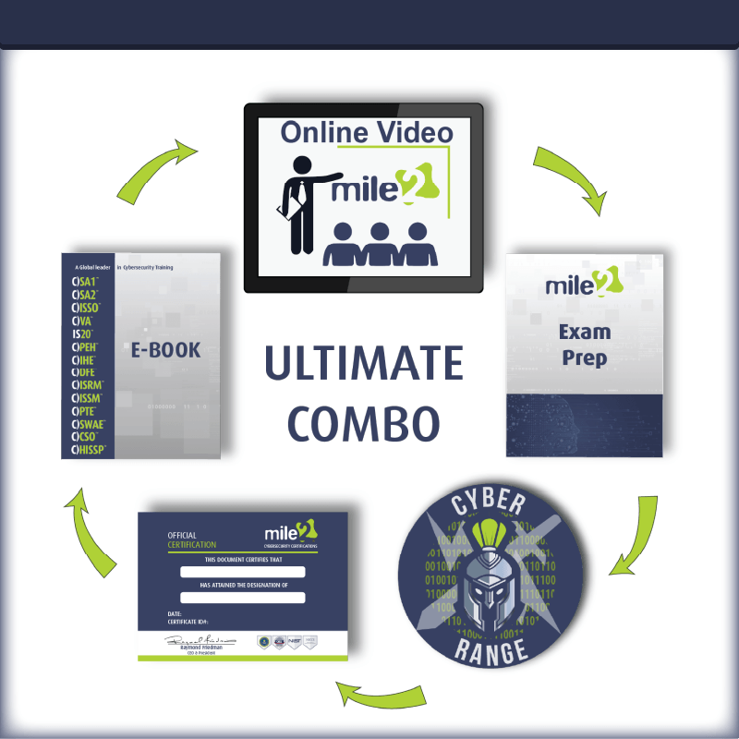



Accreditations

Re-Certification Requirements



