Description:
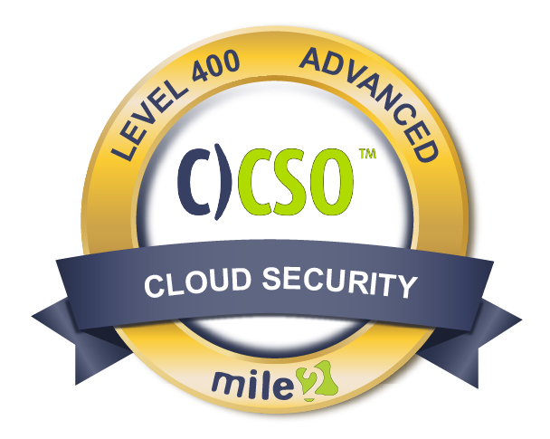

Mile2's Cloud Security Officer, C)CSO, course will provide you something you will not find in other class! The Cloud is being widely adopted today for a diverse set of reasons. However, many are finding that security in the cloud is a huge challenge.

The C)CSO looks to fill the gap in cloud security education and give you the skills you need to develop strong cloud security.
What makes this course powerful is the pairing of knowledge from leading cloud security authorities, with practical lab exercises. You will leave the course with a solid understanding of the cloud stack having been introduced to many technologies used in the cloud. Whether you are implementing private cloud architecture or managing solutions from various vendors, this course is for you.

Annual Salary Potential $121,000 AVG/year

Live Class Duration: 5 Days
CEUs: 40
Language: English
Class Formats Available:
Instructor Led
Self-Study
Live Virtual Training
Suggested Prerequisites:
(Any of the following Mile2 Courses)
- 12 months experience with virtualization technology or equivalent knowledge.
- General understanding of cloud architectures
- Minimum 12 months experience with general security

Module 1 – Introduction to Cloud Computing and Architecture
Module 2 – Cloud Security Risks
Module 3 – ERM and Governance
Module 4 – Legal Issues
Module 5 – Virtualization
Module 6 – Data Security
Module 7 – Data Center Operations
Module 8 – Interoperability and Portabliity
Module 9 – Traditional Security
Module 10 – BCM and DR
Module 11 – Incident Response
Module 12 – Application Security
Module 13 – Encryption and Key Management
Module 14 – Identity, Entitlement and Access
Module 15 – Auditing and Compliance
Key Course Information
Modules/Lessons
Labs

Lab 1 – Cloud Migration Evaluation
Lab 2 – Service Level Agreement Compliance
Lab 3 – Virtualization 101
Lab 4 – Understanding Network Traffic
Lab 5 – Hardening Your Virtual Machines
Lab 6 – ESXi Hosting Hardening
Lab 7 – Hardening vCenter
Lab 8 – Basics of Data Security in Azure
Lab 9 – 23: See Detailed Outline
Below

*All labs are performed in our Cyber Range® on our Ghost Pentesting Platform®

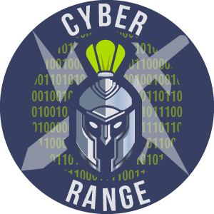

- Virtualization Admins
- Cloud Security Officers
- CIO
- Virtualization and Cloud Auditors
- Virtualization and Cloud Compliance Officers

Upon completion, Certified Cloud Security Officer students will understand Cloud security from a real-world viewpoint and comprehend the industry security standards. The student will also be prepared to take the C)CSO exam.

The Certified Cloud Security Officer exam is taken online through Mile2’s Learning Management System and is accessible on you Mile2.com account. The exam will take approximately 2 hours and consist of 100 multiple choice questions.
A minimum grade of 70% is required for certification.

All Mile2 certifications will be awarded a 3-year expiration date.

There are two requirements to maintain Mile2 certification:

- Pass the most current version of the exam for your respective existing certification
- Earn and submit 20 CEUs per year in your Mile2 account.

Question: Do I have to purchase a course to buy a certification exam?
Answer: No
Question: Do all Mile2 courses map to a role-based career path?
Answer: Yes. You can find the career path and other courses associated with it at www.mile2.com.
Question: Are all courses available as self-study courses?
Answer: Yes. There is however 1 exception. The Red Team vs Blue Team course is only available as a live class.
Question: Are Mile2 courses transferable/shareable?
Answer: No. The course materials, videos, and exams are not meant to be shared or transferred.
Who Should Attend
Course FAQ’s
Exam Information

Upon Completion

Re-Certification Requirements

Accreditations

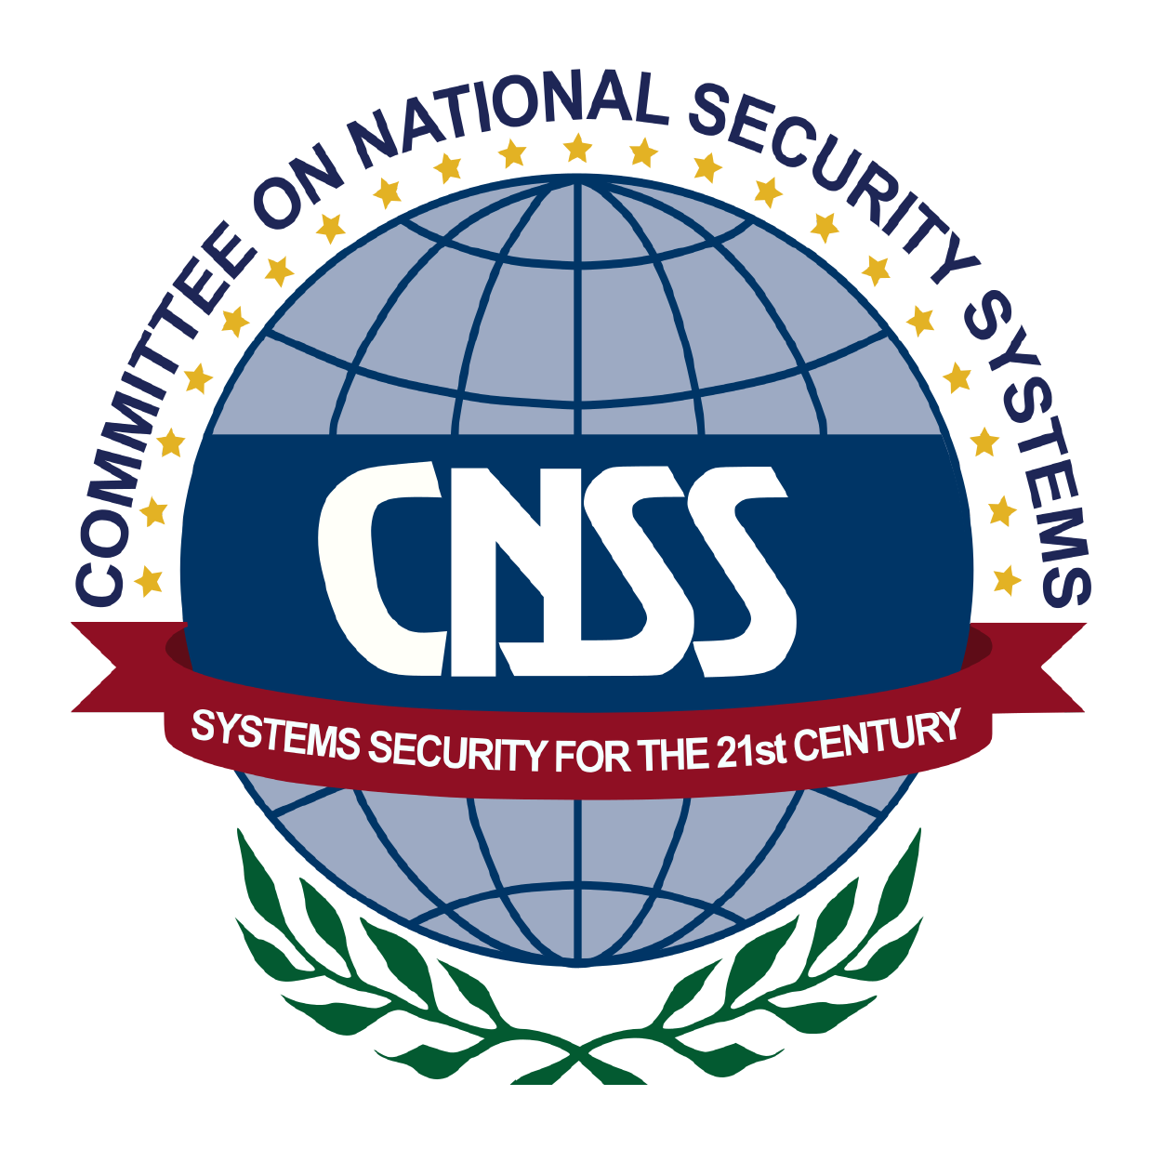

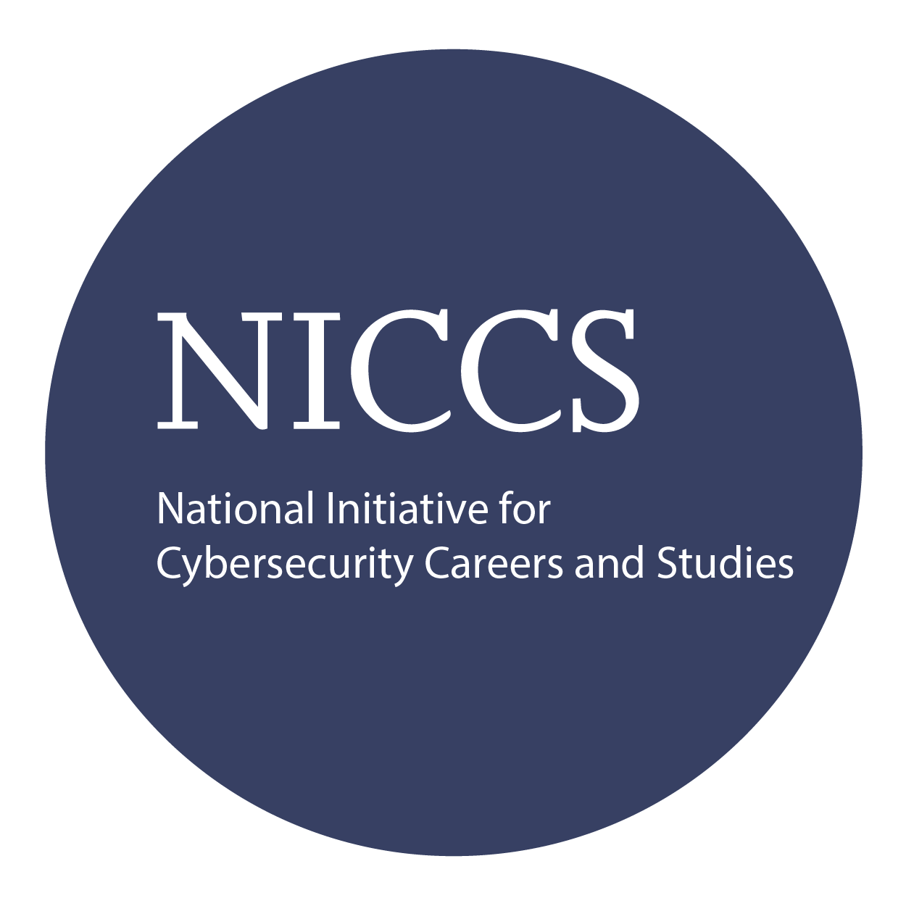

Course and Certification Learning Options
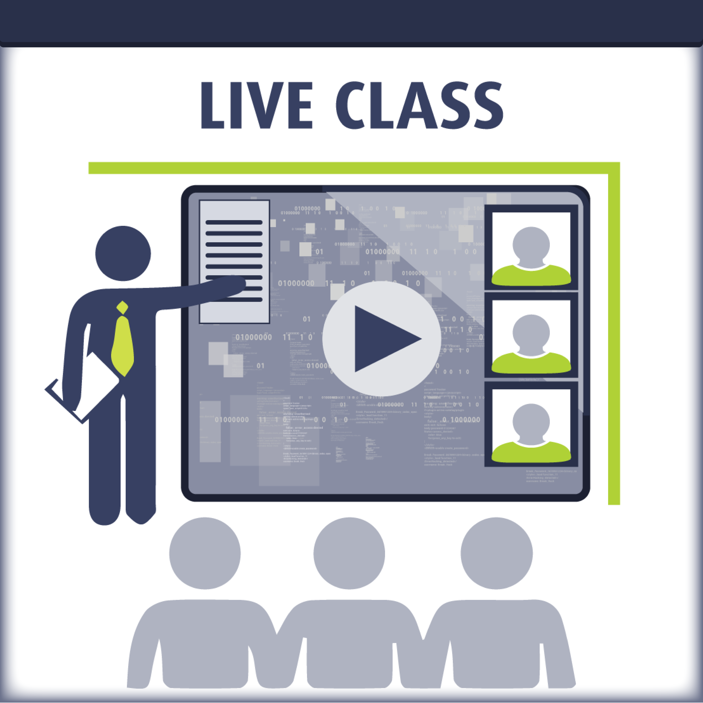
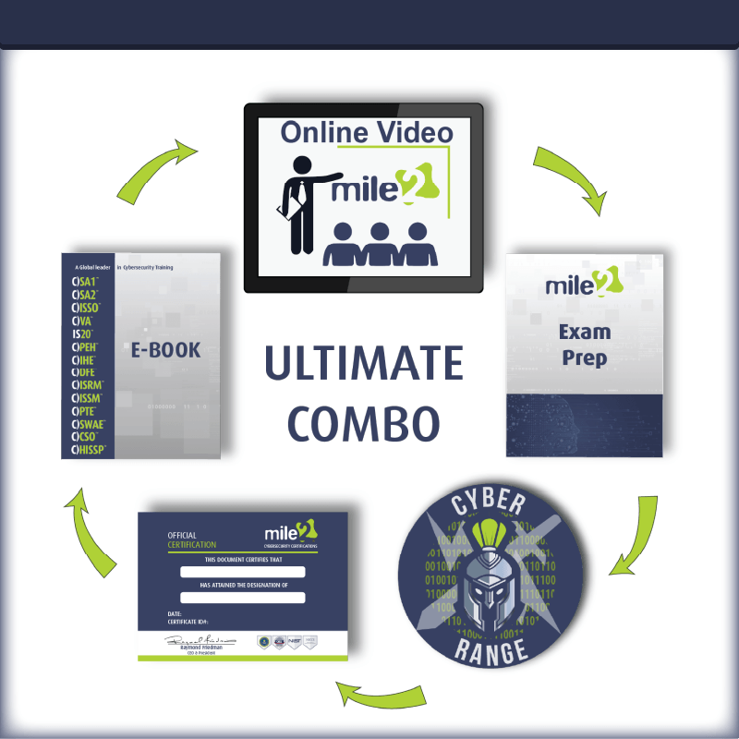
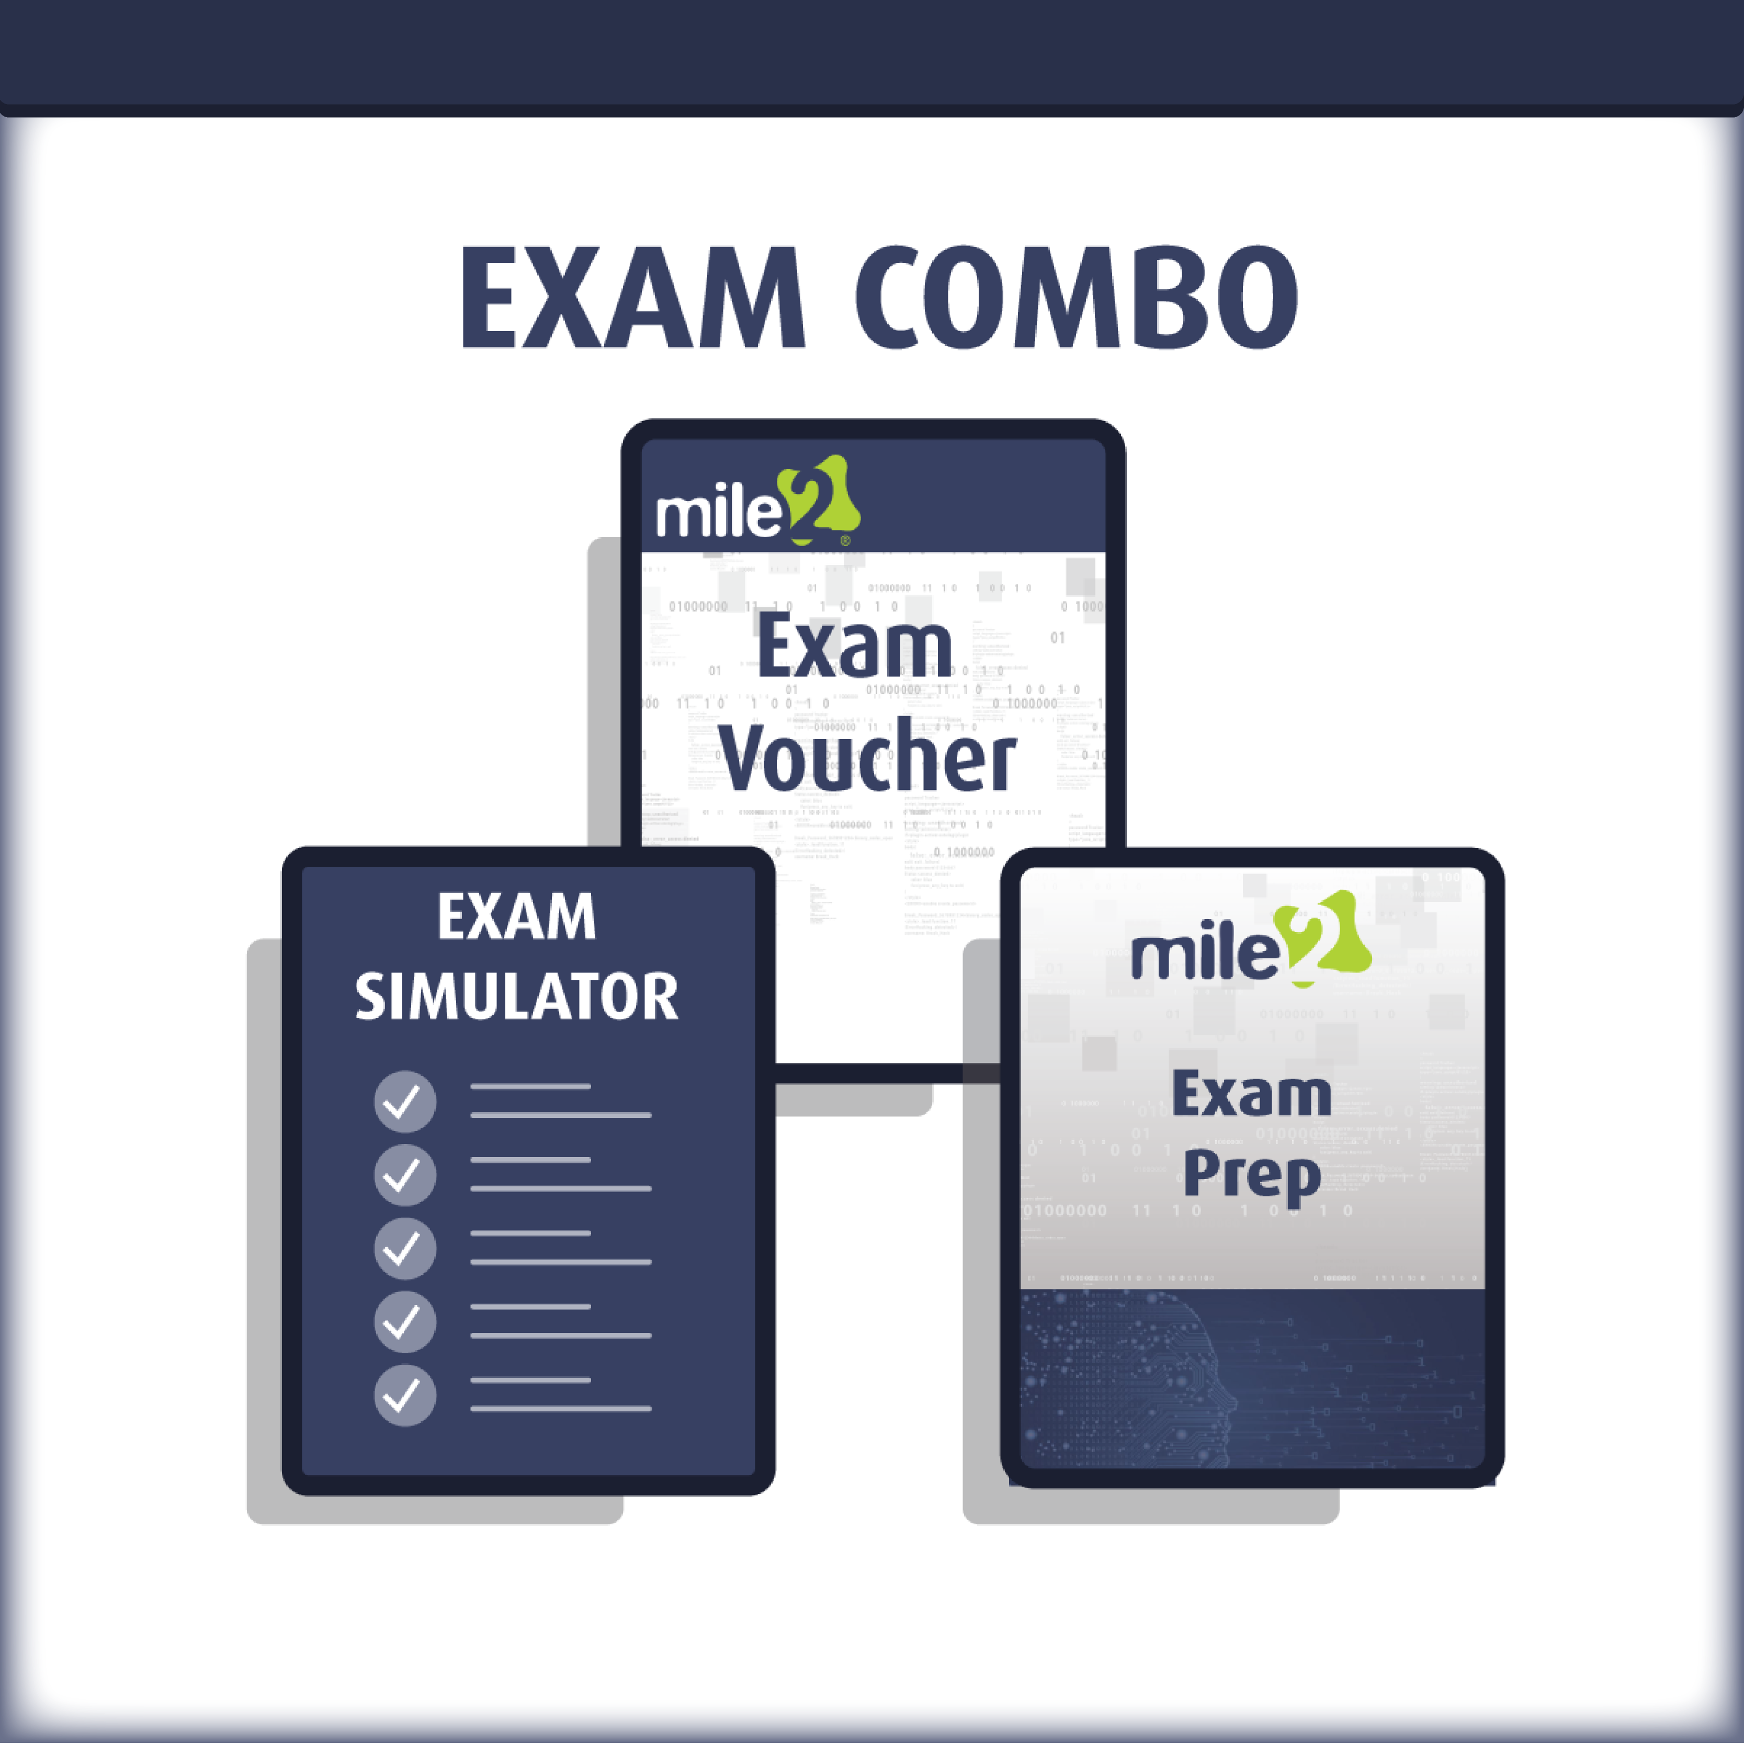

Detailed Outline:
Course Introduction

Module 1 – Introduction to Cloud Computing and Architecture
- Cloud Computing Terminology
- Cloud Computing Definition
- Cloud Computing Characteristics
- Cloud Computing Benefits
- Cost Benefit Analysis Reference Model
- What is Security for the Cloud?
Module 2 – Cloud Risks
- Cloud Migration Security Evaluation
- ENISA Risk Evaluation
- Cloud Controls Matrix
- Relevant CCM Controls
Module 3 – ERM and Governance
- Application of Governance and Risk Management to the Cloud
- Importance of the SLA
- Relevant CCM controls
Module 4 – Legal Issues
- Understanding Unique Risks in the Cloud International Law and Potential Conflicts eDiscovery
- Contract Considerations
- Relevant CCM Controls
Module 5 – Virtualization
- Virtualization Principles
- Key Components Mapped to Cloud Layer
- Key Security Concerns
- Other Technologies Used in the Cloud
- The Layers
- Relevant CCM Controls
Module 6 – Data Security
- Cloud Data Life Cycle
- Design and Implement Cloud Data Storage Architectures

- Design and Apply Data Security Strategies Understand and Implement Data Discovery and Classification Technologies
- Design and Implement Relevant Jurisdictional Data Protection for PII
- Design and Implement Data Rights Management
- Plan and Implement Data Retention, Deletion and Archival Policies
- Design and Implement Auditability, Traceability, and Accountability of Data Events
- Relevant CCM Controls
Module 7 – Data Center Operations
- Build Logical Infrastructure for Cloud Environment
- Manage Logical Infrastructure for Cloud Environment
- Manage Communications with Relevant Parties
- Relevant CCM Controls
Module 8 – Interoperability and Portablility
- Interoperability
- Portability
- Relevant CCM Controls
Module 9 – Traditional Security
- The Physical Environment
- Support the Planning Process for the Data Center Design
- Run Physical Infrastructure for Cloud Environment
- Implement and Build Physical Infrastructure for Cloud Environment
- Manage Physical Infrastructure for Cloud Environment
- Relevant CCM Controls
Module 10 – BCM and DR
- Disaster Recovery and Business Continuity Management
- Examples
- Relevant CCM Controls
Module 11 – Incident Response
- Incident Response
- Forensics
- Relevant CCM Controls

Module 12 – Application Security
- Training and Awareness
- Secure Software Development Life Cycle Process
- Application of the Secure Software Development Life Cycle
- Verifying the use of Secure Software
- Identity and Access Management (IAM) Solutions
- Additional components for the Cloud Software Assurance and Validation
- Relevant CCM Controls
Module 13 – Encryption and Key Management
- Review from other chapters
- Key Management in today’s cloud services
- Recommendations
- Relevant CCM Controls
Module 14 – Identity, Entitlement and Access Management
- Introduction to Identity and Access Management Identities and Attributes
- Architectures for Interfacing to Identity and Attribute Providers
- The Identity Recommendations
- Relevant CCM Controls
Module 15 – Auditing and Compliance
- Compliance and Audit Cloud Issues Assurance Frameworks
- Auditing
- Relevant CCM Controls

Labs
Lab 1: Cloud Migration Evaluation
Lab 2: Service Level Agreement (SLA) Compliance Lab 3: Virtualization 101
Lab 4: Understanding Network Traffic
Lab 5: Hardening your Virtual Machines
Lab 6: ESXi Host Hardening
Lab 7: Hardening vCenter

Lab 8: Basics of Data Security in Azure
Lab 9: IaaS
Lab 10: Deploying a Cloud
Lab 11: Basic Data Center Operations in Azure Lab 12: Interoperability and Portability
Lab 13: Business Continuity in Azure
Lab 14: PaaS in Azure
Lab 15: Encryption in Azure
Lab 16: Identity and Access Management in Azure
Lab 17: SaaS
Lab 18: S-P-I Model Exercise
Lab 19: Cloud Business Driver Audit Exercise
Lab 20: IaaS Risk Assessment
Lab 21: Identity and Access Control Management in the Private Cloud Lab 22: VM Security Audit
Lab 23: Encryption/Key Management in SaaS

