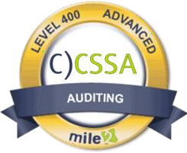

The Certified Cybersecurity Systems Auditor, C)CSSA , course covers the skills and knowledge to assess vulnerabilities, report on compliance and implement controls for private and public enterprises. Many organizations require an Cybersecurity System Auditor's expert knowledge when it comes to identifying critical issues and providing effective auditing solutions. Through the use of a risk-based approach, the C)CSSA is able to implement and maintain cost- effective security controls that are closely aligned with both business and industry standards.

- IS Security Officers
- Privacy Officers
- Health IS Managers
- Risk Mangers
- Info Security managers
- Government employees

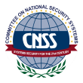

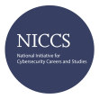

Live Class Duration: 4 Days | Module 01: The Process of Auditing Information Systems
CEUs: 40
 | Module 02: Risk-Based Auditing
Language: English  Class Formats Available: | Module 03: Audit Planning and Performance
Instructor Led | Module 04: IS Systems Reports
Self-Study  Live Virtual Training | Module 05: IT Governance and Management
Suggested Prerequisites:
- Mile2’s C)SP
- 12 months of IT experience

Upon completion, Certified Cybersecurity Systems Auditor students will be able to establish industry acceptable Cyber Security & IS management standards with current best practices and be prepared to competently take the
- CSSA exam.
The Certified Cybersecurity Systems Auditor exam is taken online through Mile2’s Learning Management System and is accessible on you Mile2.com account. The exam will take approximately 2 hours and consist of 100 multiple choice questions.
A minimum grade of 70% is required for certification.

All Mile2 certifications will be awarded a 3-year expiration date.

There are two requirements to maintain Mile2 certification:

  - Pass the most current version of the exam for your respective existing certification
  - Earn and submit 20 CEUs per year in your Mile2 account.
Question: Do I have to purchase a course to buy a certification exam?
Answer: No

Question: Do all Mile2 courses map to a role-based career path? Answer: Yes. You can find the career path and other courses associated with it at www.mile2.com.

Question: Are all courses available as self-study courses? Answer: Yes. There is however 1 exception. The Red Team vs Blue Team course is only available as a live class.

Question: Are Mile2 courses transferable/shareable?
Answer: No. The course materials, videos, and exams are not meant to be shared or transferred.

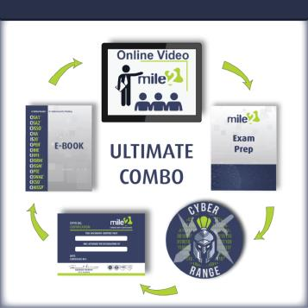
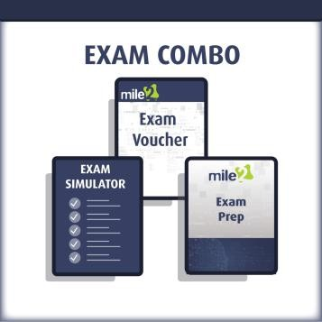

Course Introduction

Module 01: The Process of Auditing Information Systems

  - The Process of Auditing Information Systems
  - Risk Based Auditing
  - Audit Planning and Performance
  - Reporting an Audit

Module 02: Risk Based Auditing
  - IT Governance and Management
  - Strategic Planning and Models
  - Resource Management
  - Business Continuity Planning

Module 03: Audit Planning and Performance
  - Information Systems Acquisition, Development and Implementation
  - Systems Development Models
  - Types of Specialized Business Applications
  - Application Controls

Module 04: IS Systems Reports
- Information Systems Operations, Maintenance and Support
- System and Communications Hardware
- Auditing Networks
- Business Continuity and Disaster Recovery Audits

Module 05: IT Governance and Management
- Protection of Information Assets
- Access Controls
- Equipment and Network Security
- Encryption

