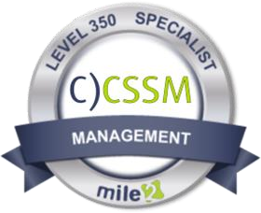

Companies will lean on a Certified Cybersecurity Systems Manager, C)CSSM to create solutions for tomorrow's problems, today. When it comes to identifying critical issues and providing effective IS management solutions. The knowledge and course content provided in the Certified Cybersecurity Systems Manager -
C)CSSM will cover a measurable certification that demonstrates proficiency in the IS Management Field. The Certified Cybersecurity Systems Manager covers the skills and knowledge to assess threat analysis and risks, Risk & incident management, and Security programs, IS security strategy and frameworks, Audit and Risk management creation of policies, compliance, and awareness, as

- Penetration Testers
- Microsoft Administrators
- Security Administrators
- Active Directory Admins

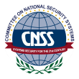

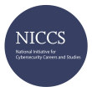

Live Class Duration: 4 Days
 | Module 01: Introduction
CEUs: 32
Language: English | Module 02: Architectural  Frameworks and Compliance
Class Formats Available: | Module 03: Risk Management and Controls
Instructor Led  Self-Study | Module 04: Evaluating Systems and Management Strategies
Live Virtual Training  Suggested Prerequisites: | Module 05: Incident Management, Law, and Ethics
- Mile2’s C)SP | Module 06: Business Continuity and Disaster Recovery Processes
- 12 months of Information Systems Experience

Upon completion, Certified Cybersecurity Systems Manager students will have a strong foundation in Cyber Security & IS management standards with current best practices and will be prepared to competently take the
- CSSM exam.
The Certified Cybersecurity Systems Manager exam is taken online through Mile2’s Learning Management System and is accessible on you Mile2.com account. The exam will take approximately 2 hours and consist of 100 multiple choice questions. A minimum grade of 70% is required for certification.

All Mile2 certifications will be awarded a 3-year expiration date.

There are two requirements to maintain Mile2 certification:

  - Pass the most current version of the exam for your respective existing certification
  - Earn and submit 20 CEUs per year in your Mile2 account.
Question: Do I have to purchase a course to buy a certification exam?
Answer: No

Question: Do all Mile2 courses map to a role-based career path? Answer: Yes. You can find the career path and other courses associated with it at www.mile2.com.

Question: Are all courses available as self-study courses? Answer: Yes. There is however 1 exception. The Red Team vs Blue Team course is only available as a live class.

Question: Are Mile2 courses transferable/shareable?
Answer: No. The course materials, videos, and exams are not meant to be shared or transferred.

