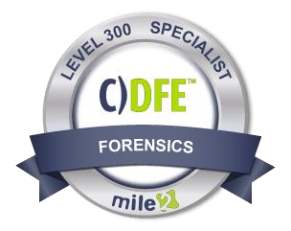
Description:
The Certified Digital Forensics Examiner, C)DFE certification is designed to train Cyber Crime and Fraud Investigators. Students are taught electronic discovery and advanced
investigation techniques. This course is essential to anyone encountering digital evidence while conducting an investigation.
Mile2's Certified Digital Forensics Examiner training teaches the methodology for conducting a computer forensic examination. Students will learn to use forensically sound investigative techniques in order to evaluate the scene,

collect and document all relevant information, interview appropriate personnel, maintain chain-of-custody, and write a findings report.
Through the use of a risk -based approach, the C)DFE is able to implement and maintain cost-effective security controls that are closely aligned with both business and industry standards.

Annual Salary Potential

$
65,000

AVG/year

Key Course Information |  | Modules/Lessons | Labs
Live Class Duration: 5 Days  CEUs: 40  Language: English  Class Formats Available:  Instructor Led  Self-Study  Live Virtual Training  Suggested Prerequisites:  - 1 YR experience in computers  - Mile2’s C)SP course  - Mile2’s Foundational Course Pack |  | Module 1 – Computer Forensic  Incidents  Module 2 – Investigative Theory  Module 3 – Investigative Process  Module 4 – Digital Acquisition and  Analysis Tools  Module 5 – Disks and Storages  Module 6 – Live Acquisitions  Module 7 – Windows Forensics  Module 8 – Linux Forensics  Module 9 – Mac Forensics  Module 10 – Examination Protocols  Module 11 – Digital Evidence  Protocols  Module 12 – Digital Evidence  Presentation  Module 13 – Laboratory Protocols  Module 14 – Artifact Recovery  Module 15 – Advanced Search Strings  Module 16 – eDiscovery and ESI  Module 17 – Mobile Forensics  Module 18 – Incident Handling  Module 19 – Reporting | Lab 1 – Chain of Custody  Lab 2 – Identify Seized Evidences  Lab 3 – Devices Acquisition  Lab 4 – Memory Acquisition  Lab 5 – Prepare the Case Evidence  Lab 6 – Investigate the Acquired  Evidence  Lab 7 – Prepare the Case Evidence  Lab 8 – Windows Event Logs  Analysis  Lab 9 – Linux Primary Info  Retrieval  Lab 10 – Investigate OSX Evidence  Lab 11 – Finding Clues  Lab 12 – Construct the Case  Events  Lab 13 -Evidence found from a  Seized Android Device  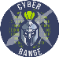  Lab 14 – Incident Response

Who Should Attend
- Virtualization Admins
- Cloud Security Officers
- CIO
- Virtualization and Cloud Auditors
- Virtualization and Cloud
Compliance Officers

Upon Completion
Upon completion, Certified Digital
Forensics Examiner students will be

able to establish industry acceptable digital forensics
standards with current best

practices and policies. Students will also be prepared to competently take the C)DFE exam..

Accreditations Exam Information
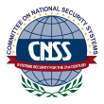
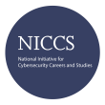
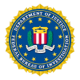
The Certified Digital Forensics Examiner exam is taken online through Mile2’s Learning Management System and is accessible on you Mile2.com account. The exam will take approximately 2 hours and consist of 100 multiple choice questions.
A minimum grade of 70% is required for certification.

Re-Certification

Requirements
All Mile2 certifications will be awarded a 3-year expiration date.

There are two requirements to maintain Mile2 certification:

- Pass the most current version of the exam for your respective existing certification
- Earn and submit 20 CEUs per year in your Mile2 account.

Course FAQ’s
Question: Do I have to purchase a course to buy a certification exam?
Answer: No
Question: Do all Mile2 courses map to a role-based career path?
Answer: Yes. You can find the career path and other courses associated with it at www.mile2.com.
Question: Are all courses available as self-study courses?
Answer: Yes. There is however 1 exception. The Red Team vs Blue Team course is only available as a live class.
Question: Are Mile2 courses transferable/shareable?
Answer: No. The course materials, videos, and exams are not meant to be shared or transferred.

Course and Certification Learning Options
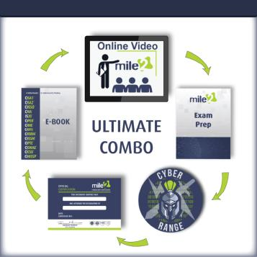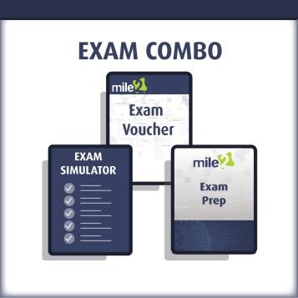

DETAILED OUTLINE

Module 1 – Computer Forensics Incidents
- Origins of digital forensic science
- Differences between criminal and civil incidents
- Types of computer fraud incidents
- Internal and external threats
- Investigative challenges
- Industry Standards

Module 2 – Computer Forensic Investigative Theory
- Investigative Theory
- Investigative Concepts
- Behavioral evidence analysis (BEA) & Equivocal Forensic Analysis (EFA)

Module 3 – Computer Forensic Investigative Process
- Investigative Prerequisites
- Scene Management
- The digital forensics process
- ISO 27043

Module 4 – Digital Acquisition and Analysis Tools
- Acquisition Procedures
- Computer forensics field triage process model (CFFTPM)
- Acquisition Authentication
- Forensic Tools

Module 5 – Disks and Storages
- Disk OS and Filesystems
- Spinning Disks Forensics
- SSD Forensics
- Files Management
- Handling Damaged Drives

Module 6 – Live Acquisitions
- Live Acquisition
- Apple Acquisition
- Linux/UNIX Acquisition

Module 7 – Windows Forensics
- Windows Event Viewer Overview
- EVTX and EVT Logs
- Logs Analysis to Identify Breaches and Attacks

Module 8 - Linux Forensics
• Linux Artifacts o File System Structure o Basic Identifiers
- Common Log Files

Module 9 – MAC Forensics • OSX Artifacts o File System Structure o Core Storage o Default Apps
- Other Artifacts

Module 10 – Forensic Examination Protocols
- Science Applied to Forensics
- Cardinal Rules
- Alpha 5
- The 20 Basic Steps of Forensics
- Scientific Working Group on Digital Evidence (SWGDE) Standard
- International Organization on Computer Evidence (IOCE) Standard

Module 11 – Digital Evidence Protocols
- Digital Evidence Categories
- Evidence Admissibility

Module 12 – Digital Evidence Presentation
- The Best Evidence Rule
- Hearsay
- Authenticity and Alteration

Module 13 – Computer Forensic Laboratory Protocols • Forensics Lab Standard Operating Procedures o Quality Assurance o Quality Control o Peer Review o Annual Review o Deviations o Lab Intake

Module 14 – Specialized Artifact Recovery
- Forensics Workstation Prep
- Windows Components with Investigative Interest
- Files Containing Historical Information
- Web Forensics

Module 15 – Advanced Search Strings and File Signatures
- Search Strings
- RegEx
- File Signatures

Module 16 – eDiscovery and ESI
• Electronically Stored Information Rules o Legal System o Disclosure o Rule 37 o eDiscovery Tools

Module 17 – Mobile Forensics
- Cellular Network
- Forensic Process
- Tools
- Paraben Forensics

Module 18 – Incident Handling • What is an Incident?
- Incident Handling Steps o Preparation o Identification and Initial Response
o Containment o Eradication o Recovery o Follow-up

Module 19 – Digital Forensics Reporting
• Report Sections and Content

