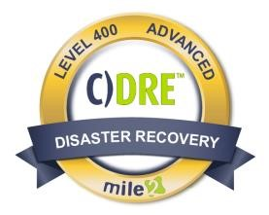
Description:

A Certified Disaster Recovery Engineer, C)DRE, is the superhero of an information System! When a business is hit by a natural disaster, cybercrime or any other disruptive tragedy, how should the organization react? What if the network

infrastructure is taken down? Will the business be able to continue operations? How much will it cost if the business is down during repairs?
The answer is found in the Certified Disaster Recovery Engineer certification course. Disaster recovery and business continuity planning is the process of having a professional work with a business to prepare processes, policies, and procedures to follow i n the event of a disruption. The C)DRE prepares students to plan and present the latest methodologies and best practices for real -world system recovery.

Annual Salary Potential

$
84
,000

AVG/year

Key Course Information  Live Class Duration: 4 Days  CEUs: 32  Language: English  Class Formats Available:  Instructor Led  Self-Study  Live Virtual Training  Suggested Prerequisites:  - 12 Months in Information Systems  - 12 Months in Information Systems Management  - Mile2’s C)ISSO Course |  | Modules/Lessons  Module 1 – Introduction  Module 2 – Business Impact Analysis  Module 3 – BCP and DRP Design  Module 4 – IT Recovery Strategies Module 5 – IT Resiliency  Module 6 – Implementation Phase  Module 7 – Testing and Exercise  Module 8 – Maintenance and Execution  Module 9 – Pandemics |  | Who Should Attend  - IS Security Officers  - IS Managers  - Risk Managers  - DR and BCP Engineers  - Info Systems Owners  - IS Control Assessors  - System Managers  - Government workers  Accreditations

Upon Completion

Upon completion, Certified
Disaster Recovery Engineer

students will be able to establish industry acceptable DR & BCP
standards with current best

practices and policies. Students will also be prepared to competently take the C)DRE exam.

Exam Information
The Certified Disaster Recovery Engineer exam is taken online through Mile2’s Learning Management System and is accessible on you Mile2.com account. The exam will take approximately 2 hours and consist of 100 multiple choice questions.
A minimum grade of 70% is required for certification.

Re-Certification Requirements

All Mile2 certifications will be awarded a 3-year expiration date.

There are two requirements to maintain Mile2 certification:

- Pass the most current version of the exam for your respective existing certification
- Earn and submit 20 CEUs per year in your Mile2 account.

Course FAQ’s

Question: Do I have to purchase a course to buy a certification exam?
Answer: No
Question: Do all Mile2 courses map to a role-based career path?
Answer: Yes. You can find the career path and other courses associated with it at www.mile2.com.
Question: Are all courses available as self-study courses?
Answer: Yes. There is however 1 exception. The Red Team vs Blue Team course is only available as a live class.
Question: Are Mile2 courses transferable/shareable?
Answer: No. The course materials, videos, and exams are not meant to be shared or transferred.

Course and Certification Learning Options
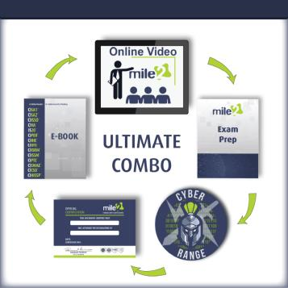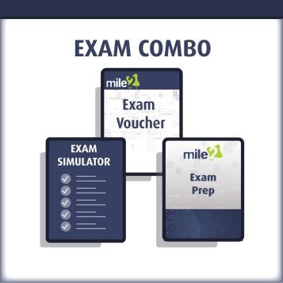

Module 1 – Introduction
Section 1 – Introduction to Business Continuity Management
Section 2 – Project Initiation (Phase 1)
Section 3 – Practice Questions

Module 2 – Business Impact Analysis
Section 1 – Functional Requirement Phase
Section 2 – Risk Analysis
Section 3 – Practice Questions

Module 3 – BCP and DRP Design
Section 1 – BC Plan Design
Section 2 – Disaster Recovery Plan
Section 3 – Practice Questions

Module 4 – IT Recovery Strategies
Section 1 – IT Recovery Strategies
Section 2 – DR Site Strategies
Section 3 – Practice Questions

Module 5 – IT Resiliency
Section 1 – IT Resiliency
Section 2 – IT Recovery
Section 3 – Practice Questions

Module 6 – Implementation Phase
Section 1 – Implementation Phase
Section 2 – Awareness and Training
Section 3 – Practice Questions

Module 7 – Testing and Exercise
Section 1 – Testing and Exercise
Section 2 – Practice Questions

Module 8 – Maintenance and Execution
Section 1 – Maintenance and Updating
Section 2 – Execution Phase
Section 3 – Practice Questions

Module 9 – Pandemics

