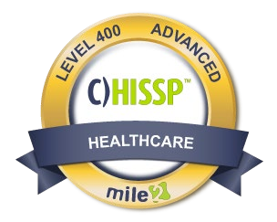
Description:

The Certified Healthcare IS Security Practitioner, C)HISSP certification course covers

the skills and knowledge to implement the best IT healthcare practices, as well as, regulatory compliance and standards in the healthcare industry.

Because of growing industry regulations and privacy requirements in the healthcare industry, the C)HISSP was developed by Mile2. Graduates of this course have become vital in managing and protecting healthcare data and are

tasked to protect patient information by implementing, managing, and assessing proper IT controls for patient health information integrity.

Annual Salary Potential

$
112
,000

AVG/year

Key Course InformationClass Information  Live Class Duration: 4 Days  CEUs: 32  Language: English  Class Formats Available:  Instructor Led  Self-Study  Live Virtual Training  Suggested Prerequisites:  - 12 Months of Healthcare Information Systems Management |  | Modules/Lessons  Module 1 – Intro to the Healthcare Industry  Module 2 – Regulatory Environment  Module 3 – Healthcare Privacy and Security Policies  Module 4 – Information  Governance  Module 5 – Risk Managment  Module 6 – Thrid-Party Management |  | Who Should Attend  - IS Security Officers  - Privacy Officers  - Health IS Managers  - Risk Mangers  - Info Security Managers  - Compliance and Privacy Officers  Accreditations

Upon Completion
Upon completion, Certified
Healthcare Information Systems

Security Practitioner students will be versed with best practices in the
healthcare industry and will be

able to establish a framework with current best practices in respects to privacy, regulation and risk management.

Exam Information
The Certified Healthcare
Information Systems Security Practitioner exam is taken online through Mile2’s Learning Management System and is accessible on you Mile2.com account. The exam will take approximately 2 hours and consist of 100 multiple choice questions.
A minimum grade of 70% is required for certification.

Re-Certification Requirements
All Mile2 certifications will be awarded a 3-year expiration date.

There are two requirements to maintain Mile2 certification:

- Pass the most current version of the exam for your respective existing certification
- Earn and submit 20 CEUs per year in your Mile2 account.

Course FAQ’s

Question: Do I have to purchase a course to buy a certification exam?
Answer: No
Question: Do all Mile2 courses map to a role-based career path?
Answer: Yes. You can find the career path and other courses associated with it at www.mile2.com.
Question: Are all courses available as self-study courses?
Answer: Yes. There is however 1 exception. The Red Team vs Blue Team course is only available as a live class.
Question: Are Mile2 courses transferable/shareable?
Answer: No. The course materials, videos, and exams are not meant to be shared or transferred.

Course and Certification Learning Options
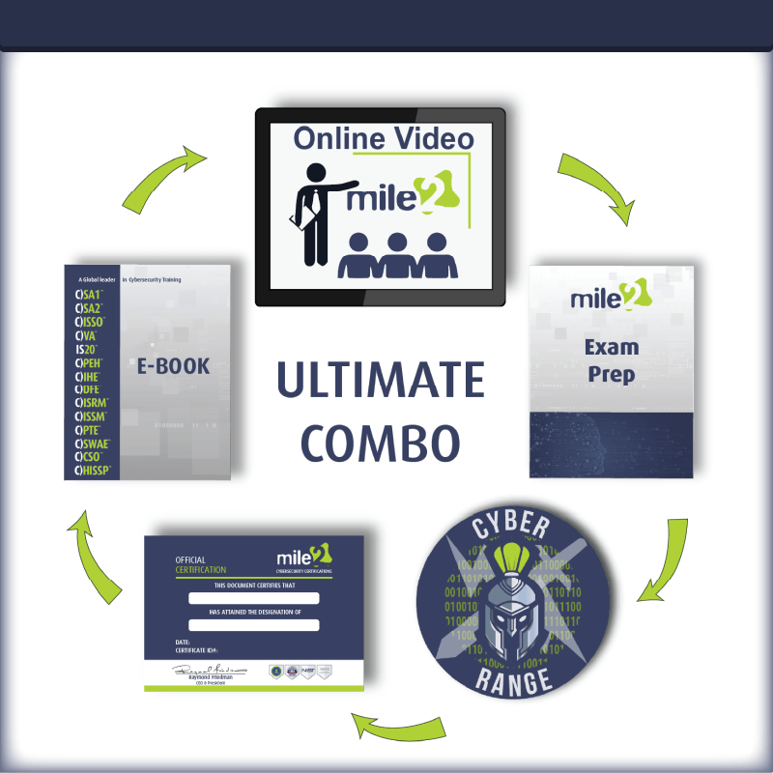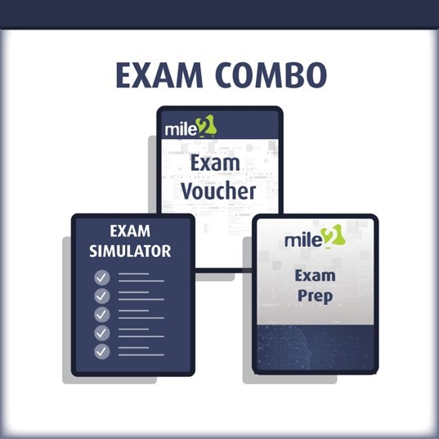

Detailed Outline:
Course Introduction

Module 1: Intro to the Healthcare Industry
- Healthcare Environment
- Third-Party Relationships
- Health Data Management Concepts

Module 2: Regulatory Environment
Applicable Regulations
- International Regulations and Controls
- Internal Practices Compared to New Policies and Procedures
- Compliance Frameworks
- Risk-Based Decisions
- Code of Conduct/Ethics

Module 3 – Healthcare Privacy & Security Policies
- Security Objectives/Attributes
- Security Definitions/Concepts
- Privacy Principles
- Disparate Nature of Sensitive Data and Handling Implications

Module 4 – Information Governance & Risk Management - How organizations manage information risk through security and privacy governance, risk management lifecycles, and principle risk activities

- Security and Privacy Governance
- Risk Management Methodology
- Information Risk Management Life Cycles
- Risk Management Activities

Module 5: Information Governance & Risk Assessment

- Risk Assessment
- Procedures from within Organization Risk Frameworks
- Risk Assessment Consistent with Role in Organization
- Efforts to Remediate Gaps

Module 6: Third-Party Risk Management - Definition of Third-Parties in Healthcare Context

- Third-Party Management Standards and Practices
- Third-Party Assessments and Audits
- Security/Privacy Events
- Third-Party Connectivity
- Third-Party Requirements

