Description:
The C)HT and C)OST courses will kick start your career in the IT field by providing the foundational knowledge needed to install, configure, and support computer hardware systems and operating systems.
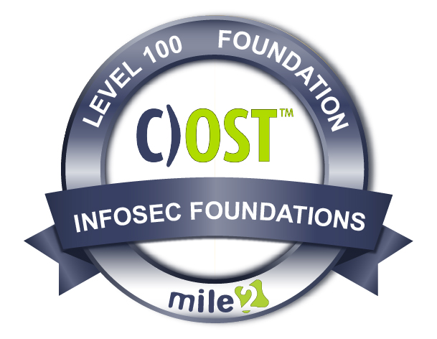
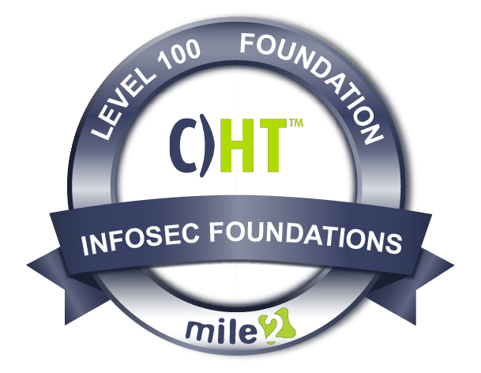

The C)HT will also provide an understanding of the fundamentals of networking and security/forensics; properly and safely diagnosing, resolving, and documenting common issues; as well as applying troubleshooting skills.

The Certified Operating Systems Technician, C)OST course builds on the C)HT course by focusing on operating systems; this includes installing, configuring and maintaining devices, PCs, and software for end users; understanding the basics of networking and security/forensics from the operating system view.
Properly and safely diagnose, resolve, and document common software issues. Apply troubleshooting skills, and providing appropriate customer support. We will cover virtualization, security, desktop imaging, and deployment. You will also learn the security foundations needed for the various operating systems.

Class Information

C)HT Live Class Duration: 5 Days
C)OST Live Class Duration: 5 Days

CEUs: 80

Language: English

Class Formats Available:
Instructor Led
Self-Study
Live Virtual Training

C)OST Modules/Lessons

Module 1 - Troubleshooting Module 2 - Motherboards and CPUs
Module 3 - Power Supplies Module 4 - Memory
Module 5 - Computer Expansion
Module 6 - Physical Storage Module 7 - Input-Output Devices
Module 8 - Display Devices Module 9 - Network Cables and Connectors
Module 10 - Printers and Multifunction Print Devices Module 11 - TCP/IP and Transport Protocols
Module 12 - Custom Computers
Module 13 - Operational Procedures
Key Course Information
C)HT Modules/Lessons

Module 1 - Operating Systems Module 2 - Windows Management
Module 3 - Network Basics Module 4 - Network Protocols Module 5 - Wireless Networking
Module 6 - Windows Networking
Module 7 - Virtualization and Cloud Computing
Module 8 - Security Principles Module 9 - Security Technologies
Module 10 - Securing Devices and Data
Module 11 - SOHO Network Configurations

Exam Information
Upon Completion

The Certified Hardware Technician and Certified Operating Systems Technician exam is taken online through Mile2’s Learning Management System and is accessible on you Mile2.com account. The exam will take approximately 2 hours and consist of 100 multiple choice questions.
A minimum grade of 70% is required for certification.

All Mile2 certifications will be awarded a 3-year expiration date.

There are two requirements to maintain Mile2 certification:

- Pass the most current version of the exam for your respective existing certification
- Earn and submit 20 CEUs per year in your Mile2 account.

Upon completion, the Certified Hardware Technician and Certified Operating Systems Technician candidate will be able to competently take the C)OST & C)HT exams well as the CompTIAA+ 220-1002 exam.

- Anyone

Question: Do I have to purchase a course to buy a certification exam?
Answer: No
Question: Do all Mile2 courses map to a role-based career path?
Answer: Yes. You can find the career path and other courses associated with it at www.mile2.com.
Question: Are all courses available as self-study courses?
Answer: Yes. There is however 1 exception. The Red Team vs Blue Team course is only available as a live class.
Question: Are Mile2 courses transferable/shareable?
Answer: No. The course materials, videos, and exams are not meant to be shared or transferred.
Course FAQ’s

Who Should Attend

Re-Certification Requirements

Accreditations

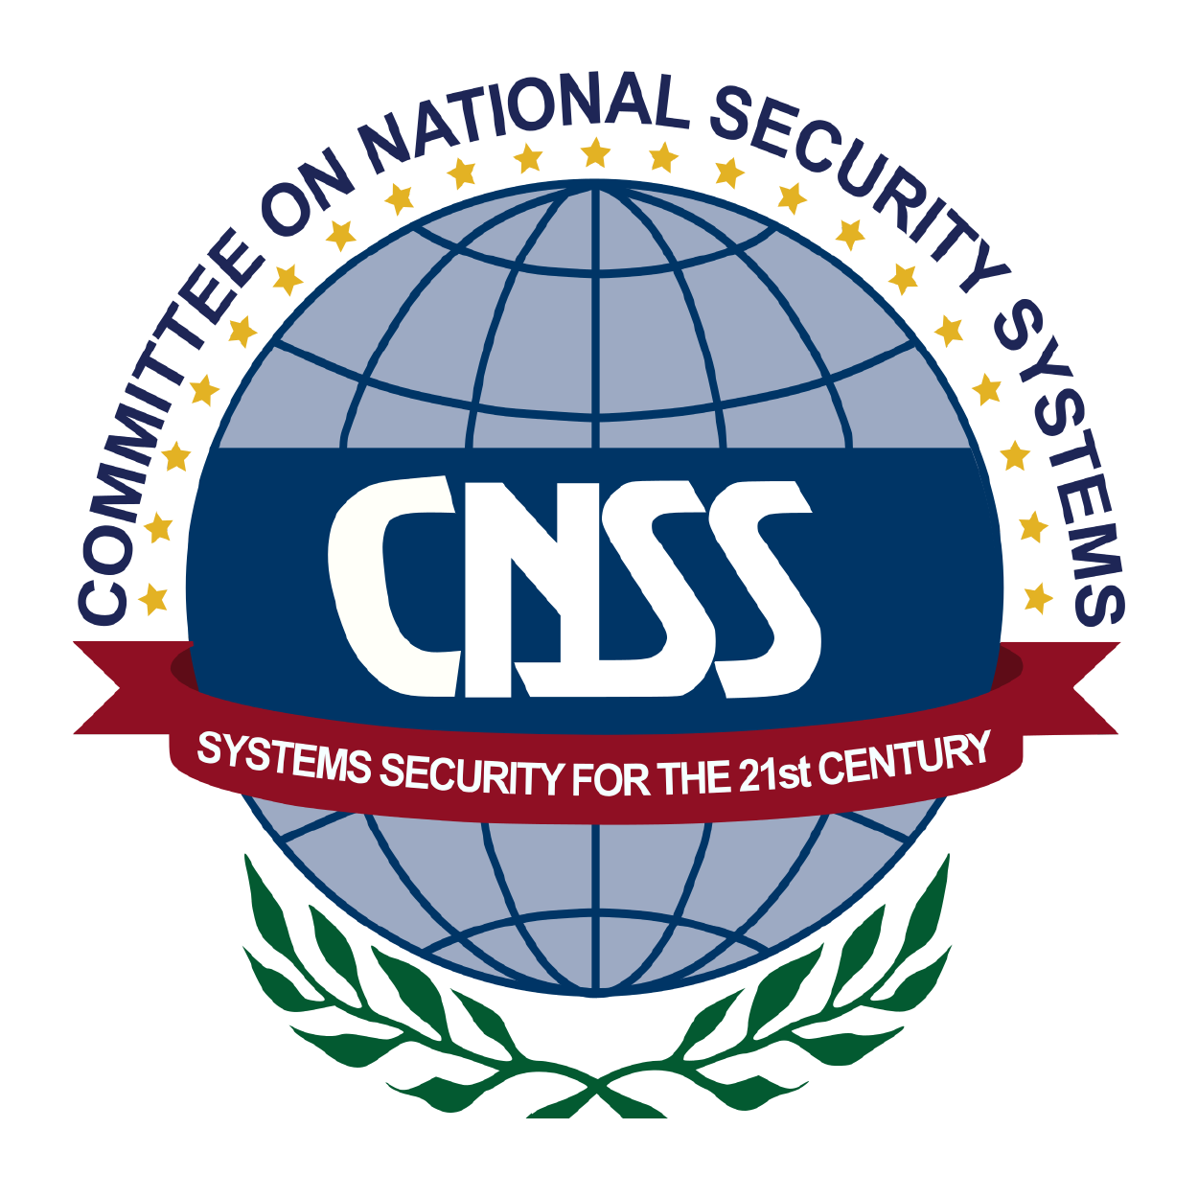

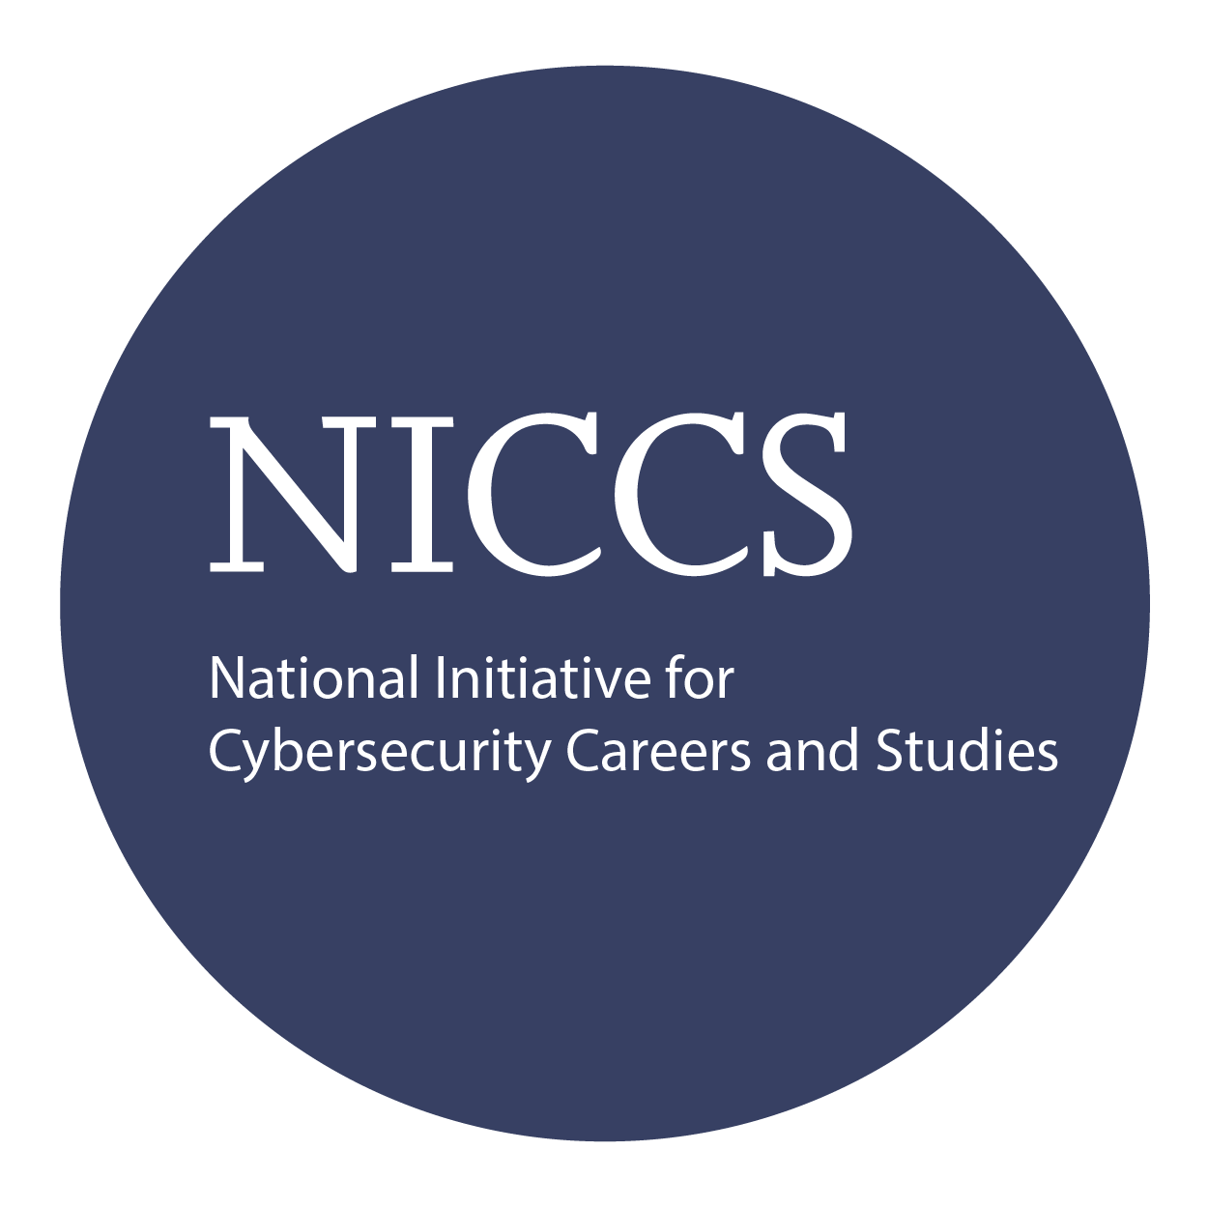

Course and Certification Learning Options
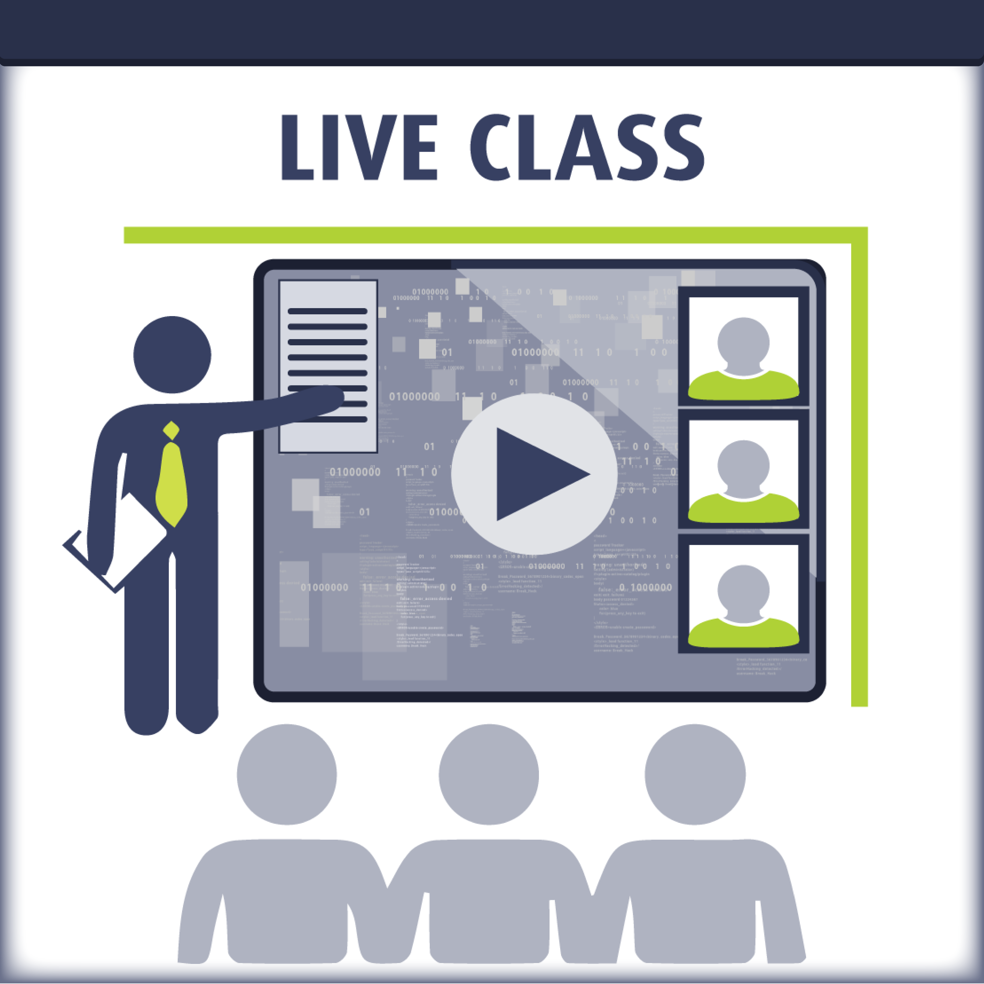
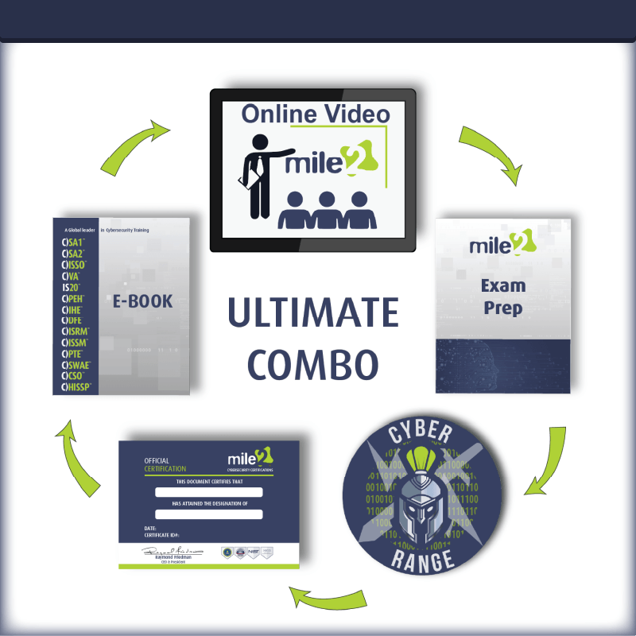
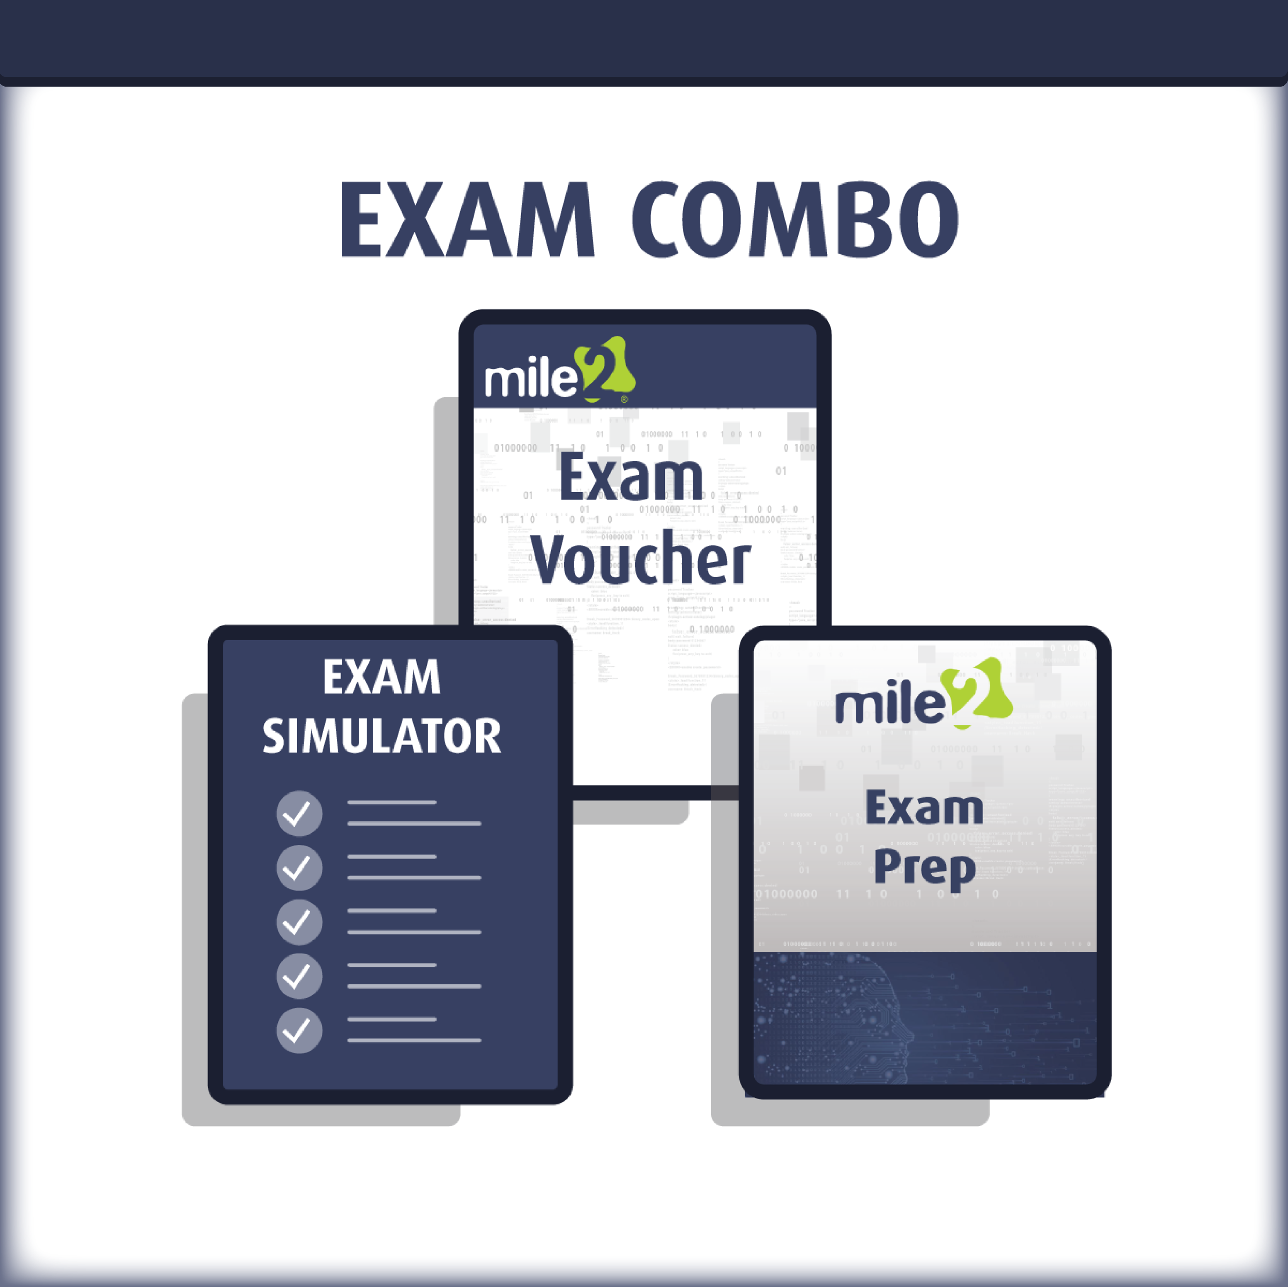

C)HT Detailed Outline:
Course Introduction

Chapter 1: Troubleshooting
Section 1: Troubleshooting theory
Section 2: Safety
Chapter 2: Motherboards and CPUs
Section 1: Motherboards
Section 2: CPUs
Chapter 3: Computer Power Supplies
Section 1: Power supply connectors
Section 2: Power supply installation
Section 3: Power supply troubleshooting
Chapter 4: Memory
Section 1: Read-only memory
Section 2: Random access memory
Chapter 5: Computer Expansion
Section 1: Expansion interfaces
Section 2: Expansion card installation
Section 3: Connectors and cables
Chapter 6: Physical Storage
Section 1: Disk drives
Section 2: Redundant array of independent disks (RAID)
Section 3: Optical drives
Section 4: Other storage methods
Chapter 7: Input-Output Devices
Section 1: Input devices
Section 2: Output devices
Section 3: Dual input-output devices
Chapter 8: Display Devices
Section 1: Display types
Section 2: Display installation
Section 3: Display troubleshooting
Chapter 9: Network Cables and Connectors
Section 1: Twisted-pair connections
Section 2: Coaxial connections
Section 3: Optical media

Chapter 10: Mobile Devices
Section 1: Mobile device types
Section 2: Mobile device troubleshooting
Chapter 11: Printers and Multifunction Print Devices
Section 1: Printer technologies
Section 2: Printer installation
Section 3: Printer maintenance
Section 4: Printer troubleshooting
Chapter 12: Custom Computers
Section 1: Wi-Fi standards
Section 2: Wireless encryption
Chapter 13: Operational Procedures
Section 1: Environment
Section 2: Safety
Section 3: Content Privacy
Section 4: Professionalism

C)OST Detailed Outline:
Chapter 1: Operating Systems
Section 1: Windows versions and features
Section 2: Windows installation and upgrades
Section 3: Non-Windows operating systems
Section 4: Applications and Scripting
Chapter 2: Windows Management
Section 1: Operating system features and tools
Section 2: Control Panel utilities
Section 3: Command-line tools
Section 4: Troubleshooting
Chapter 3: Network Basics
Section 1: Classifying Networks
Section 2: Network Devices
Section 3: Internet Connections
Chapter 4: Network Protocols
Section 1: TCP/IP Settings
Section 2: Transport Protocols
Section 3: Application Protocols
Chapter 5: Wireless Networking
Section 1: Wi-Fi Standards
Section 2: Wireless Encryption

Chapter 6: Windows Networking
Section 1: Sharing and Security
Section 2: Network Connections
Section 3: Connection Troubleshooting
Chapter 7: Virtualization and Cloud Computing
Section 1: Virtualization
Section 2: Cloud Computing
Chapter 8: Security Principles
Section 1: Threats and Vulnerabilities
Section 2: Security Controls
Chapter 9: Security Technologies
Section 1 – Operating System Securities
Section 2 – Security Hardware and Software
Chapter 10: Securing Devices and Data
Section 1 – Workstation Security
Section 2 – Mobile Device Security
Section 3 – Security Troubleshooting
Chapter 11: SOHO Network Configurations
Section 1 – SOHO Router Features
Section 2 – Network Security

