Description:

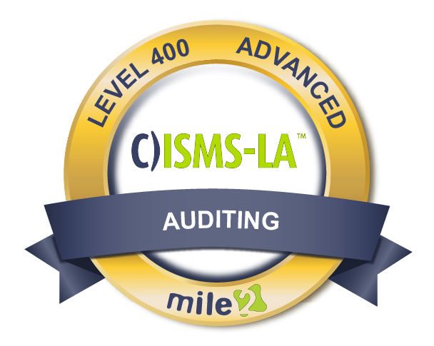

The Certified Information Security Management Systems Lead Auditor course prepares students to conduct audits of information security management systems ("ISMS") to ensure that they meet ISO/IEC 27001 standards in any organization.

**Mile2's ISMS ISO/IEC 27001 Audit Methodology:**

Planning

Control Evaluation

Substantive Testing

Completion

The C)ISMS-LA is perfect for those looking to perform an internal or external ISMS 1S0/IEC 27001 audit.

Annual Salary Potential $89,862 AVG/year

Class Information

**Live Class Duration:** 3 Days

**CEUs:** 24

**Language:** English

**Class Formats Available:**

Instructor Led

Self-Study

Live Virtual Training

**Suggested Prerequisites:**

- Experience with Information Systems

- Interest in Auditing

* Internal Auditor
* IT Auditor and Lead Auditor
* It Consultant
* Chief Information Officer
* Security Consultant

Who Should Attend

**Module 1** – Lead Auditor Intro

**Module 2** – The ISO/27001:2013

**Module 3** – Information Security and Key Controls

**Module 4** – Risk Management

**Module 5** – Risk Treatment

**Module 6** – Audits and Auditors

**Module 7** – Auditing the Information Security Management System

**Module 8** – Planning and Conducting an Audit

Key Course Information

Modules/Lessons

Accreditations



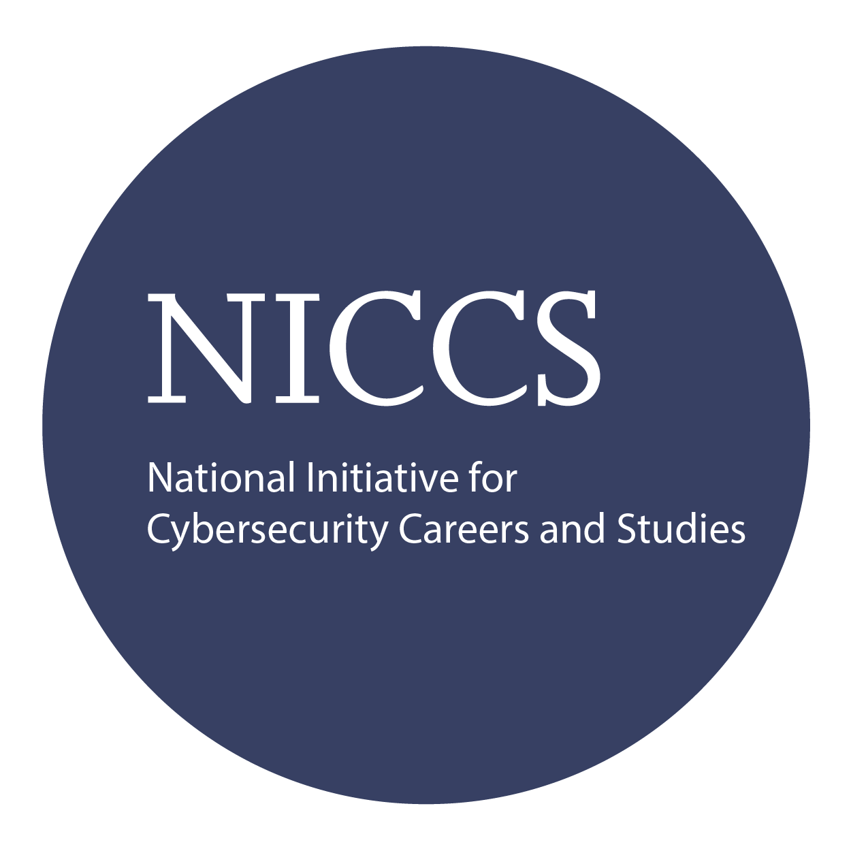



Exam Information

Upon Completion

The Certified Information Security Management Systems – Lead Auditor exam is taken online through Mile2’s Learning Management System and is accessible on you Mile2.com account. The exam will take approximately 2 hours and consist of 100 multiple choice questions.

A minimum grade of 70% is required for certification.

All Mile2 certifications will be awarded a 3-year expiration date.

There are two requirements to maintain Mile2 certification:

1. Pass the most current version of the exam for your respective existing certification
2. Earn and submit 20 CEUs per year in your Mile2 account.

Upon completion, the Certified Information Security Management Systems - Lead Auditor candidate will be able to competently take the C)ISMS-LA exam and acquire the necessary knowledge to manage an ISMS audit

**Question:** Do I have to purchase a course to buy a certification exam?

Answer: No

**Question:** Do all Mile2 courses map to a role-based career path?

Answer: Yes. You can find the career path and other courses associated with it at [www.mile2.com](http://www.mile2.com).

**Question:** Are all courses available as self-study courses?

Answer: Yes. There is however 1 exception. The Red Team vs Blue Team course is only available as a live class.

**Question:** Are Mile2 courses transferable/shareable?

Answer: No. The course materials, videos, and exams are not meant to be shared or transferred.

Course FAQ’s

Re-Certification Requirements

Course and Certification Learning Options

