Description:

,663,6629
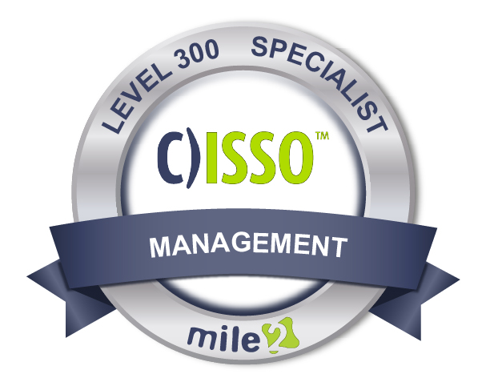

If you are look for the "gotta have it" cybersecurity course, then the Certified Information Systems Security Officer is for you. The C)ISSO will prepare you with a broad range of knowledge and skills required of a security officer. However, these skills can be applied across a broad range of role-based careers.

A C)ISSO is able to implement and maintain cost-effective security controls that are closely aligned with business and industry standards. The C)ISSO certification course is an ideal way to increase knowledge, expertise, and skill for managers, auditors, and INFOSEC professionals.
At Mile2 we consider the C)ISSO to be one of our flagship courses. The things you learn in this course can be applied to management, prevention teams, and recovery professionals.

Annual Salary Potential $92,662 AVG/year

Key Course Information

Live Class Duration: 5 Days
CEUs: 40
Language: English
Class Formats Available:
Instructor Led
Self-Study
Live Virtual Training
Suggested Prerequisites:

- Mile2’s C)SP
- Mile2’s C)ISSM
- 12 months of Information Systems Management Experience

Module 1 -Risk Management
Module 2 -Security Management
Module 3 -Identification and Authentication
Module 4 -Access Control
Module 5 -Security Models and Evaluation Criteria
Module 6 -Operations Security
Module 7 -Vulnerability Assessments
Module 8 -Symmetric Cryptography and Hashing Module 9 -Network Connections
Module 10 -Network Protocols and Devices
Module 11 -Telephony, VPNs, and Wireless
Module 12 through 19 – See Detailed Outline Below
Who Should Attend
Key Course Information
Modules/Lessons

- IS Security Officers
- IS Managers
- Risk Managers
- Auditors
- Info Systems Owners
- IS Control Assessors
- System Managers
- Government Employees

Accreditations
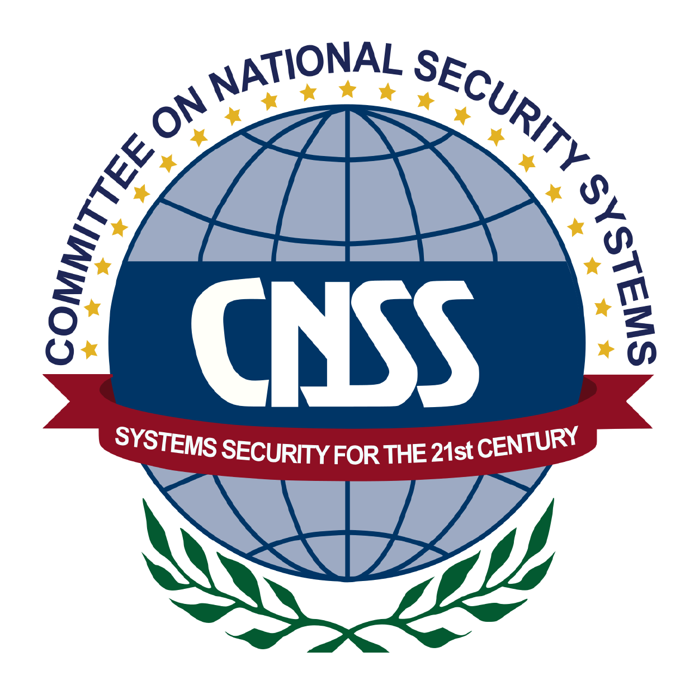

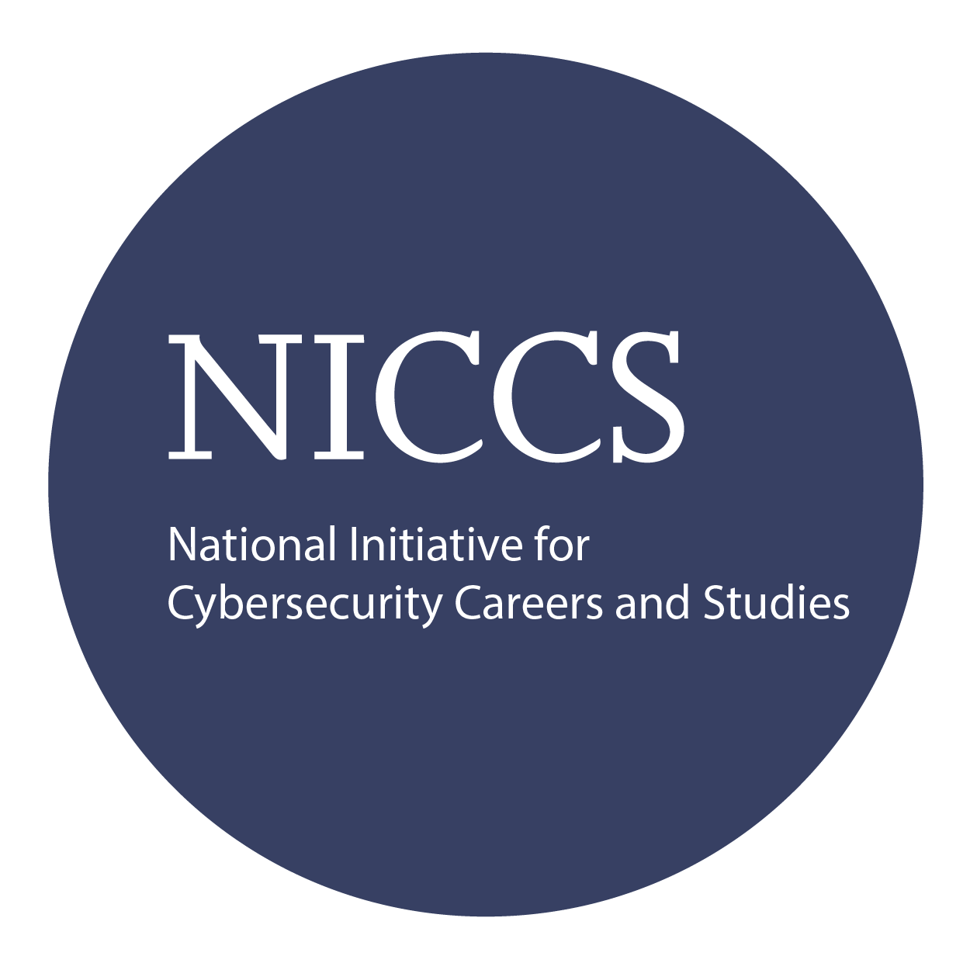

Exam Information
Upon Completion

The Certified Information Systems Security Officer exam is taken online through Mile2’s Learning Management System and is accessible on you Mile2.com account. The exam will take approximately 2 hours and consist of 100 multiple choice questions.
A minimum grade of 70% is required for certification.

All Mile2 certifications will be awarded a 3-year expiration date.

There are two requirements to maintain Mile2 certification:

- Pass the most current version of the exam for your respective existing certification
- Earn and submit 20 CEUs per year in your Mile2 account.

Upon completion, Certified Information Systems Security Officer students be able to establish industry acceptable Cyber Security and Information Systems management standards with current best practices.

Question: Do I have to purchase a course to buy a certification exam?
Answer: No
Question: Do all Mile2 courses map to a role-based career path?
Answer: Yes. You can find the career path and other courses associated with it at www.mile2.com.
Question: Are all courses available as self-study courses?
Answer: Yes. There is however 1 exception. The Red Team vs Blue Team course is only available as a live class.
Question: Are Mile2 courses transferable/shareable?
Answer: No. The course materials, videos, and exams are not meant to be shared or transferred.
Course FAQ’s

Re-Certification Requirements

Course and Certification Learning Options
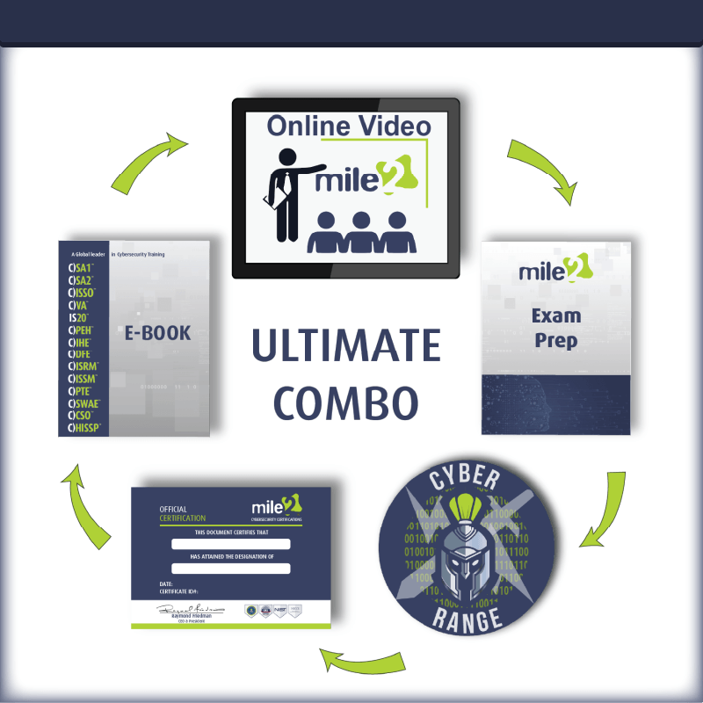
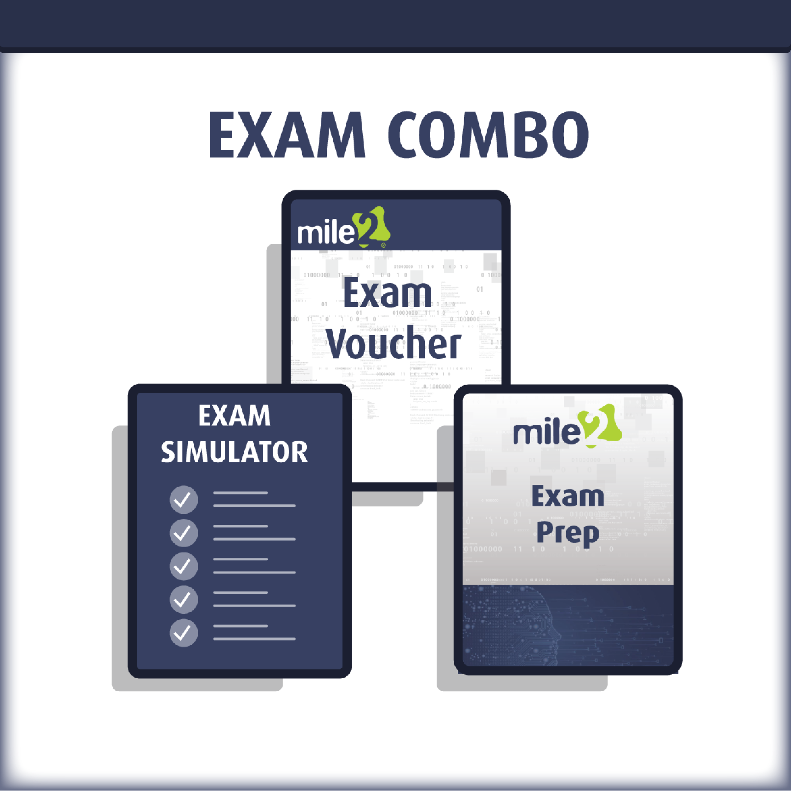

Detailed Outline:
Course Introduction

- Module 1 – Risk Management
  - Risk Definitions
  - Risk Management
  - Risk Assessment
  - Responding to Risk
- Module 2 – Security Management
  - Understanding Security
  - Information Security Management System
  - Roles and Responsibility
  - Security Frameworks
  - Human Resources
- Module 3 – Identification and Authentication
  - Identity Management
  - Authentication Techniques
  - Single Sign-on
  - Access Control Monitoring
- Module 4 – Access Control
  - Access Control Types and Characteristics
  - Information Classification
  - Access Control Models and Techniques
  - Access Control Methods
- Module 5 – security Models and Evaluation Criteria
  - Trusted Computing Base
  - Protection Mechanisms
  - Security Models
  - Evaluation Criteria
- Module 6 – Operations Security
  - Administrative Management Responsibilities
  - Product Implementation Management
  - Redundancy and Fault Tolerance
  - Operational Issues and Responses
  - Threats to Operations
- Module 7 – Symmetric Cryptography and Hashing
  - Cryptography Terms
  - Historical Uses of Cryptography
  - Cryptography Foundations
  - Modern Cryptography
  - Hashing

- Module 8 – Asymmetric Cryptography and PKI
  - Asymmetric Cryptography
  - Hybrid Crypto and Digital Signatures
  - Public Key Infrastructure
  - Cryptography in Use
  - Attacks on Cryptography
- Module 9 – Network Connections
  - Network and Communications Security
  - Topologies
  - Cabling
  - LAN and WAN
- Module 10 – Network Protocols and Devices
  - OSI Model
  - Network Devices
  - Network Security Sentries
  - Ports, Protocols and Services
- Module 11 – Telephony, VPNs and Wireless
  - Telephony
  - VPNs
  - Wireless
  - Network Based Attacks
- Module 12 – Security Architecture and Attacks
  - Security Architecture
  - Architectural Models
  - System Threats
- Module 13 – Software Development Security
  - Software Security Concerns
  - Software Lifecycle Development Processes
  - Web Application Security
  - PCI-DSS Compliance
- Module 14 – Database Security
  - Database Models &Terminology
  - Database Security Issues
  - Artificial Intelligence
- Module 15 – Malware and Attacks
- Module 16 – Business Continuity
  - Project Initiation
  - Business Impact Analysis
  - Determining Recovery Strategies
  - Writing the Plan
  - Preparing for a Disaster
  - Introduction to Business Continuity Management
- Module 17 – Incident Management, Law and Ethics
  - Incident Management
  - Law
  - Computer Crime

  - Evidence Handling
  - Privacy Legislations
  - Ethics
- Module 18 – Physical Security
  - Facility Location and Construction
  - Risks, Threats and Countermeasures
  - Perimeter Protection
  - Electrical Power Issues
  - Fire Prevention, Detection and Suppression.

