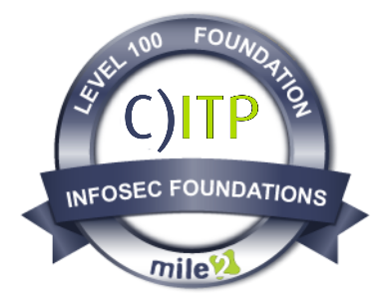
Description:

The Mile2® Certified Information Technology Principles - C)ITP certification course, is intended for anyone interested in learning computer fundamentals and IT Security. The C)ITP provides essential technology competencies and enhances foundational IT skills to improve students' job performance. Students will learn competencies such as how to Utilize a computer, its hardware, database, and network. In addition, introductory computer security concepts are taught, such as access controls and best practices.
The C)ITP certification course is excellent for secondary or post-secondary students wanting to have a career in IT or professionals considering a career change or simply looking for a broader understanding of IT. The C)ITP curriculum is an excellent foundational program that can be included in academic two-year/four-year degree programs.
Statistics: The IT job space is predicted to double its demand in the next ten years. In fact, according to the U.S. Bureau of Labor Statistics, IT jobs are expected to outpace available IT engineers and are considered the fastest-growing field in engineering. There is no better time than now to get certified with Mile2!
Security Awareness | IT  Principles | Hardware Technician | Operating  Systems | Network Principles | Security Principles

Live Class Duration: 40 Hours

CEUs: 40

Language: English

Class Formats Available:
- Instructor Led
- Self-Study
- Live Virtual Training

Suggested Prerequisites: None

Key Course Information

Module 1 - Utilizing Computers

Module 2 - Utilizing Databases and Applications

Module 3 - Utilizing Computer Hardware

Module 4 - Utilizing Networks

Module 5 - Introduction to Security Concepts

- Everyone
- Employees
- IT Starters
- Career Changers
- Secondary Students
- Post-secondary Students

Who Should Attend
Modules/Lessons

Accreditations
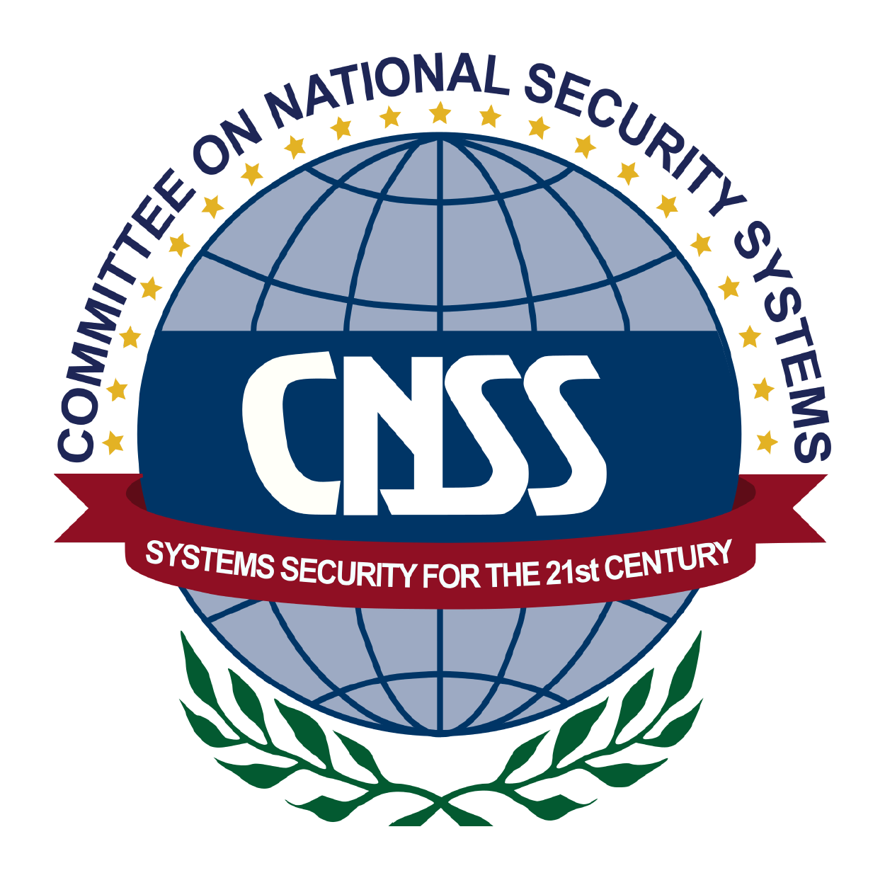

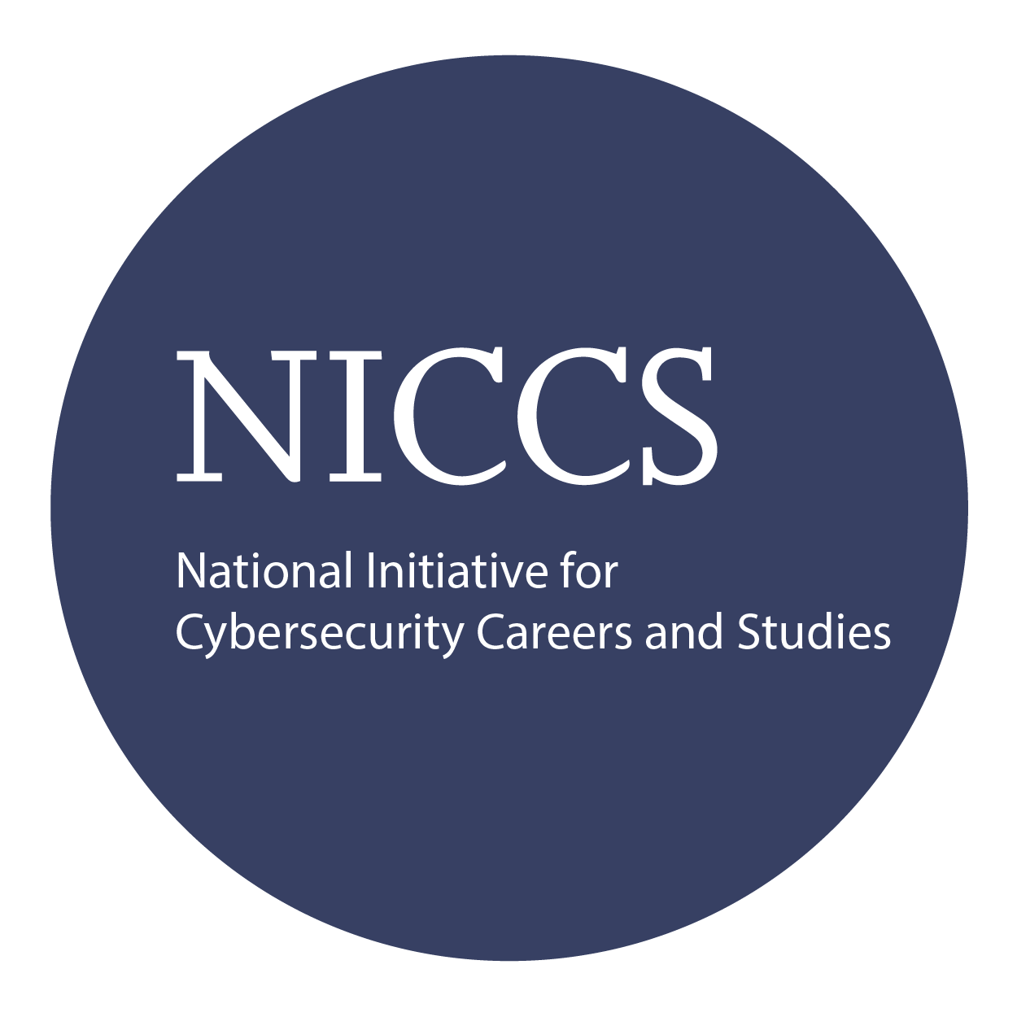

Upon completion, the Certified Internet Technology Principles (CITP) candidate will be able to competently take the C)ITP exams as well as be able to understand basic IT principles to provide individuals with the fundamentals of computer and network security concepts.

Upon Completion

Question: Do I have to purchase a course to buy a certification exam?
Answer: No

Question: Do all Mile2 courses map to a role-based career path?
Answer: Yes. You can find the career path and other courses associated with it at www.mile2.com.
Question: Are all courses available as self-study courses?
Answer: Yes. There is however 1 exception. The Red Team vs Blue Team course is only available as a live class.
Question: Are Mile2 courses transferable/shareable?
Answer: No. The course materials, videos, and exams are not meant to be shared or transferred.

The Certified IT Principles exam is taken online through Mile2’s Learning Management System and is accessible on you mile2.com account.

A minimum grade of 70% is required for certification.

All Mile2 certifications will be awarded a 3-year expiration date.

There are two requirements to maintain Mile2 certification:

- Pass the most current version of the exam for your respective existing certification.

- Earn and submit 20 CEUs per year in your Mile2 account.

Course FAQ’s
Exam Information

Course and Certification Learning Options
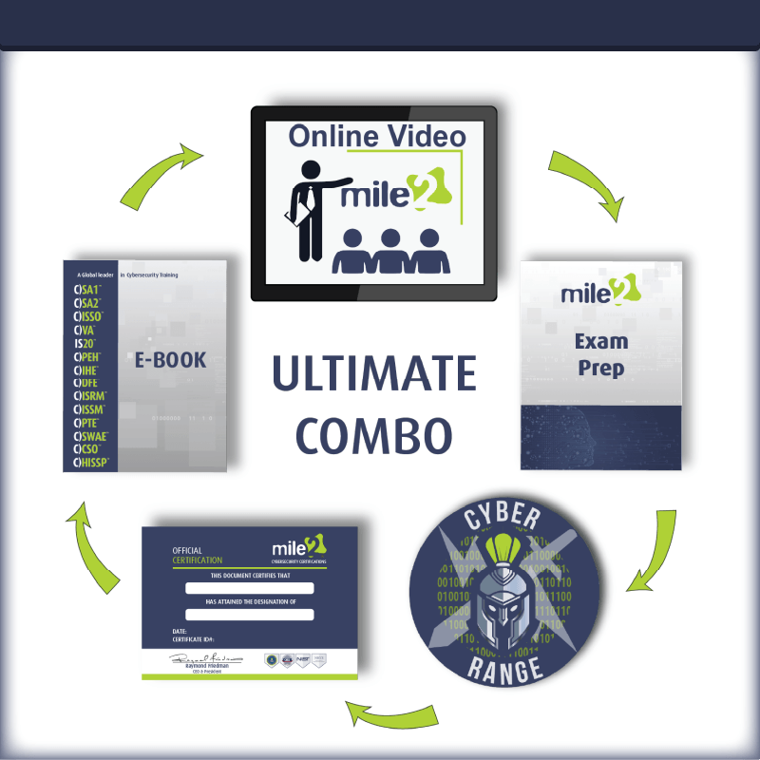
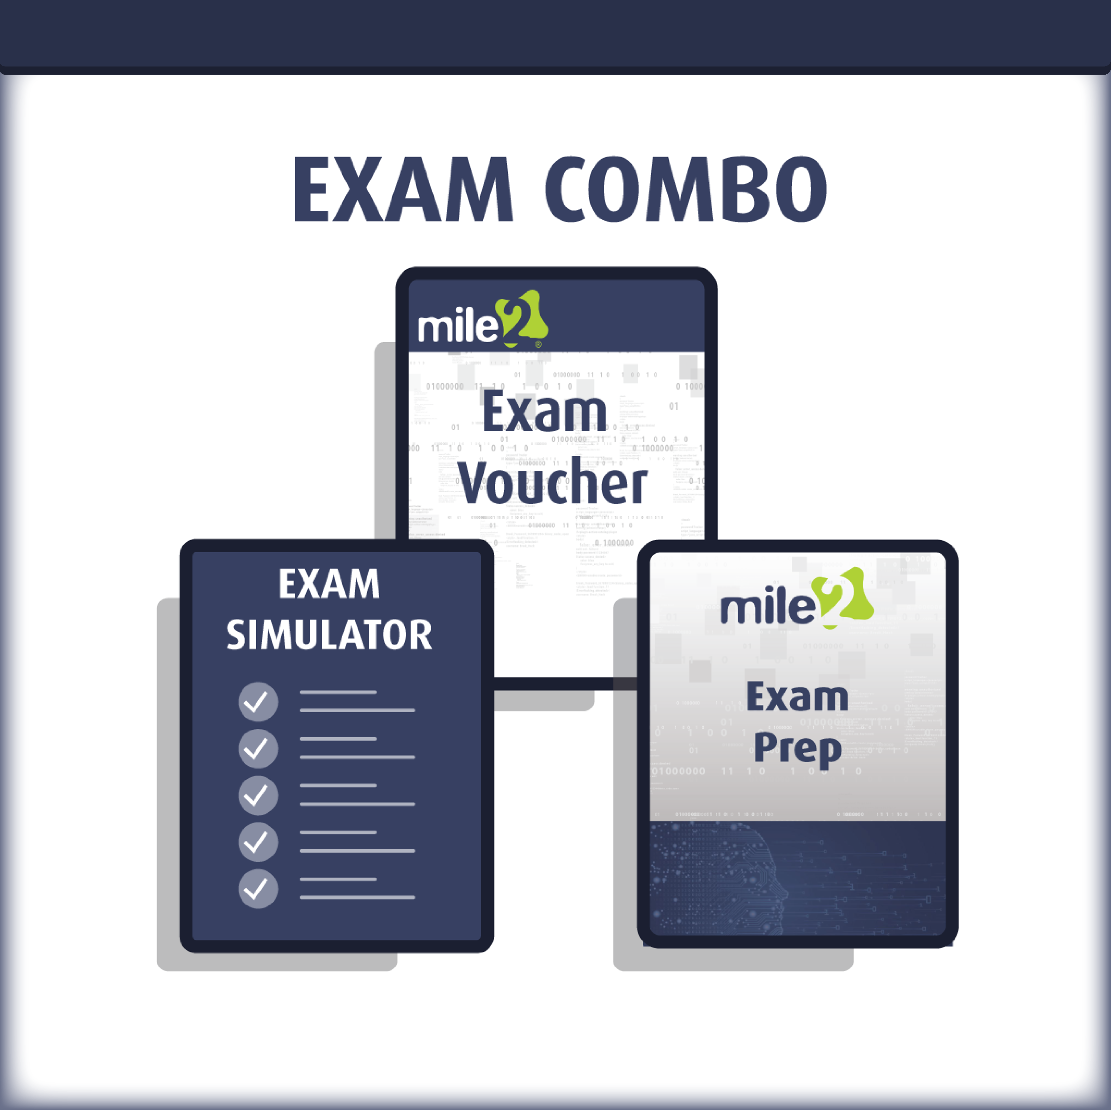
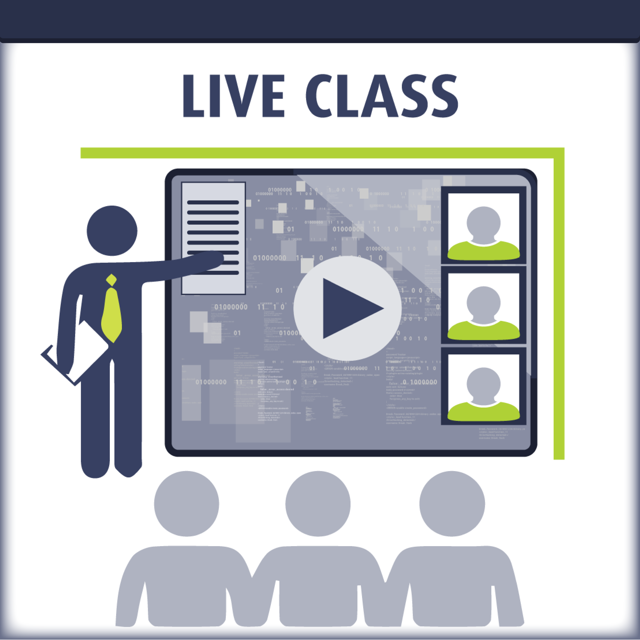

Re-Certification Requirements

Detailed Outline:

Module 1 - Utilizing Computers
- Widely used computing devices
- Utilizing a workstation
- Utilizing an operating system (OS)
- Operating system administration
- Troubleshooting and supporting

Module 2 - Utilizing Databases and Applications
- Utilizing applications
- Utilizing databases
- Utilizing data types and units
- Application development and programming
- Utilizing databases and applications

Module 3 - Utilizing Computer Hardware
- Components of the system
- Utilizing device interfaces
- Utilizing peripheral devices
- Utilizing storage devices
- Utilizing file systems
- Utilizing computer hardware

Module 4 - Utilizing Networks
- Concepts of the network
- Connecting to a network
- Utilizing mobile devices
- Utilizing shared storage
- Secure web browsing
- Utilizing networks

Module 5 - Introduction to Security Concepts
- Concerns about security
- Behavioral security concepts
- Managing access controls
- Security best practices
- Managing security

