Description:
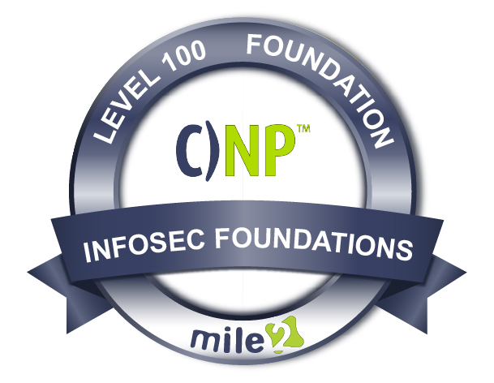

Live Class Duration: 5 Days
CEUs: 40
Language: English
Class Formats Available:
Instructor Led
Self-Study
Live Virtual Training
Suggested Prerequisites:
(Any of the following Mile2 Courses)
- C)HT/C)OST or equivalent knowledge

Modules/Lessons
Key Course Information

- Everyone
- End Users
- Employees
- Managers

Module 1 - Intro to Network Fundamentals
Module 2 -The Physical Networking Fundamentals
Module 3 - TCP/IP Primer
Module 4 - Connecting Networks with Switches and Routers
Module 5 - Wireless Networking
Module 6 - Security Principles
Module 7 - Defending the Network
Module 8 - Network Technology Boom
Module 9 - Day to Day Networking
Module 10 - Network Planning
What is a network? You hear the word all of the time, and you may have a vague idea about what it means. However, in today's computing space, networks are EVERYTHING and a vague understand is just not enough.

In this fun and fast paced course you will learn concepts and skills needed to plan, install, maintain, and troubleshoot today's networks including wireless and server-based networks!
Want to learn about new technologies like virtual networks and SD Networks found in many cloud architectures? We've got you covered, and then we move to physical components, TCP/IP Stack, OSI Model, switches, routers, wireless, and Bluetooth.
Lastly, we finish up the C)NP with the knowledge you need to perform the day to day operations of an organization, so you will be able to secure and maintain an entire network!

Who Should Attend

Accreditations
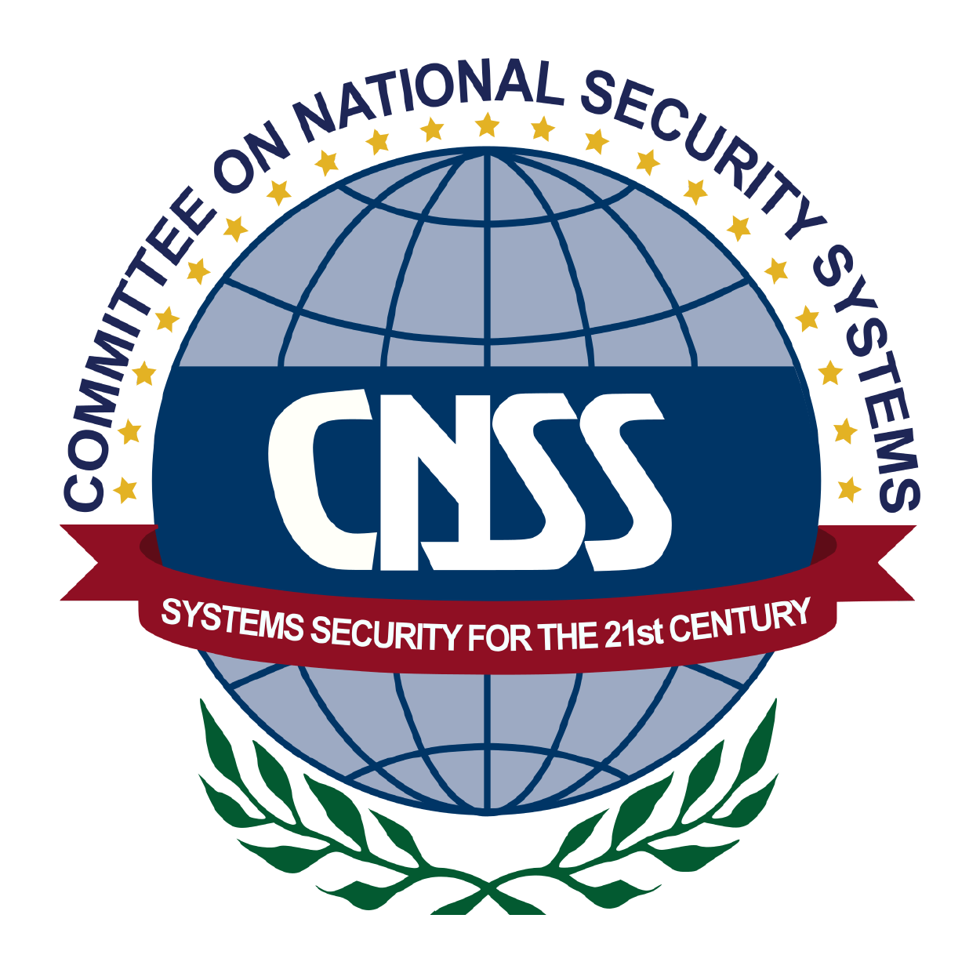

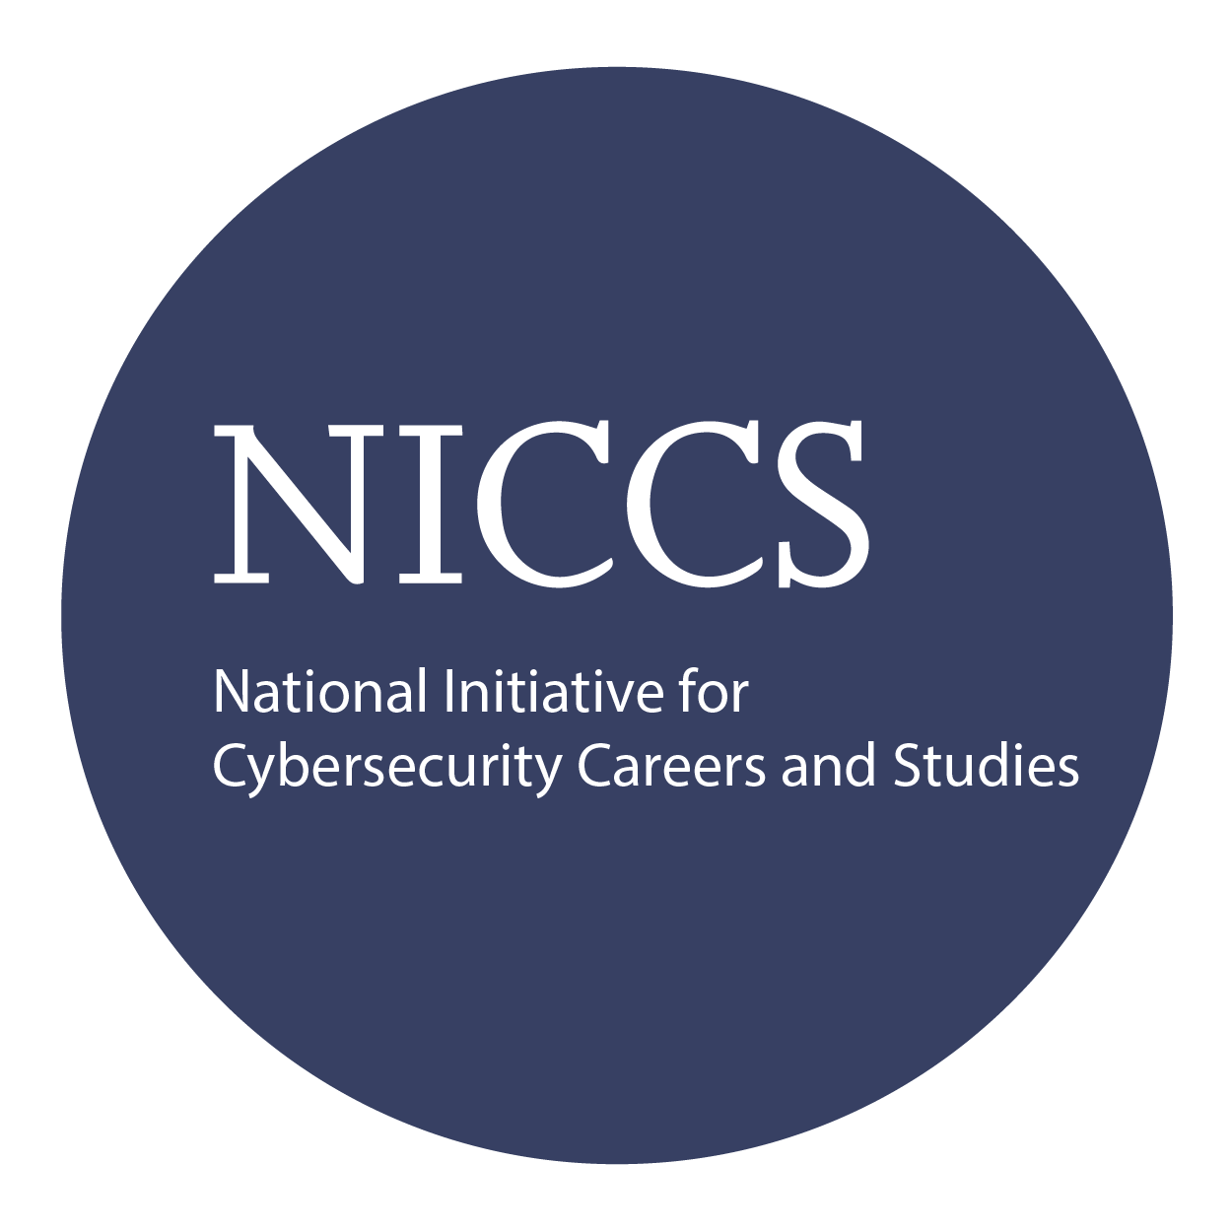

Upon Completion

Question: Do I have to purchase a course to buy a certification exam?
Answer: No
Question: Do all Mile2 courses map to a role-based career path?
Answer: Yes. You can find the career path and other courses associated with it at www.mile2.com.
Question: Are all courses available as self-study courses?
Answer: Yes. There is however 1 exception. The Red Team vs Blue Team course is only available as a live class.
Question: Are Mile2 courses transferable/shareable?
Answer: No. The course materials, videos, and exams are not meant to be shared or transferred.

The Certified Network Principles exam is taken online through Mile2’s Learning Management System and is accessible on you Mile2.com account. The exam will take approximately 2 hours and consist of 100 multiple choice questions.
A minimum grade of 70% is required for certification.

All Mile2 certifications will be awarded a 3-year expiration date.

There are two requirements to maintain Mile2 certification:

- Pass the most current version of the exam for your respective existing certification
- Earn and submit 20 CEUs per year in your Mile2 account.

Upon completion, the Certified Network Principles candidate will be able to competently take the C)NP exams well as the Comp TIA Network+ exam. You will have the knowledge to keep a companies' IP network infrastructure secure.

Course FAQ’s
Exam Information

Course and Certification Learning Options
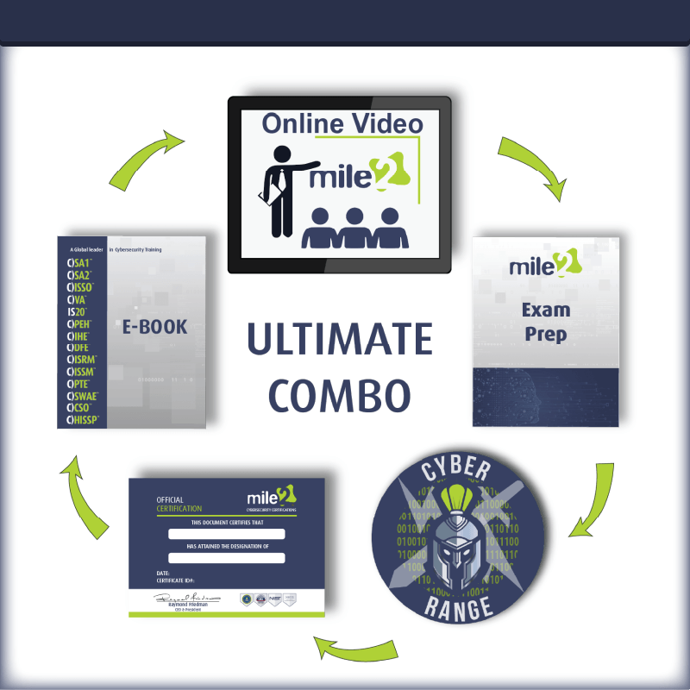
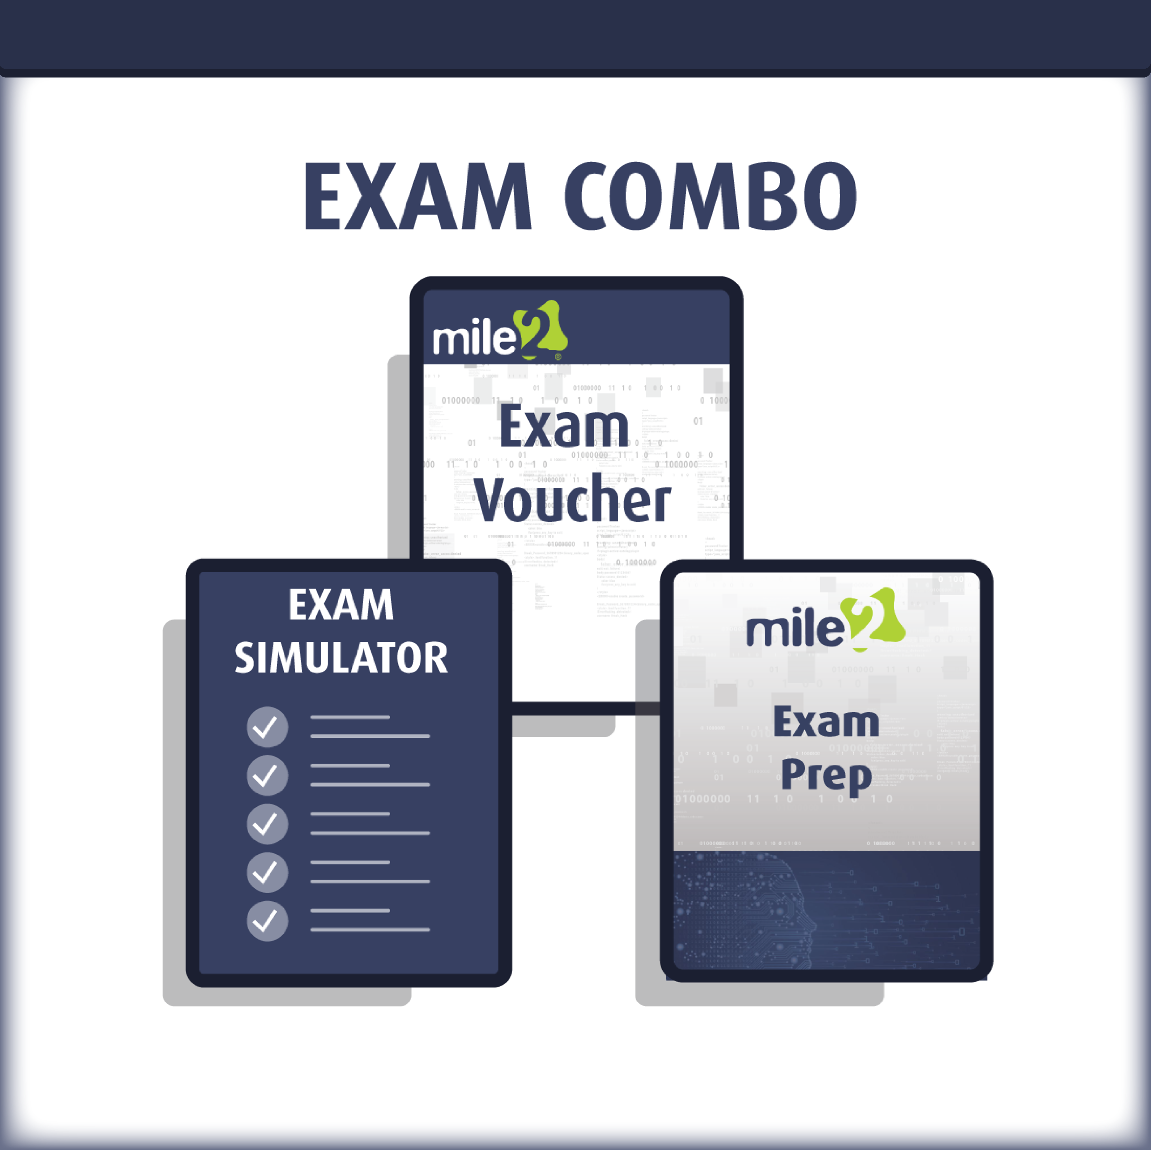
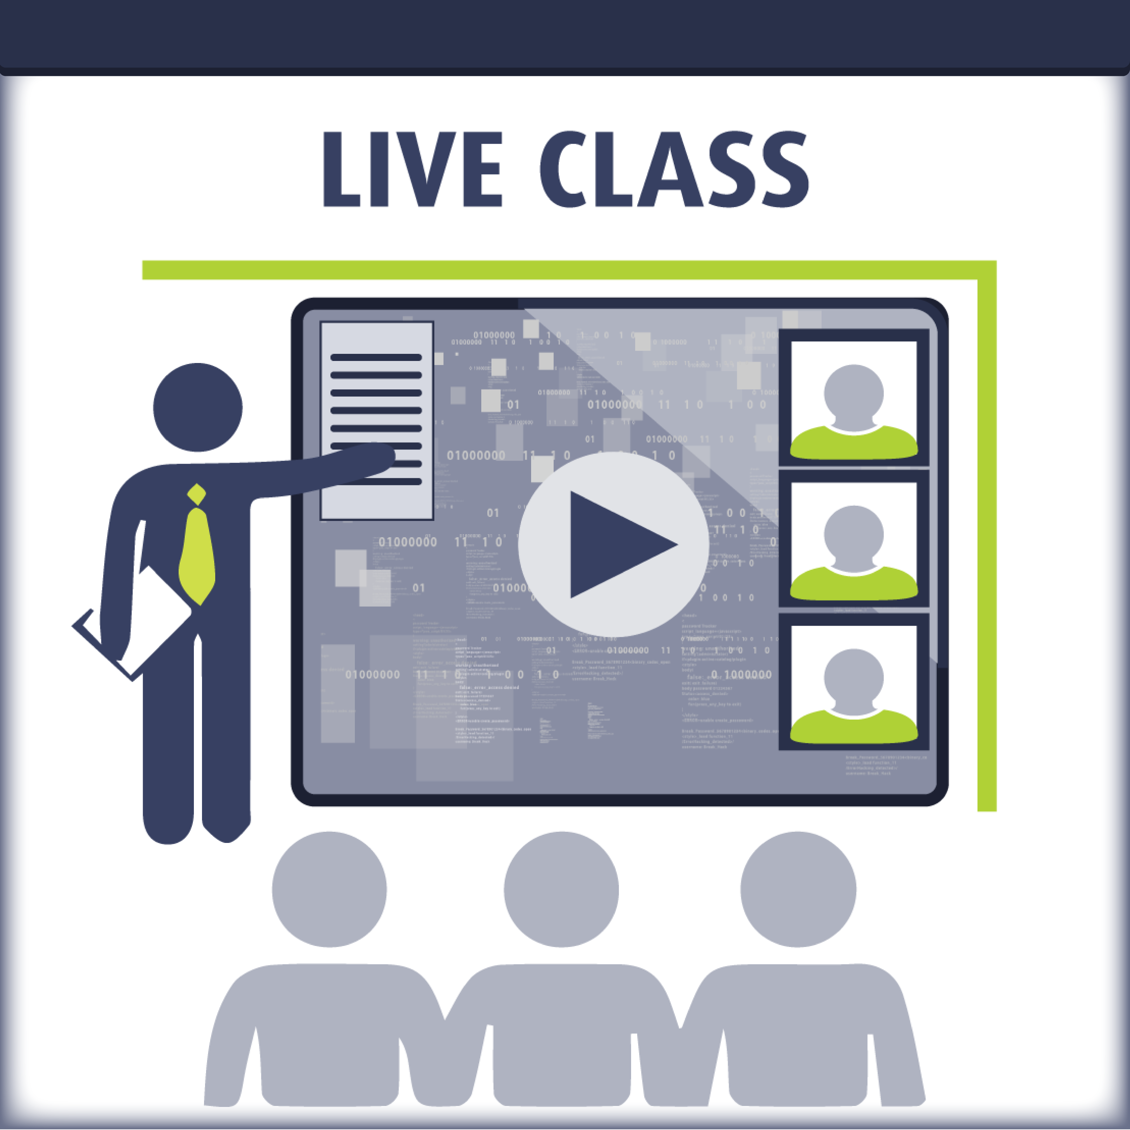

Re-Certification Requirements

Detailed Outline:
Course Introduction

Module 1 – Introduction to Network Fundamentals
Section 1: Networking concepts
Section 2: Classifying networks
Section 3: Network models
Section 4: The troubleshooting process

Module 2 – The Physical Networking Fundamentals
Section 1: Connection technologies
Section 2: Network devices
Section 3: Copper media
Section 4: Optical media
Section 5: Ethernet standards

Module 3 – TCP/IP Primer
Section 1: IP addressing
Section 2: Core protocols
Section 3: Network ports and applications

Module 4 – Connecting Networks with Switches and Routers
Section 1: Switching
Section 2: Routing

Module 5 – Wireless Networking
Section 1: Wireless networks
Section 2: Wireless LAN standards
Section 3: Internet connections
Section 4: WAN infrastructure

Module 6 – Security Principles
Section 1: Goals and threats
Section 2: Digital security
Section 3: Transport encryption

Module 7 – Defending the Network
Section 1: Network security components
Section 2: Network authentication systems
Section 3: Hardening networks

Module 8 – Network Technology Boom
Section 1: Network convergence
Section 2: Virtual and cloud systems

Module 9 – Day to Day Networking
Section 1: Network convergence
Section 2: Virtual and cloud systems

Module 10 – Network Planning
Section 1: Network policy design
Section 2: Network installation
Section 3: Maintenance and upgrades

