Description:

This course enhances leadership skills and organizational acumen. Targeted at mid-to-senior level managers and executives, this course empowers participants with advanced strategies in leadership, change management, and effective communication.

Starting Annual Salary Potential $75,000 AVG/year

This course explores core aspects of organizational behavior, leadership ethics, and strategic decision-making. It is facilitated through a blend of online modules, interactive workshops, and real-world case studies.

Participants will learn to master critical thinking, improve team dynamics, and drive innovation within their organizations. The course also includes a unique mentoring component, pairing learners with seasoned leaders to foster practical insights and personalized growth. Upon completion, graduates receive the Mile2 Certified Organizational Leader designation, recognizing their enhanced capabilities and readiness to tackle complex challenges in today’s dynamic business environment.

**Module 1**: Visionary Leadership: From Crafting Visions to Influence Impact and Navigating Challenges

**Module 2**: Building Resilient Leadership: Trust Empowerment and Adaptability for Change and Innovation

**Module 3**: Mastering Leadership Excellence: Communication, Ethics, Reflection, and Legacy Building

**Module 4**: Strategic Leadership Mastery: Vision, Resilience, and Long-Term Thinking for Transformational Impact

**Live Class Duration:** 2 Days

**CEUs:** 16

**Language:** English

**Class Formats Available:**

Instructor Led

Self-Study

Live Virtual Training

**Suggested Prerequisites:**

No prerequisites

Labs

(No Labs At this time)

Modules/Lessons

Key Course Information

The Certified Cybersecurity Framework Officer exam is taken online through Mile2’s Learning Management System and is accessible on you Mile2.com account. The exam will take approximately 2 hours and consist of 50 multiple choice questions.

A minimum grade of 70% is required for certification.

All Mile2 certifications will be awarded a 3-year expiration date.

There are two requirements to maintain Mile2 certification:

1. Pass the most current version of the exam for your respective existing certification
2. Earn and submit 20 CEUs per year in your Mile2 account.

Anyone who leads a team, wanting gain leadership confidence, influencers, speakers, teachers.

Graduates receive the Mile2 Certified Organizational Leader designation, recognizing their enhanced capabilities and readiness to tackle complex challenges in today’s dynamic business environment.

Who Should Attend

**Question:** Do I have to purchase a course to buy a certification exam?

**Answer**: No

**Question:** Do all Mile2 courses map to a role-based career path?

**Answer**: Yes. You can find the career path and other courses associated with it at [www.mile2.com](http://www.mile2.com).

**Question:** Are all courses available as self-study courses?

**Answer**: Yes. There is however 1 exception. The Red Team vs Blue Team course is only available as a live class.

**Question:** Are Mile2 courses transferable/shareable?

**Answer**: No. The course materials, videos, and exams are not meant to be shared or transferred.

Course FAQ’s

Exam Information

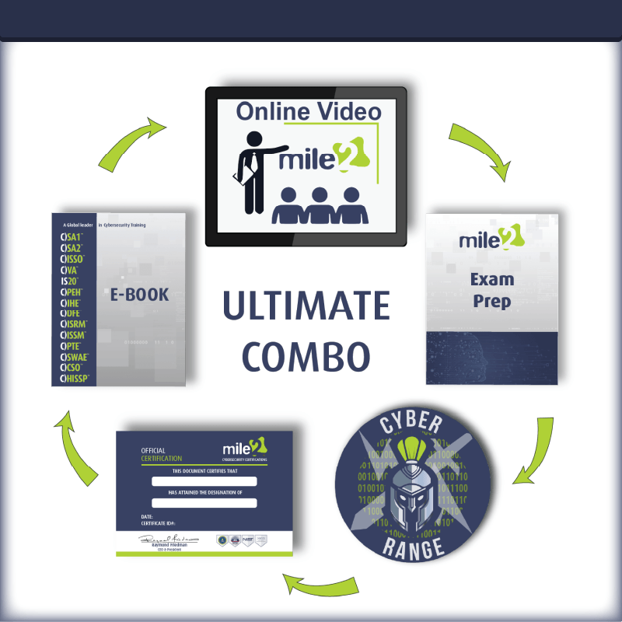

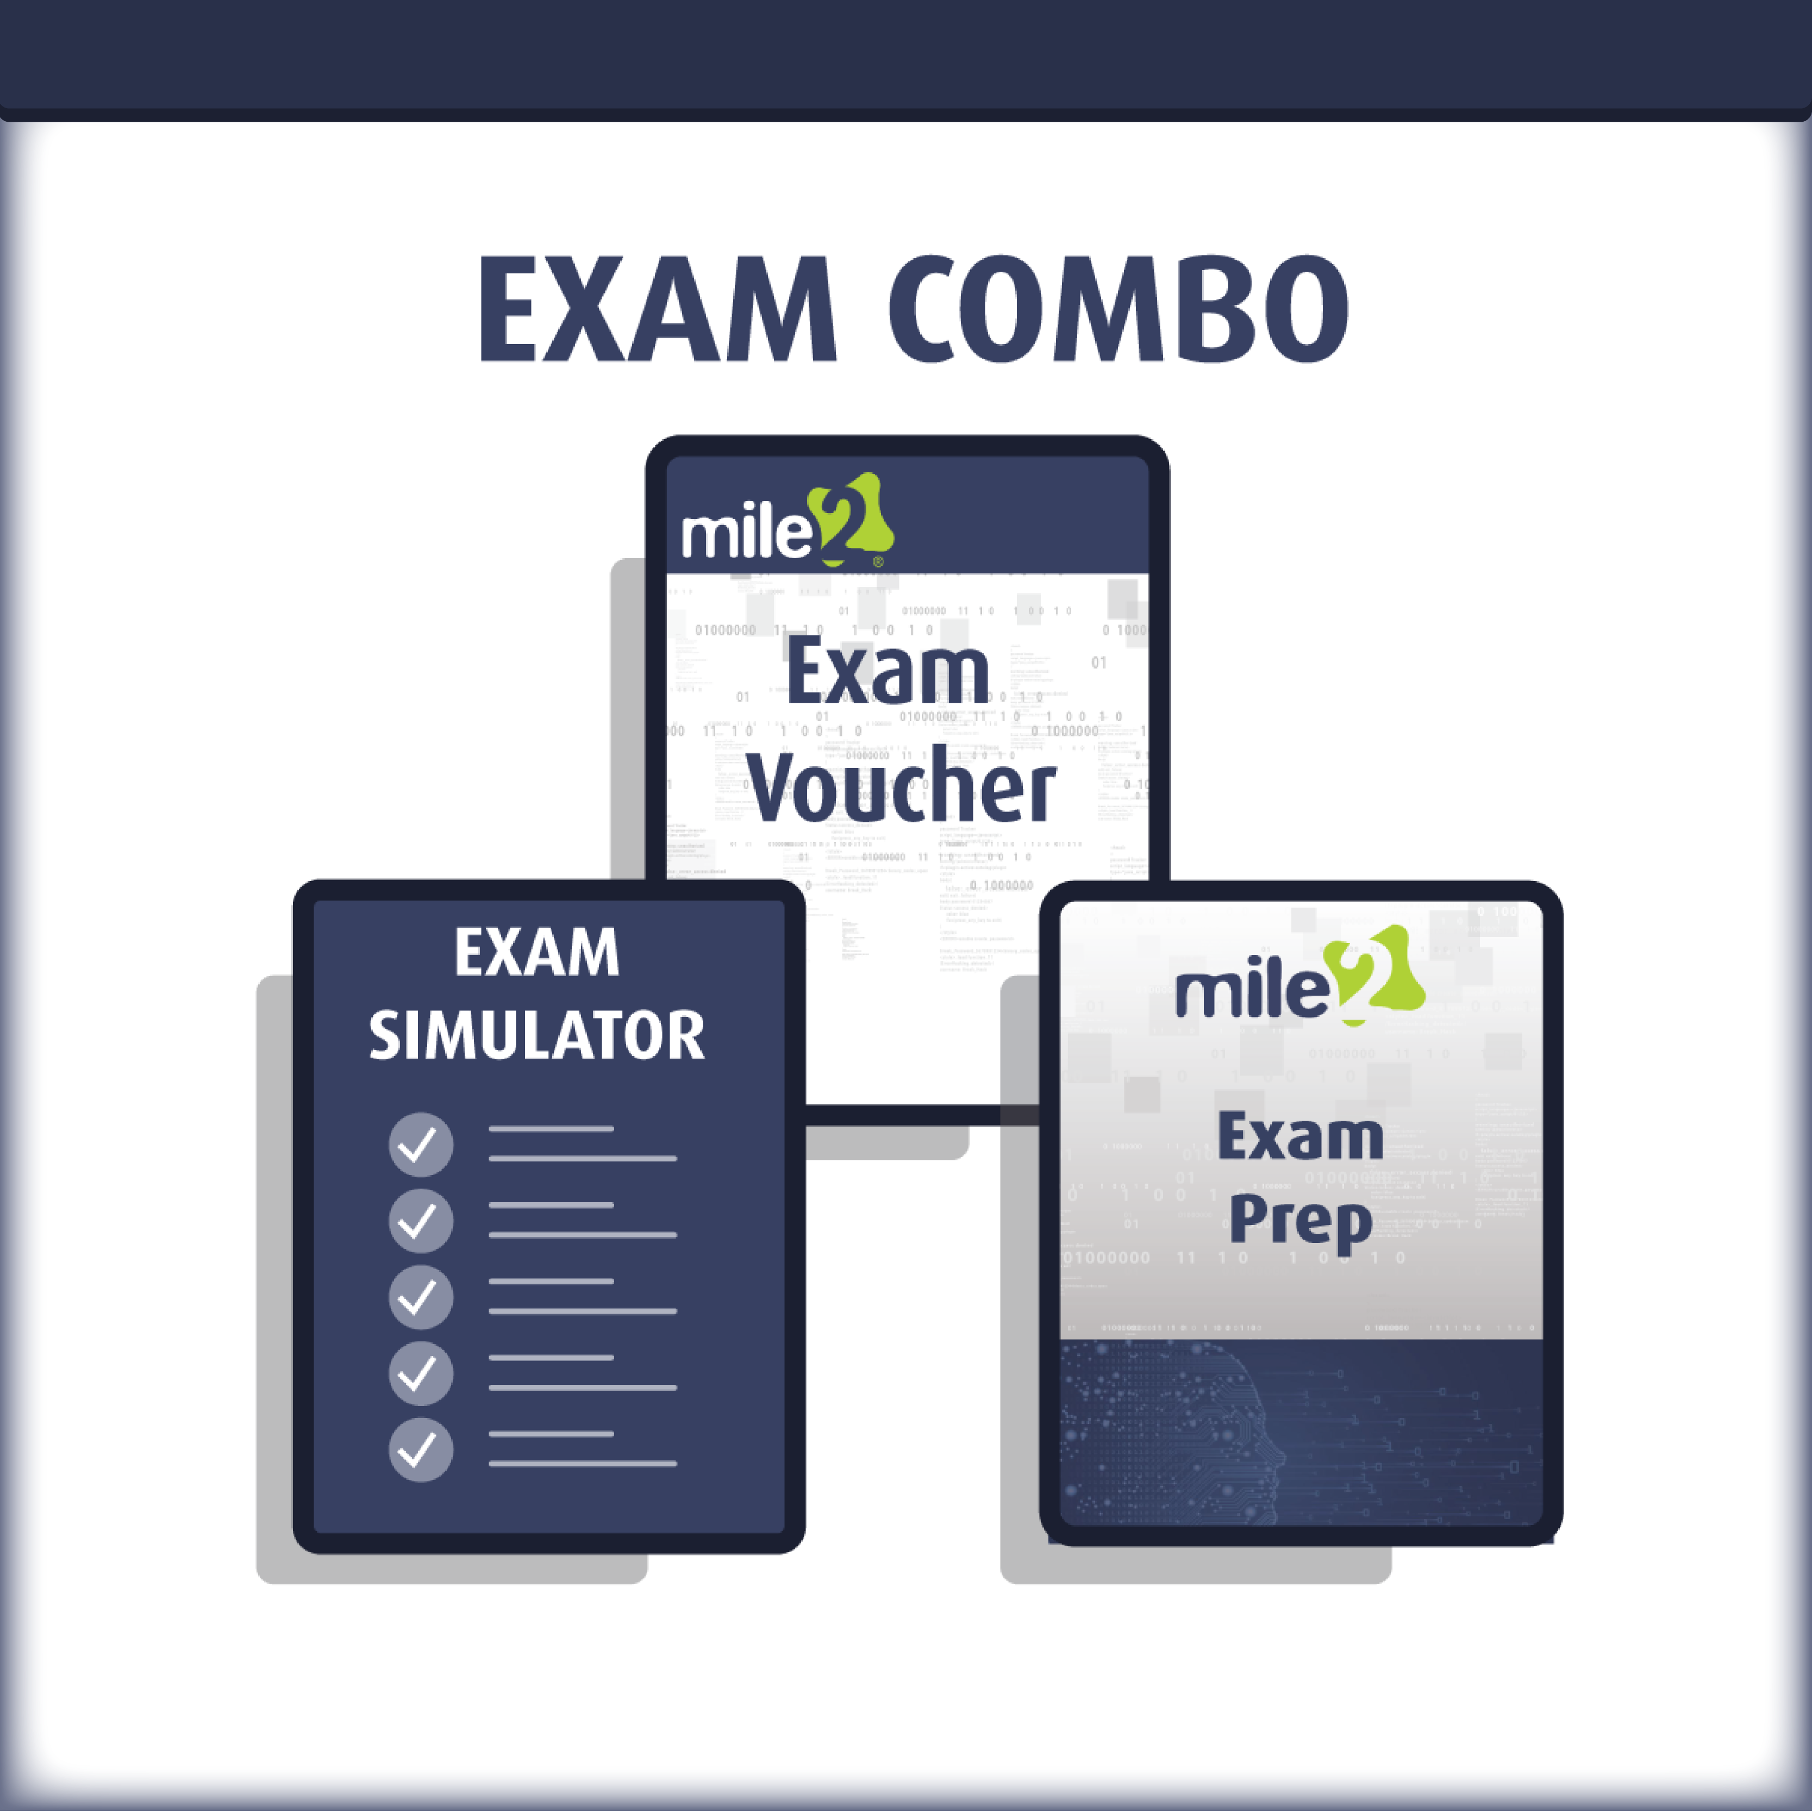

Upon Completion

Re-Certification Requirements

Accreditations



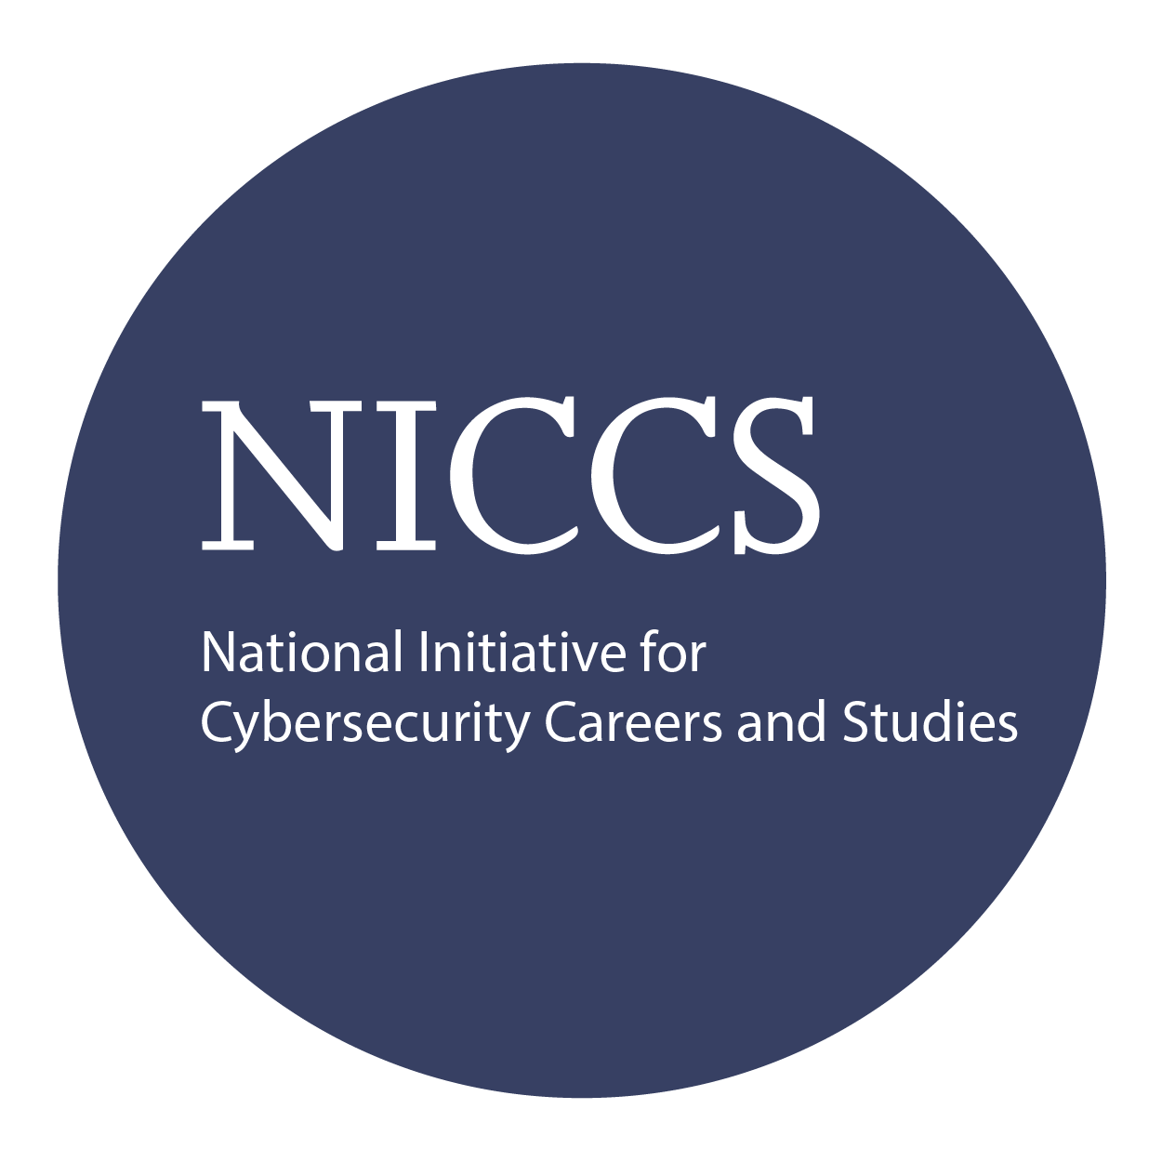

Course and Certification Learning Options