Description:

,663,6629
Mile2’s Risk Management Framework Analyst training quantifies the process of certifying, reviewing, and accrediting an information system by IT professionals.
This course was created as a standard to measure the set of skills that specific members of an organization are required to have for the practice of certifying, reviewing, and accrediting the security of information systems. Specifically, this training was designed for the individuals who are responsible for creating and implementing the processes used to evaluate risk and institute security baselines and requirements. These critical decisions will be essential in making sure that the security of the information systems outweighs the potential risks to an organization from any internal or external threats.

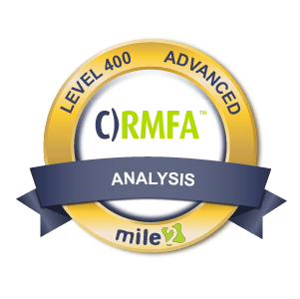

Annual Salary Potential $120,077 AVG/year

Key Course Information

Live Class Duration: 3 Days
CEUs: 40
Language: English
Class Formats Available:
Instructor Led
Self-Study
Live Virtual Training
Suggested Prerequisites:
(any one of the following)
This is an advanced look into how the RMF applies to government systems. 4-5 years of information systems security management is suggested (or equivalent education).
Case Study Labs

Introduction
Module 1 -Intro to the RMF
Module 2 -The RMF Integration into the Software Development Life Cycle
Module 3 – The Prepare Stage of the RMF Model
Module 4 – Categorize the System
Module 5 – Select Security Controls
Module 6 – Implement Security Controls
Module 7 – Assess Security Controls
Module 8 – Authorize Information System
Module 9 – Monitor Security Controls
Module 10 -RMF Process Deployment Considerations

Key Course Information
Modules/Lessons

Introduction
Lab 1 – RMF Structure
Lab2 – RMF Integration into the SDLC
Lab 3 – RMF Implementation: Prepare
Lab 4 – RMF Implementation: Categorize
Lab 5 – RMF Implementation: Select
Lab 6 – RMF Implementation: Implement
Lab 7 – RMF Implementation: Assess
Lab 8 – RMF Implementation: Authorize
Lab 9 – RMF Implementation: Monitor

Course FAQ’s
Exam Information

The exam is taken online through Mile2’s Learning Management System and is accessible on you Mile2.com account. The exam will take approximately 2 hours and consist of 100 multiple choice questions.
A minimum grade of 70% is required for certification.

All Mile2 certifications will be awarded a 3-year expiration date.

There are two requirements to maintain Mile2 certification:

- Pass the most current version of the exam for your respective existing certification
- Earn and submit 20 CEUs per year in your Mile2 account.

Question: Do I have to purchase a course to buy a certification exam?
Answer: No
Question: Do all Mile2 courses map to a role-based career path?
Answer: Yes. You can find the career path and other courses associated with it at www.mile2.com.
Question: Are all courses available as self-study courses?
Answer: Yes. There is however 1 exception. The Red Team vs Blue Team course is only available as a live class.
Question: Are Mile2 courses transferable/shareable?
Answer: No. The course materials, videos, and exams are not meant to be shared or transferred.
Upon Completion

Upon completion, the Certified Professional Ethical Hacker candidate will be able to competently take the exam.

• IS Security Owners
• Security Officers
• Ethical Hackers
• Information Owners
• Penetration Testers
• System Owners and
Managers
• Cyber Security Engineers

Who Should Attend

Re-Certification Requirements

Accreditations

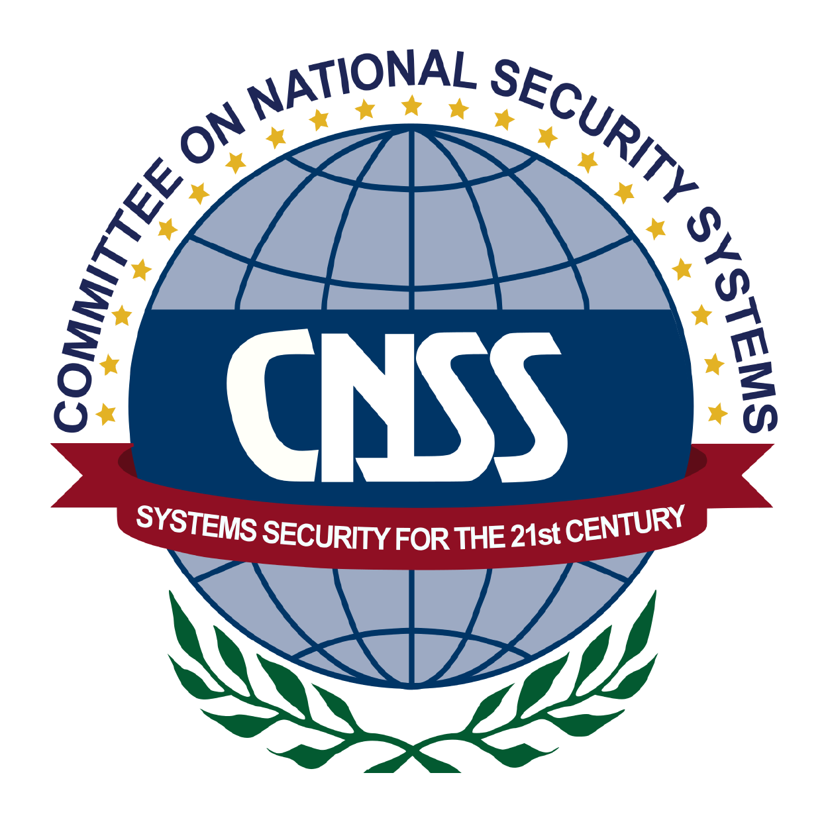

Course and Certification Learning Options
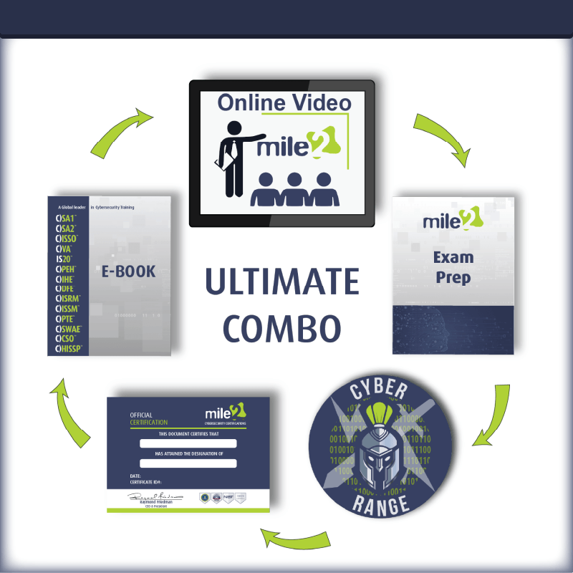
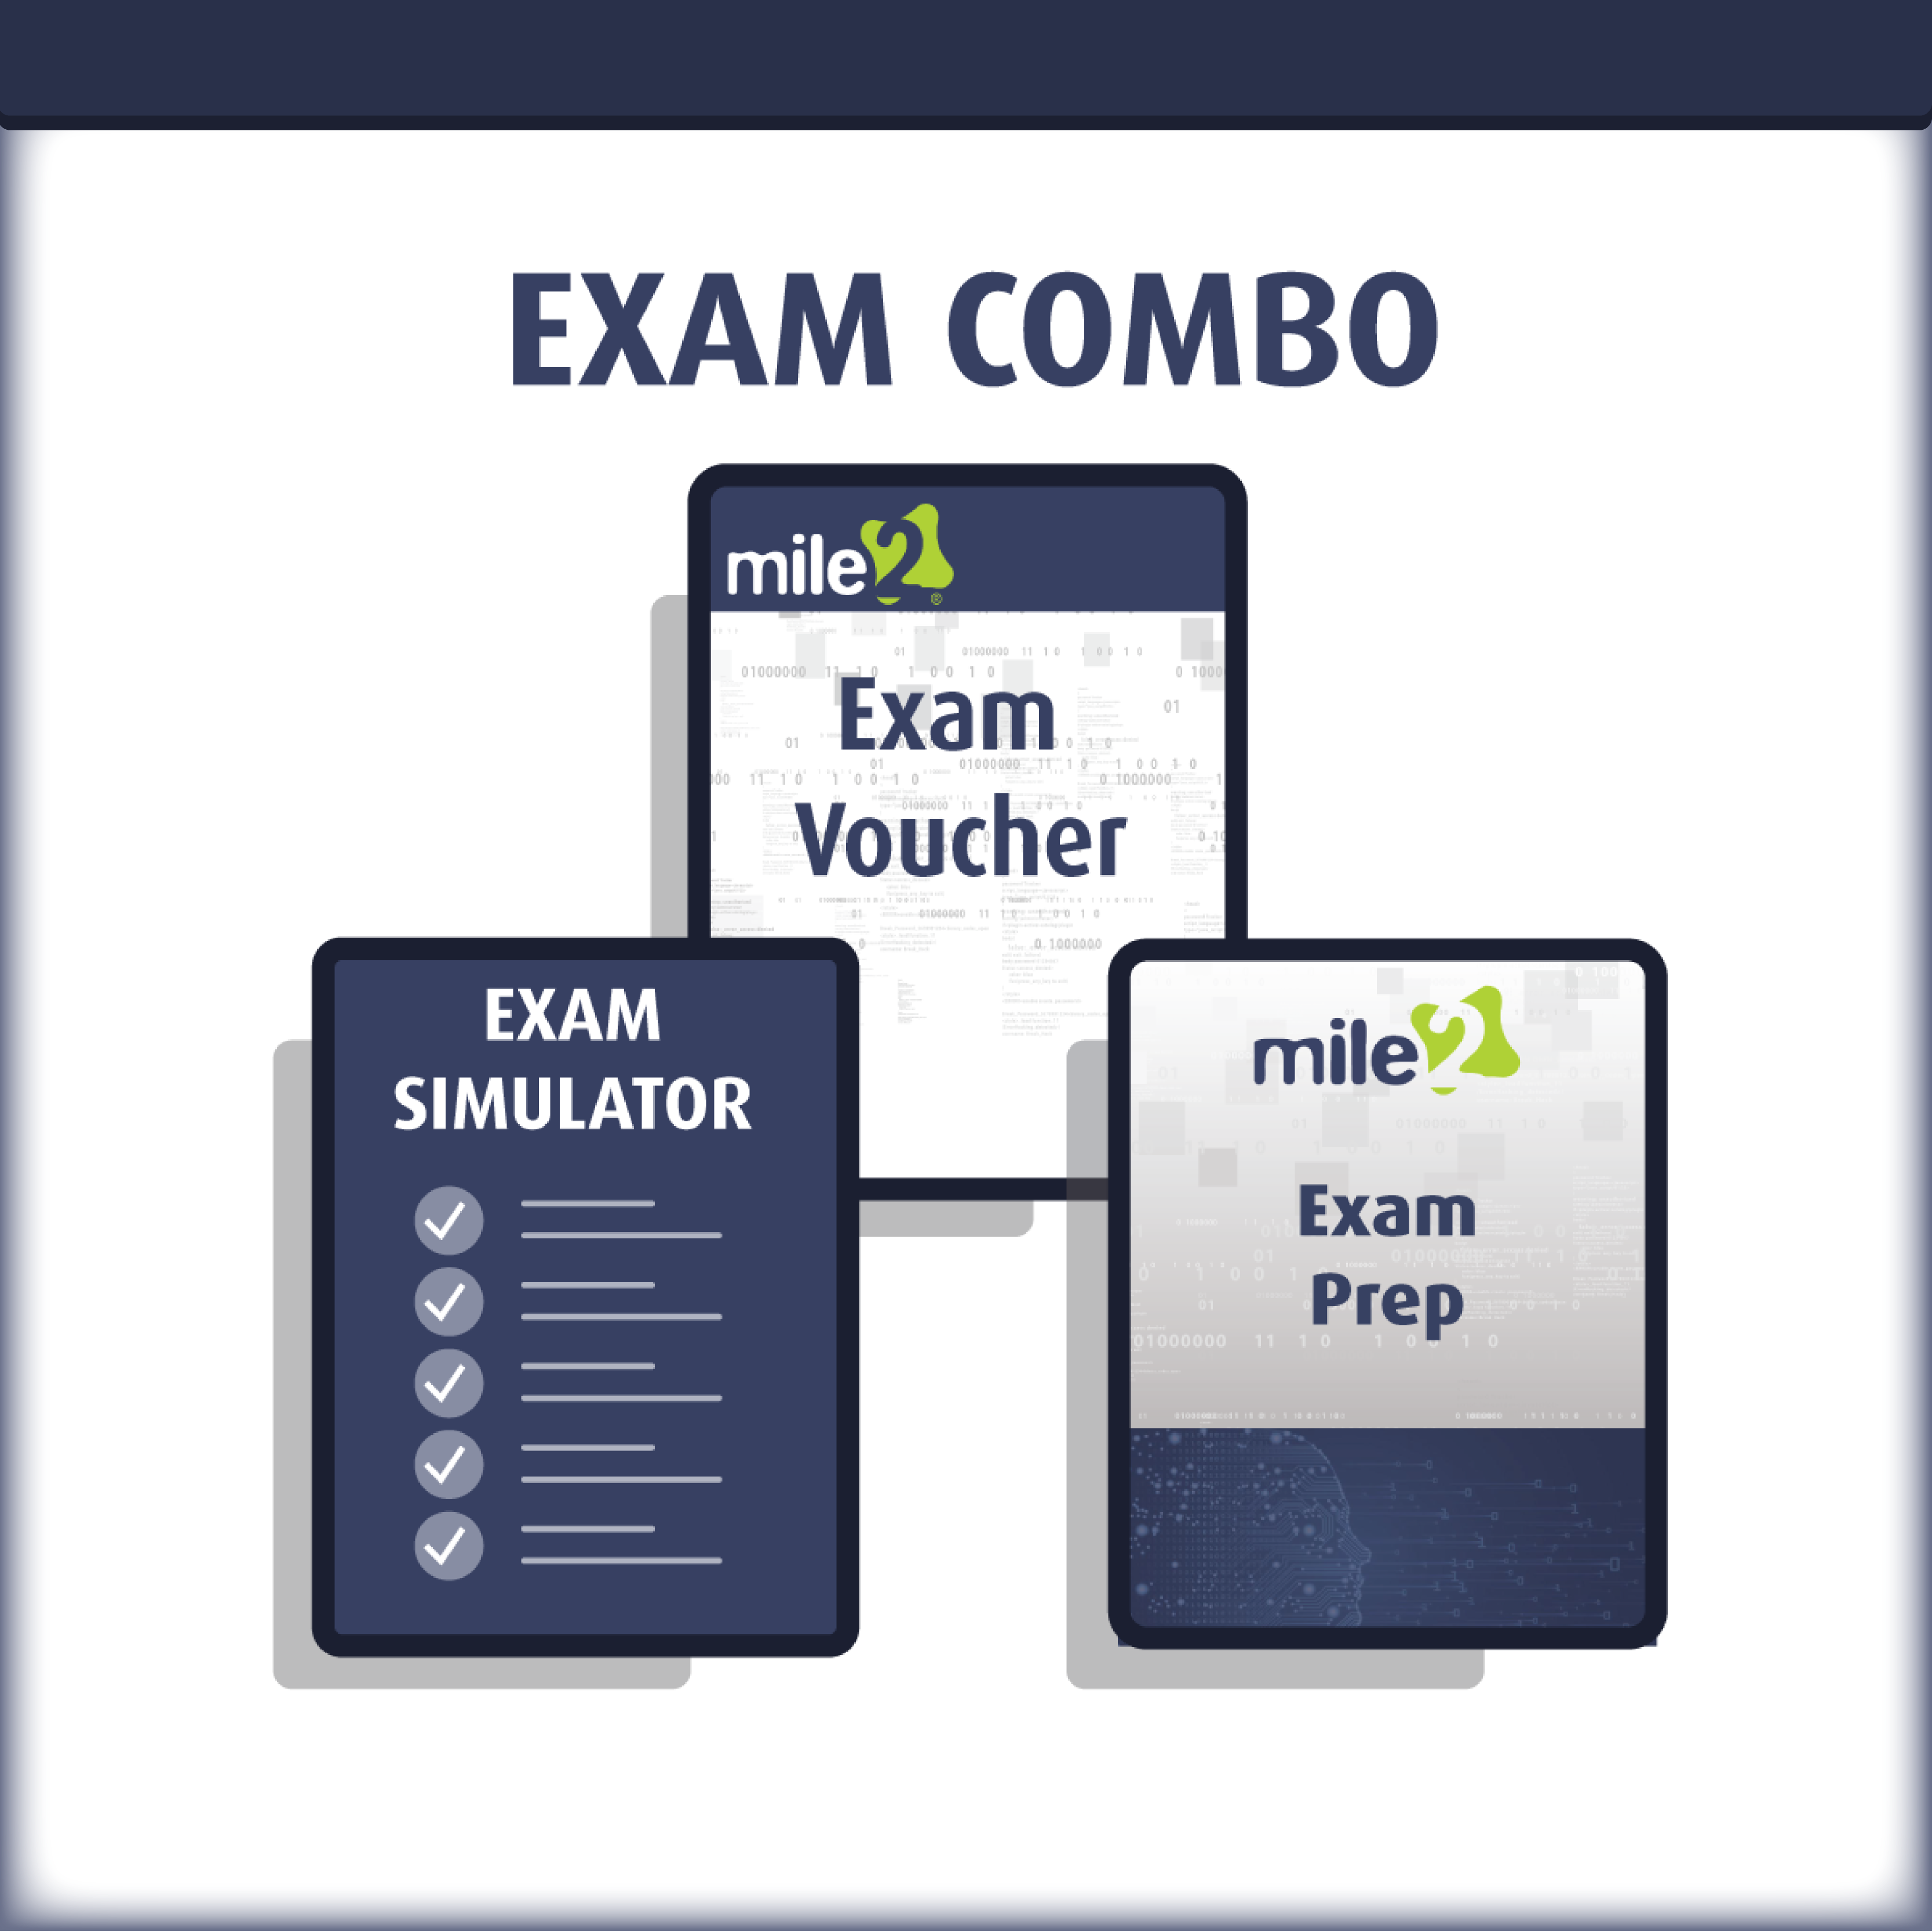

Detailed Outline:
DETAILED MODULE DESCRIPTION

Module 0 – Introduction

Logistics
Introduction
Class Rules
The ISCAP Credential
What information will be covered?
Relationship to Other Processes
Changes in Terminology
Understanding the Risk Management Framework
NIST SP800-37 Rev1
Emphasis of SP800-37
Multi-tiered Risk Management
The Risk Management Framework
What information will be covered?
Summary

Module 1 - Introduction to the RMF

What’s covered in this domain?
The RMF
The pillars of CIA
National Strategy on Cybersecurity
Cyber Attacks
Federal Policy
Actions of Executive Agencies
Federal Policies
E-Government Act of 2002
FISMA
Applying NIST
Special Publications
800-39 Purpose
NIST SP 800-39
Information Systems
What is Risk?
Types of Risk
Security Risk
Information Security Risk
Core Documents
Risk Management
Risk Management Process
IS Risk Management
Threats
Objectives of the RMF
Effective Risk Management
Risk Tolerance / Acceptance

Risk Assessment
Risk Response
Risk Monitoring
Risk Management Process
Frame Risk
Multi-tiered Risk Management
Key Parts of Tier 1
Tier 2 Activities
Key Parts of Tier 2
IS Requirements Integration
Tier 3
Developing Trust
Trustworthiness
Frame Risk
Frame Risk Activities
Risk Assessment
Assess Risk Activities
Threat
Vulnerability
Likelihood
Adversarial Likelihood
Impact
Aggregation

Quantitative Risk
Qualitative Risk
Semi-Quantitative
Risk Assessment Process
Step 1 – Preparing for the Assessment
Conducting the Risk Assessment
Conducting the Risk Assessment
Communicating and Sharing Risk Assessment Information
Maintaining the Risk Assessment
Risk Management Process
Risk Responses
Risk Response Strategy
Risk Management Process
Monitoring Risk
Risk Monitoring Activities
Moving to the RMF
The RMF
Security Control Assessment
Applying the RMF
Applying the RMF cont.
The RMF Process
Summary

Module 2 - The Software Development Life Cycle

The RMF Process
Purpose of SP800-37
Definitions
Guidelines for Implementing SP800-37
Relationship with other SPs
Tiered Risk
Management Approach
Steps of the RMF
Effective Controls
The SDLC
Balancing all Considerations
The Phases of the SDLC Security Requirements
Benefits of Early Integration
Integration
Integrated Project Teams
Role of ISSOs
Reuse of Information
Benefits of Reuse
Identifying Boundaries
Well-defined Boundaries
Correct Boundary Size
Size of Information System Boundaries
Key Words in Boundary Determination
Software Applications
Boundaries for Complex Systems
Complex System Boundaries
What is Security?
Allocation of Controls to Subsystems
Types of Controls
Architecture and Controls
Common Controls
Control Selection
Security Control Allocation
Summary

Module 3 - RMF Step 1

The RMF Tasks
RMF Tasks
Milestones
Sequence
The Last Step
Legacy Systems
Level of Effort Required
The RMF Process
Security Categorization
Categorization
Map Impact Levels
Influence of Architecture
Accuracy of Categorization
Impact–based Categorization
Categorization Levels
Format of Categorization

Categorization
Appropriate Controls
SSP
Information System Description

Information System Registration
System Registration
Milestone Checkpoint # 1
Summary

Module 4 - RMF Step 2

Common Control Identification
Common Controls
Supplementing Common Controls
Inheriting Controls
Common Control Providers
Documentation of Common Controls
Security Control Selection
Selection of Controls
Control Selection
Preparing for Monitoring
Monitoring Strategy
Control Monitoring
Effective Monitoring
Continuous Monitoring
Security Plan Approval
Milestone Checkpoint # 2

Module 5 - RMF Step 3

The RMF Process
Security Control Implementation
Security Controls
Security Control Assurance
Common Controls
Assessments
Security Control Documentation
Documentation
Functional Description
Milestone Checkpoint #3

Module 6 - RMF Step 4

The RMF Process
Assessment Preparation
The Assessment Plan
Purpose of the Plan
Type of Assessment
Approval of the Plan
External Providers
Assessor Competence
Assessor Independence
Security Control Assessment

Control Assessments
Timing of Assessments
Assess and Recommend Findings
Incremental Assessments
Access
Security Assessment Report
Assessment Report
Determination of Risk

Assessment Results
Remediation Actions
Report Findings
Response to Findings
Reassessment
Updating the Security Plan
The Updated Plan
Optional Addendum
Milestone #4

Module 7 - RMF Step 5

The RMF Process
Plan of Action and Milestones
PoA&M
Milestones
Monitoring the PoA&M
Documenting Weaknesses
PoA&M Not Required
Security Authorization Package
Common Controls
Updating the SSP
Risk Determination
Assess Current Security State
Risk Management Strategy
Risk Acceptance
Explicit Acceptance of Risk
Risk Decision
The Authorization Decision
Communicating the Decision
Authorization to Operate
Termination Date
Interim Authorization to Test
Interim Authorization to Operate
Type Authorization
Examples of Type Authorizations
Authorization Approaches
Authorization Rescission
Denial of Authorization
Authorization Decision Document
The Decision
Termination Date
Decision Document
Change in Authorizing Official
Acceptance of Previous Authorization
Milestone Checkpoint #5

The RMF Process
Continuous Monitoring
Control Monitoring
Ongoing Remediation Actions
Updated Assessments
Remediation Actions
Reassessing Controls
Key Updates
Updating the SSP
Updating the PoA&M
Supporting
Continuous Monitoring
Security Status Reporting
Reporting to
the Authorizing Official
Security Status Reports
Frequency of Reporting
Reauthorization
Ongoing Risk
Determination and Acceptance
Reviewing Reports
Metrics and Dashboards
Maintaining Security
Information System Removal and Decommissioning
Disposal
Milestone Checkpoint #6

Information System and Environment Changes
Constant Change
Controlling Change
Record Changes
Impact on Security
Impact on Controls
Documenting Impact
Reauthorization
Ongoing Security
Control Assessments
Ongoing Monitoring

