Description:
The Mile2® Certified Security Awareness 1, C)SA 1, certification course is intended for anyone that uses a computer on the internet. Attendees will learn the security threats inherent to today's workplace as well as the countermeasures associated with these attacks.
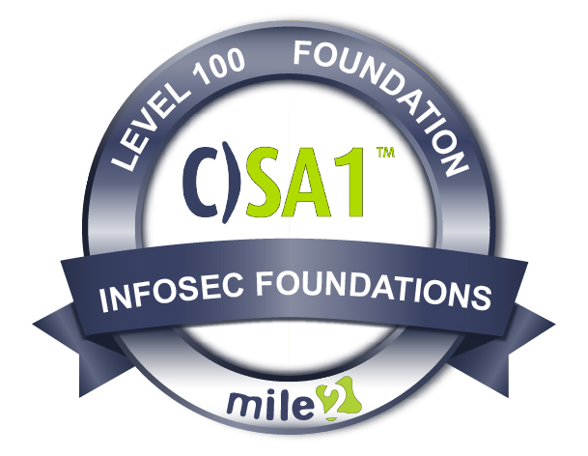

Live Class Duration: 2 Hours
CEUs: 4
Language: English
Class Formats Available:
Instructor Led
Self-Study
Live Virtual Training
Suggested Prerequisites:

None.

Modules/Lessons
Key Course Information

- Everyone
- End Users
- Employees
- Managers

Module 1 - Creating a Cybersecurity Culture
Module 2 - Social Engineering Attacks: Executive Management and Assets
Module 3 - Incident Preparedness and Management Planning
Module 4 - Law and Global Compliance Standards

Employees will learn that the weakest link in any security program is a poorly trained department. The Certified Security Awareness 1, C)SA 1, course teaches general security awareness as well as how to develop a strong security culture within your company's community. The Social Engineering portion of the class is designed to teach the participants the skills used by Social Engineers to facilitate the extraction of information from an organization using technical and non-technical methods.

Security Security Hardware Operating Network Security
Awareness 1 Awareness 2 Technician Systems Principles Principles
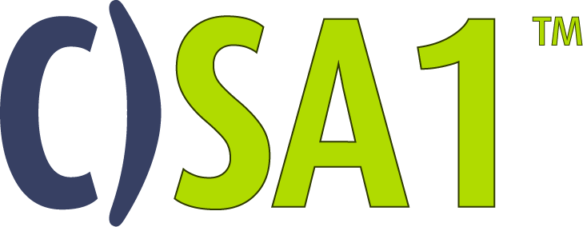
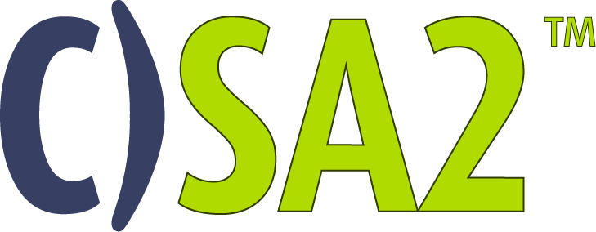
The C)SA1 is a part of our Foundational Course Path

Who Should Attend

Accreditations
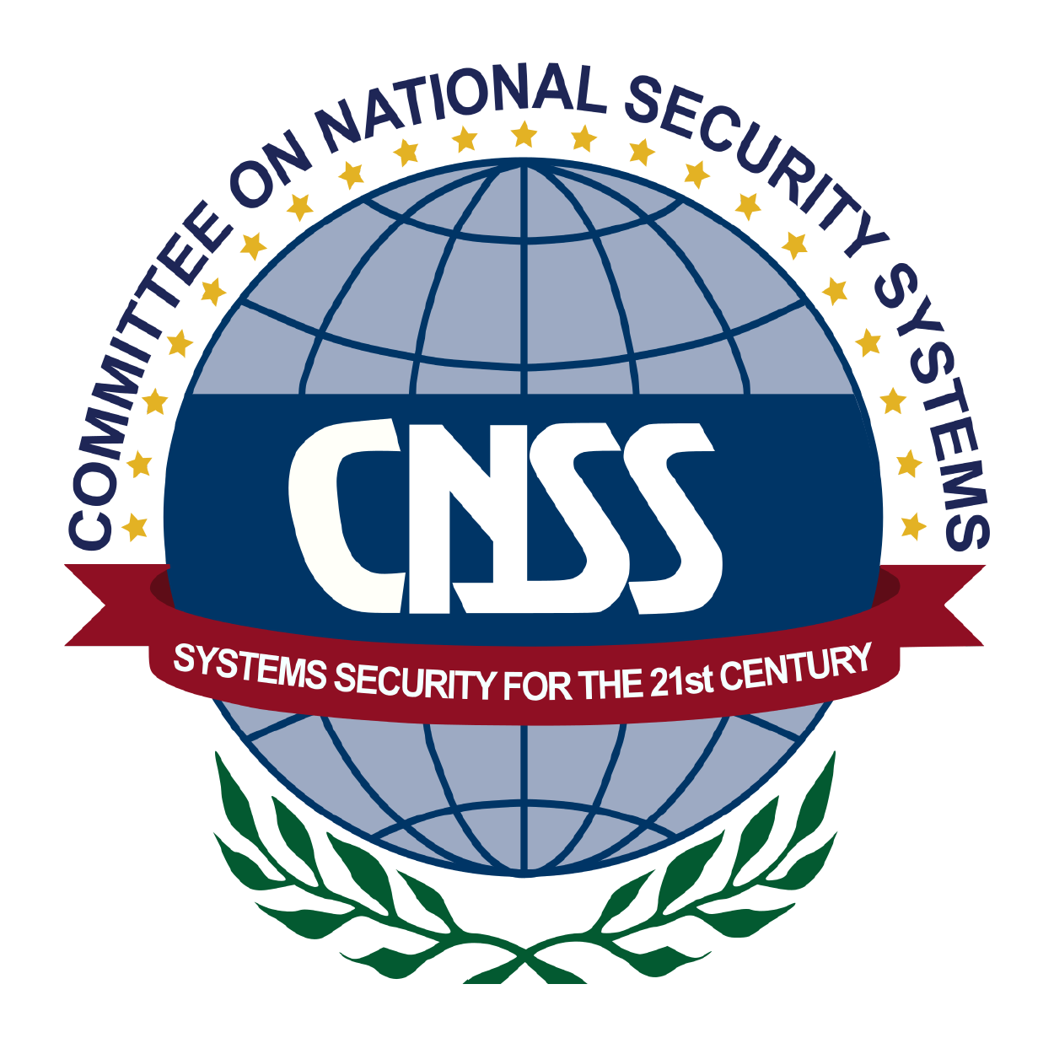

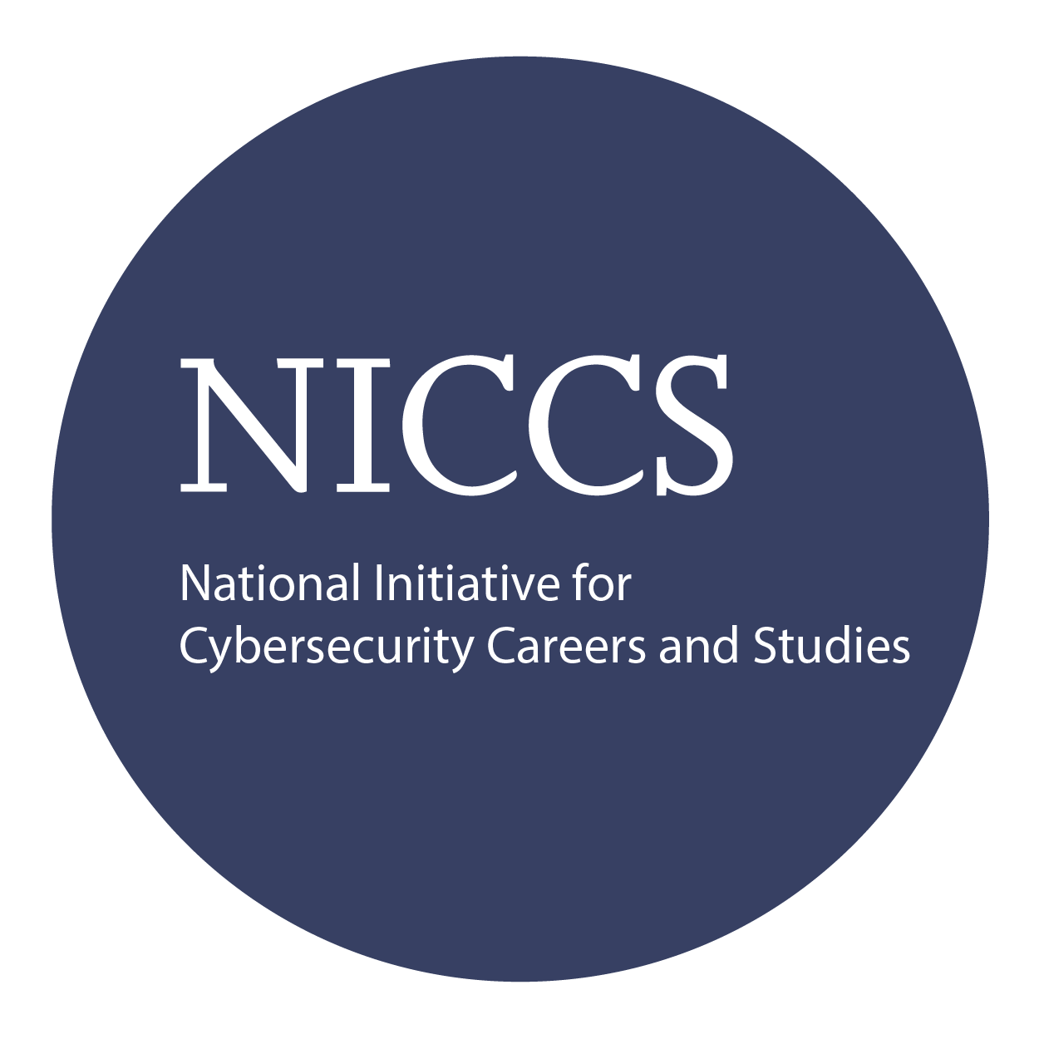

Upon Completion

Question: Do I have to purchase a course to buy a certification exam?
Answer: No
Question: Do all Mile2 courses map to a role-based career path?
Answer: Yes. You can find the career path and other courses associated with it at www.mile2.com.
Question: Are all courses available as self-study courses?
Answer: Yes. There is however 1 exception. The Red Team vs Blue Team course is only available as a live class.
Question: Are Mile2 courses transferable/shareable?
Answer: No. The course materials, videos, and exams are not meant to be shared or transferred.

The Certified Network Principles exam is taken online through Mile2’s Learning Management System and is accessible on you Mile2.com account.
A minimum grade of 80% is required for certification.

All Mile2 certifications will be awarded a 3-year expiration date.

There are two requirements to maintain Mile2 certification:

- Pass the most current version of the exam for your respective existing certification
- Earn and submit 20 CEUs per year in your Mile2 account.

Upon completion, the Certified Security Awareness 1 candidate will be able to competently take the C)SA1 exams well as be able to understand basic cybersecurity principles to keep companies' IP and IT infrastructure safe.

Course FAQ’s
Exam Information

Course and Certification Learning Options
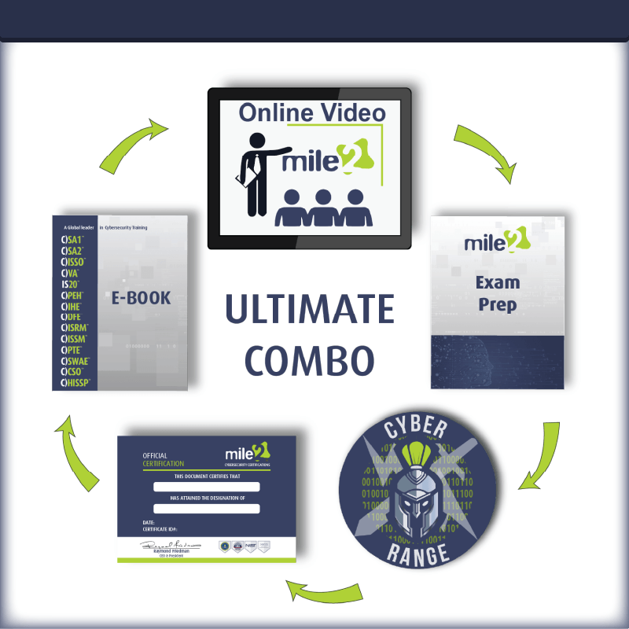
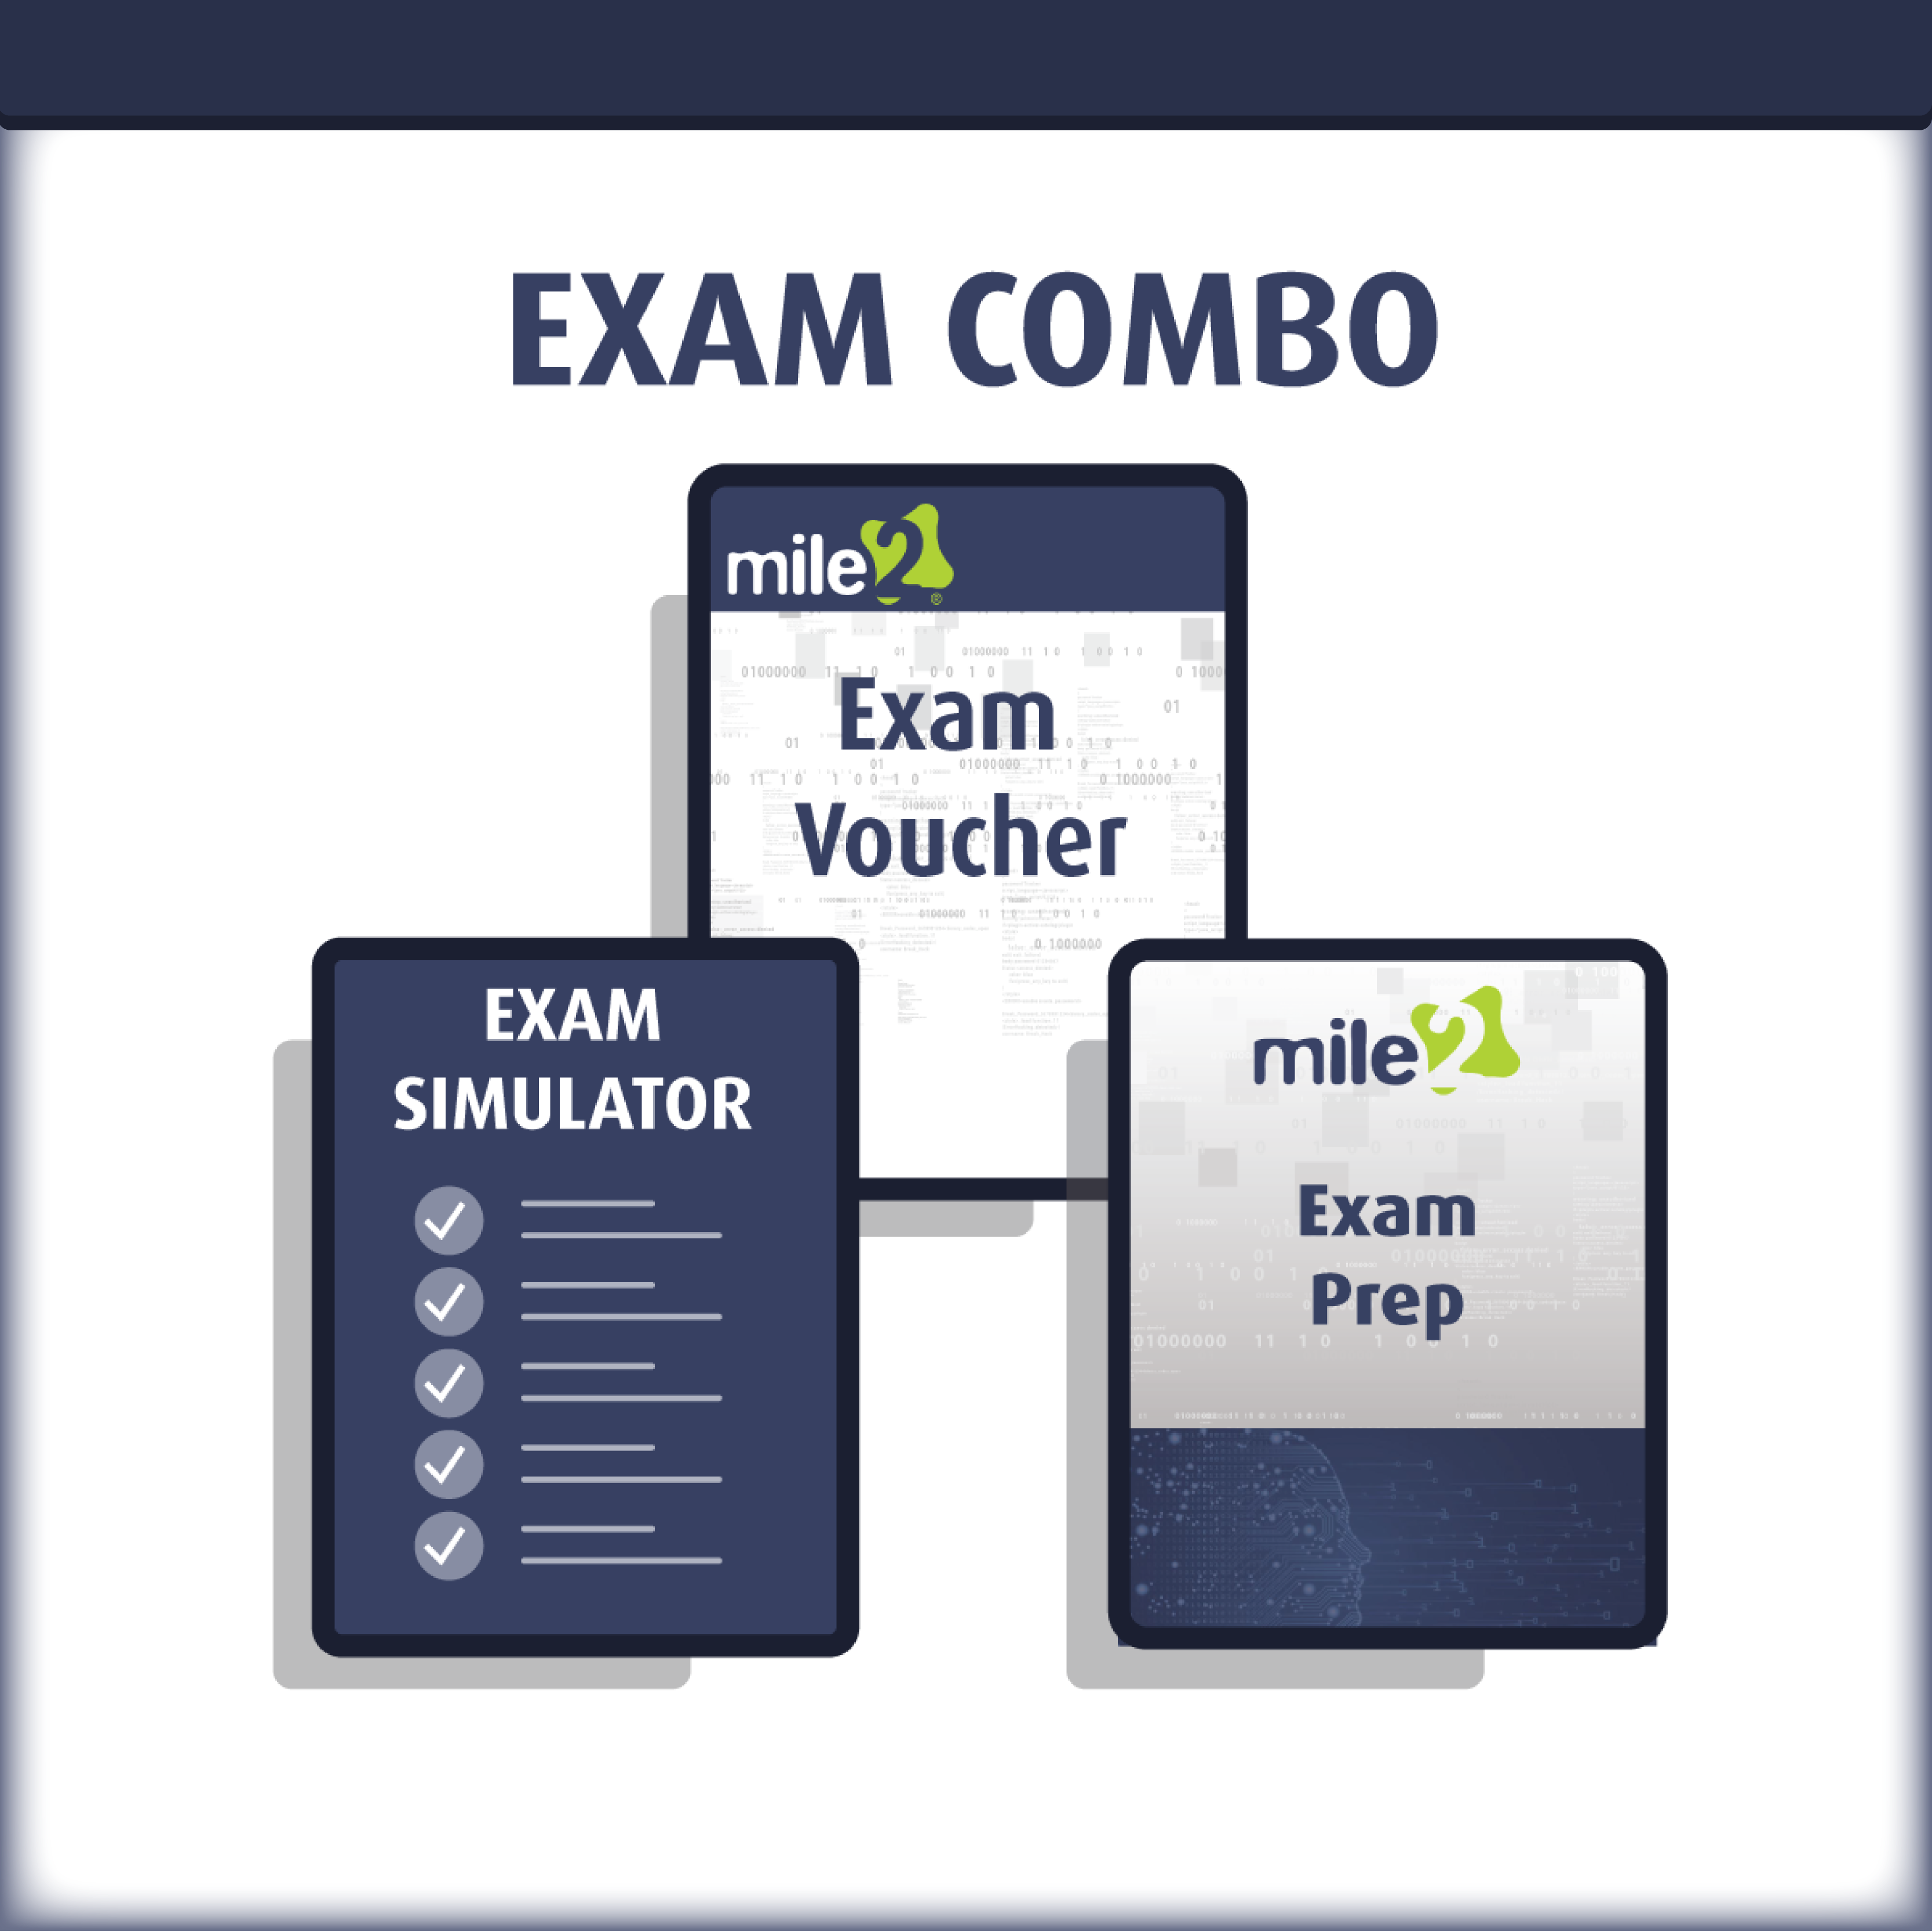

Re-Certification Requirements

Detailed Outline:
Course Introduction

Module 1 - Basic Security Awareness
What is it and why it’s needed?
End User Risk Trends
- Who, What and How are people the target
- What are the losses associated to end user hacks?
  - The policies are as good as the employee who embraces them

Module 2 - Social Engineering
Phishing
- mail, via phone, social websites are common
Spear Phishing
- Example: Fake email sample
Social media
Personification

Module 3 - Data Classification and corporate use (Safe Guarding)
Corporate
- Sensitive, internal or public classification
- Objectives of securing data (IP, Compliance/legislature)
Personal vs. Business Use
- Segregating personal use with business use
Data management
    - Business standard for deleting data
    - Personal standard of data dumping (old phones/hard drives and usb)
    - Did you know that I can unearth deleted docs from a USB drive from a standard Forensics app off of the internet?
How to delete and get rid of your old data

Module 4 - End User Best Practices
Internet utilization
- Hot spots, public places & roaming risks
Safe Web Site surfing
- Discerning safe secure sites (never go to a site link indirectly)
- Locks and HTTPS
Computer Usage
- Using computer in non-admin mode
- Ransomware
Password management
Removable Devices
Mobile, Smart Phones and Tablets (risks associated with mobile devices)
- Device always locked
- Device should always be trackable

