Description:
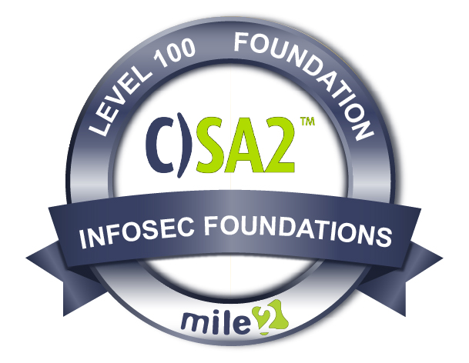

Live Class Duration: 3 Hours
CEUs: 3
Language: English
Class Formats Available:
Instructor Led
Self-Study
Live Virtual Training
Suggested Prerequisites:

None.

Modules/Lessons
Key Course Information

- Everyone
- End Users
- Employees
- Managers

Module 1 - Creating a Cybersecurity Culture
Module 2 - Social Engineering Attacks: Executive Management and Assets
Module 3 - Incident Preparedness and Management Planning
Module 4 - Law and Global Compliance Standards
The Mile2® Certified Security Awareness 2, C)SA2, course is to help the student take organizational cyber awareness to the next level. Attendees will understand the security threats that are associated with a company culture.

Specifically designed for managers, the Certified Security Awareness 2, C)SA2, delves into how to respond to a breach, the legal requirements for response, and how to prevent future breaches. The Certified Security Awareness 2 course provides lower and executive management a window as to the techniques of malicious hackers as well as the counter response controls management can implement to detour a major compromise.

The C)SA2 is a part of our Foundational Course Path
Security Security Hardware Operating Network Security
Awareness 1 Awareness 2 Technician Systems Principles Principles

Who Should Attend

Accreditations
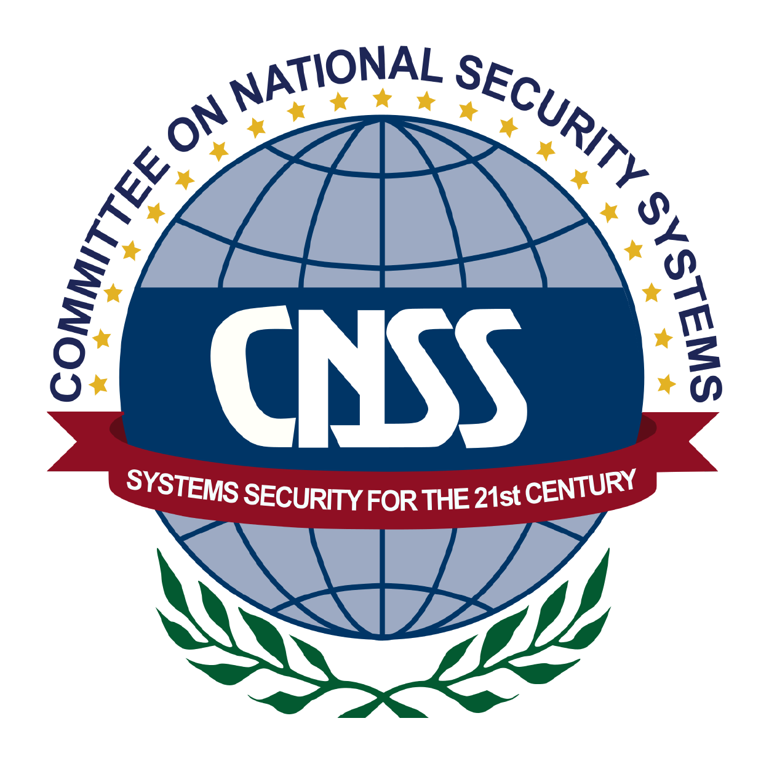

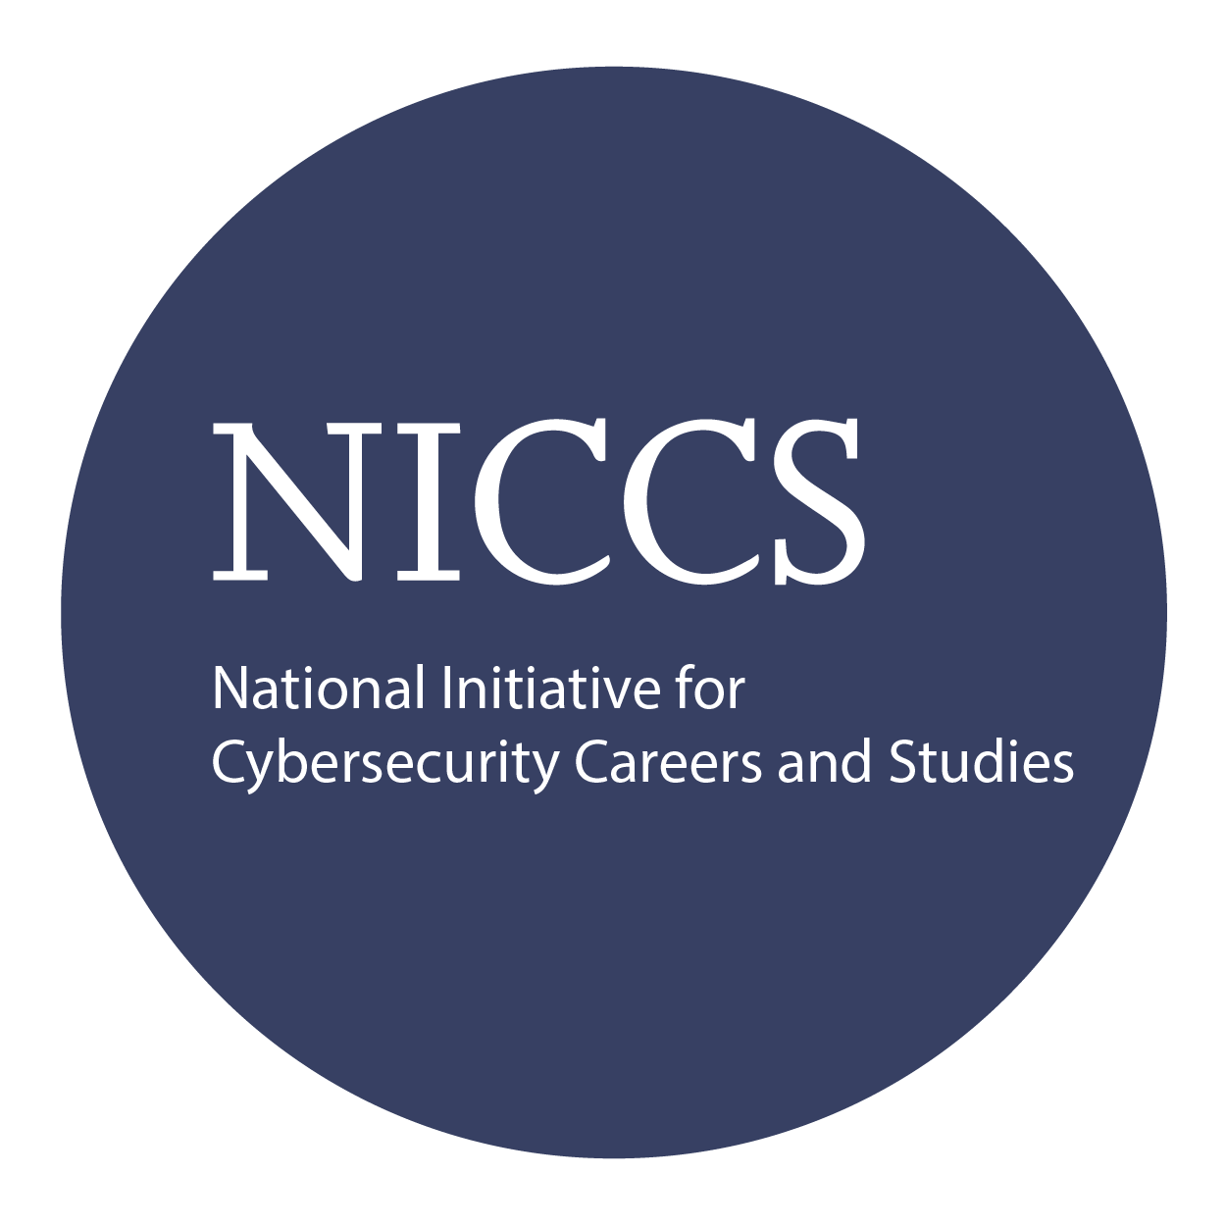

Upon Completion

Question: Do I have to purchase a course to buy a certification exam?
Answer: No
Question: Do all Mile2 courses map to a role-based career path?
Answer: Yes. You can find the career path and other courses associated with it at www.mile2.com.
Question: Are all courses available as self-study courses?
Answer: Yes. There is however 1 exception. The Red Team vs Blue Team course is only available as a live class.
Question: Are Mile2 courses transferable/shareable?
Answer: No. The course materials, videos, and exams are not meant to be shared or transferred.

The Certified Network Principles exam is taken online through Mile2’s Learning Management System and is accessible on you Mile2.com account.
A minimum grade of 80% is required for certification.

All Mile2 certifications will be awarded a 3-year expiration date.

There are two requirements to maintain Mile2 certification:

- Pass the most current version of the exam for your respective existing certification
- Earn and submit 20 CEUs per year in your Mile2 account.

Upon completion, the Certified Security Awareness 1 candidate will be able to competently take the C)SA1 exams well as be able to understand basic cybersecurity principles to keep companies' IP and IT infrastructure safe.

Course FAQ’s
Exam Information

Course and Certification Learning Options
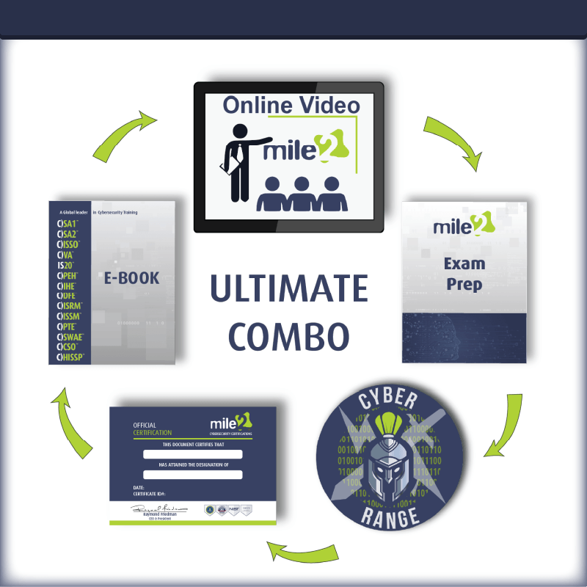

Re-Certification Requirements

Detailed Outline:
Course Introduction

Chapter 1 – Creating a Cyber Security Culture
- Non-malware Attack Statistics 2017 (Carbon Black)
- Cyber Security Culture
- Requirements for Successful CSC
- Steps to Create CSC
- Key People for a Successful CSC and Their Roles
- How Various Departments are Related to the CSC Program
- Leadership Skills
- Techniques Used by Successful Leaders
- Yearly Training and Drills
Chapter 2 - Social Engineer Attacks: Executive Management and Assets
- Techniques used by Hackers
- Why Executives are Pinpointed as Targets
- Whaling Attacks
- Recent Successful Whaling Attacks
- Whaling Mitigation
- Intellectual Property
- IP Categories
- IP Legally Defined Categories
- Keeping IP Safe
- Keeping IP Safe - Recommendation
Chapter 3 – Incident Preparedness and Management Planning
- Incident Mitigation
- Incident Mitigation
- Cyber Insurance
- Cyber Insurance Gaps
- Incident Preparedness Steps
- Preparation Step
- Identification Step
- Crisis Management
- Post Crisis Management
- Post Crisis Management
- General Recommendation for Post Crisis

Chapter 4 – Laws and Global Compliance Standards
- Laws & Standards
- Laws & Standards
- 12 PCI DSS Requirements
- Laws & Standards
- SOX Most Important Sections
- Laws & Standards
- Data Classification
- Objectives of Data Classification
- Personal vs. Business Use
- Personal vs. Business Use
- Business Standard for Deleting Data
- Mobile Device Security Risks
- Mobile Device Security
- BYOD Challenges
- BYOD Policy

