Description:

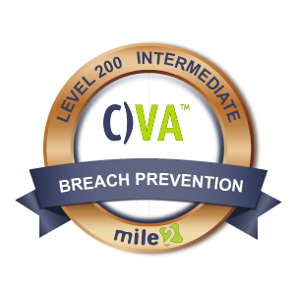
Mile2's Vulnerability Assessor course, C)VA provides an solid understanding of the tools an IT engineer needs to review an Information System. In this course, you will learn the importance of vulnerability assessments and how they are used to prevent serious cyber break-ins. Lessons include understanding malware and viruses and how they can infiltrate an organization's network. After you take this course, you will be able to assess a company's security posture and perform a basic vulnerability test. Plus, you will be able to generate reports to guide new security implementation.

Key Course Information

- Information System Owners
- Analysts
- Ethical Hackers
- ISSOs
- IT Engineers
- Cyber Security Managers

Live Class Duration: 3 Days
CEUs: 24
Language: English
Class Formats Available:
Instructor Led
Self-Study
Live Virtual Training
Suggested Prerequisites:
- Basic Networking Understanding

Module 1 -Why Vulnerability Assessment
Module 2 -Vulnerability Types
Module 3 -Assessing the Network
Module 4 -Assessing Web Servers and Applications
Module 5 -Assessing Remote and VPN Services
Module 6 - Vulnerability Assessments & Tools of the Trade
Module 7 -Output Analysis
LABS
Lab 1 -Intro to Common Vulnerability Exposures
Lab 2 -Drafting Incident Response Procedures
Lab 3 -Patch Management Architecture
Lab 4 -Operations
Lab 5 -Patch Management
Lab 6 – Installing Nessus and Conducting a Vulnerability Scan Lab 7 -Generating Metrics on a Security Report

Modules/Lessons
Who Should Attend

Accreditations
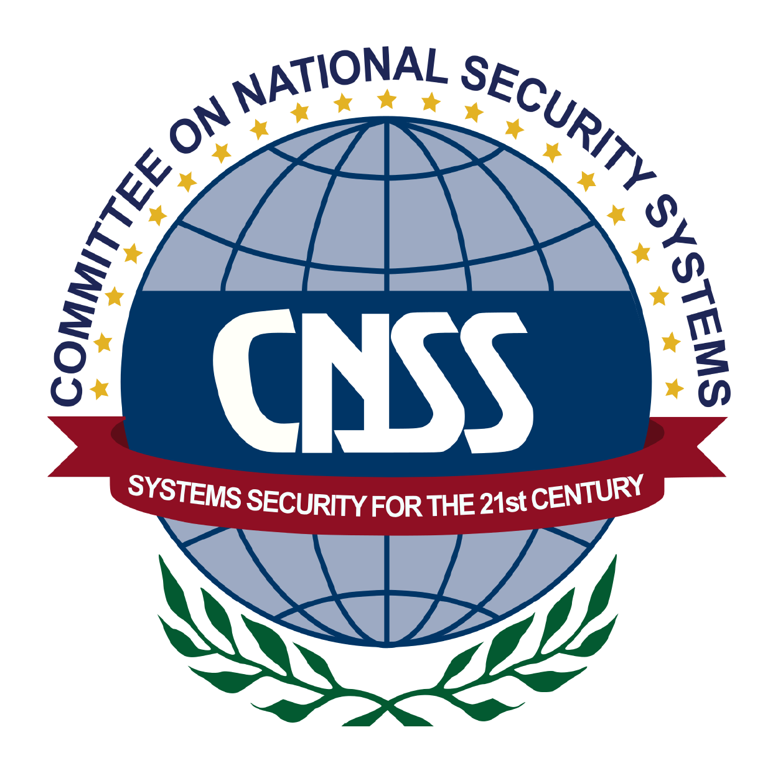

Upon Completion

Question: Do I have to purchase a course to buy a certification exam?
Answer: No
Question: Do all Mile2 courses map to a role-based career path?
Answer: Yes. You can find the career path and other courses associated with it at www.mile2.com.
Question: Are all courses available as self-study courses?
Answer: Yes. There is however 1 exception. The Red Team vs Blue Team course is only available as a live class.
Question: Are Mile2 courses transferable/shareable?
Answer: No. The course materials, videos, and exams are not meant to be shared or transferred.

The Certified Vulnerability Assessor exam is taken online through Mile2’s Learning Management System and is accessible on you Mile2.com account.
A minimum grade of 80% is required for certification.

All Mile2 certifications will be awarded a 3-year expiration date.

There are two requirements to maintain Mile2 certification:

- Pass the most current version of the exam for your respective existing certification
- Earn and submit 20 CEUs per year in your Mile2 account.

Upon completion, the Certified Vulnerability Assessor candidate will be able to competently take the C)VA exam.

Course FAQ’s
Exam Information

Course and Certification Learning Options
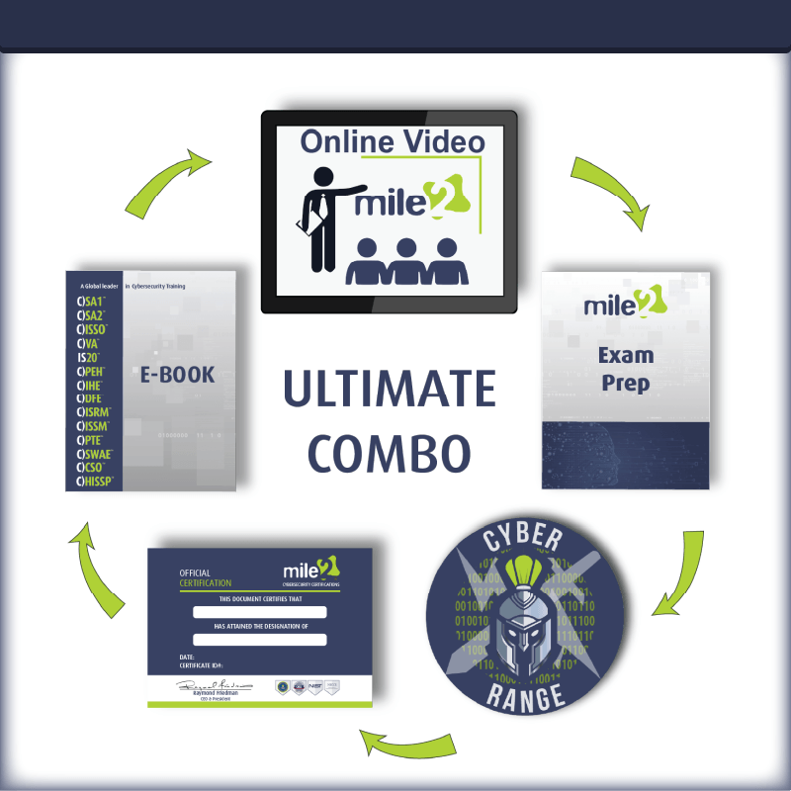

Re-Certification Requirements

DETATILED OUTLINE
- Why Vulnerability Assessment
- What is a Vulnerability Assessment?
- Examination
- Benefits of a Vulnerability Assessment
- What are Vulnerabilities?
- Compliance and Project Scoping
- The Project Overview Statement
- Assessing Current Network Concerns
- Network Vulnerability Assessment Methodology
- Risk Management
- What is the Value of an Asset?
- Types of Policy
- Vulnerability Types
- Vulnerability Severity and Critical Vulnerabilities
- Information Leaks
- Denial of Service and Best Practices
- Introduction to Patch Management
- What is Patch Management?
- Different Types of Patches
- Why Patch Management is Necessary
- Patch Management Process
- Patch Management Program Challenges
- Timing, Prioritization, and Testing
- Patch Management Configuration
- Alternative Host Architectures
- Other Challenges
- Patch Management Technologies
- Components and Architecture
- Security Capabilities
- Management Capabilities
- Vulnerability Assessment Tools of the Trade
- Types of Vulnerability Scanners
- Cyber Vulnerability Assessment Tools
- Metrics
- Vulnerability Severity
- Reportable Vulnerabilities
- Readability Factor
- Tool Output and Data Provided
- Compliance Audits

