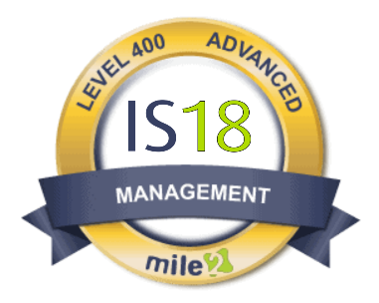
Description:
The Mile2® IS18 Controls – IS18 certification course is intended for anyone interested in learning effective information systems governance and management. This 4-day training course focuses on the implementation and analysis of the IS18 Top Controls. These controls have been identified as critical by leading government and private organizations with expertise in understanding attack techniques and mitigating risks. They are designed to prevent known attacks and minimize the impact of successful attacks.
By adopting the IS18 Top Controls, organizations can enhance the security of their sensitive information. This training course equips security professionals with the tools and methodologies necessary to execute and assess these controls within their existing network infrastructure. Automation is emphasized as a highly effective and cost-efficient approach to implementing these controls.
For management personnel, this training provides valuable insights into assessing the effectiveness of the security controls in place. It enables them to evaluate whether the controls are being properly administered and to make informed decisions regarding security measures.

Live Class Duration: 4 Days

CEUs: 32

Language: English

Class Formats Available:
- Instructor Led
- Self-Study
- Live Virtual Training

Suggested Prerequisites:

Broad Understanding of Multiple Networking and Security Technologies

Module 01: Introduction
Module 02: Inventory and Control
Module 03: Inventory and Control of Software Assets
Module 04: Data Protection
Module 05: Secure Configuration of Enterprise Assets and Software Concept
Module 06: Account Management
Module 07: Access Control Management
Module 08: Continuous Vulnerability Management
Module 09: Audit Log Management
Module 10: Email and Browser Protection
Module 11: Malware Defenses
Module 12: Data Recovery
Module 13: Network Infrastructure Management
Module 14: Network Monitoring and Defense
Module 15: Security Awareness and Skills Training
Module 16: Service Provider Management
Module 17: Applications Software Security
Module 18: Incident Response Mgmt.
Module 19: Penetration Testing

- Information Assurance Managers/Auditors
- System Implementers
- IT Administrators
- Auditors
- Federal Agencies
- Security Vendors and Consulting Groups

Who Should Attend
Modules/Lessons
Key Course Information

Accreditations
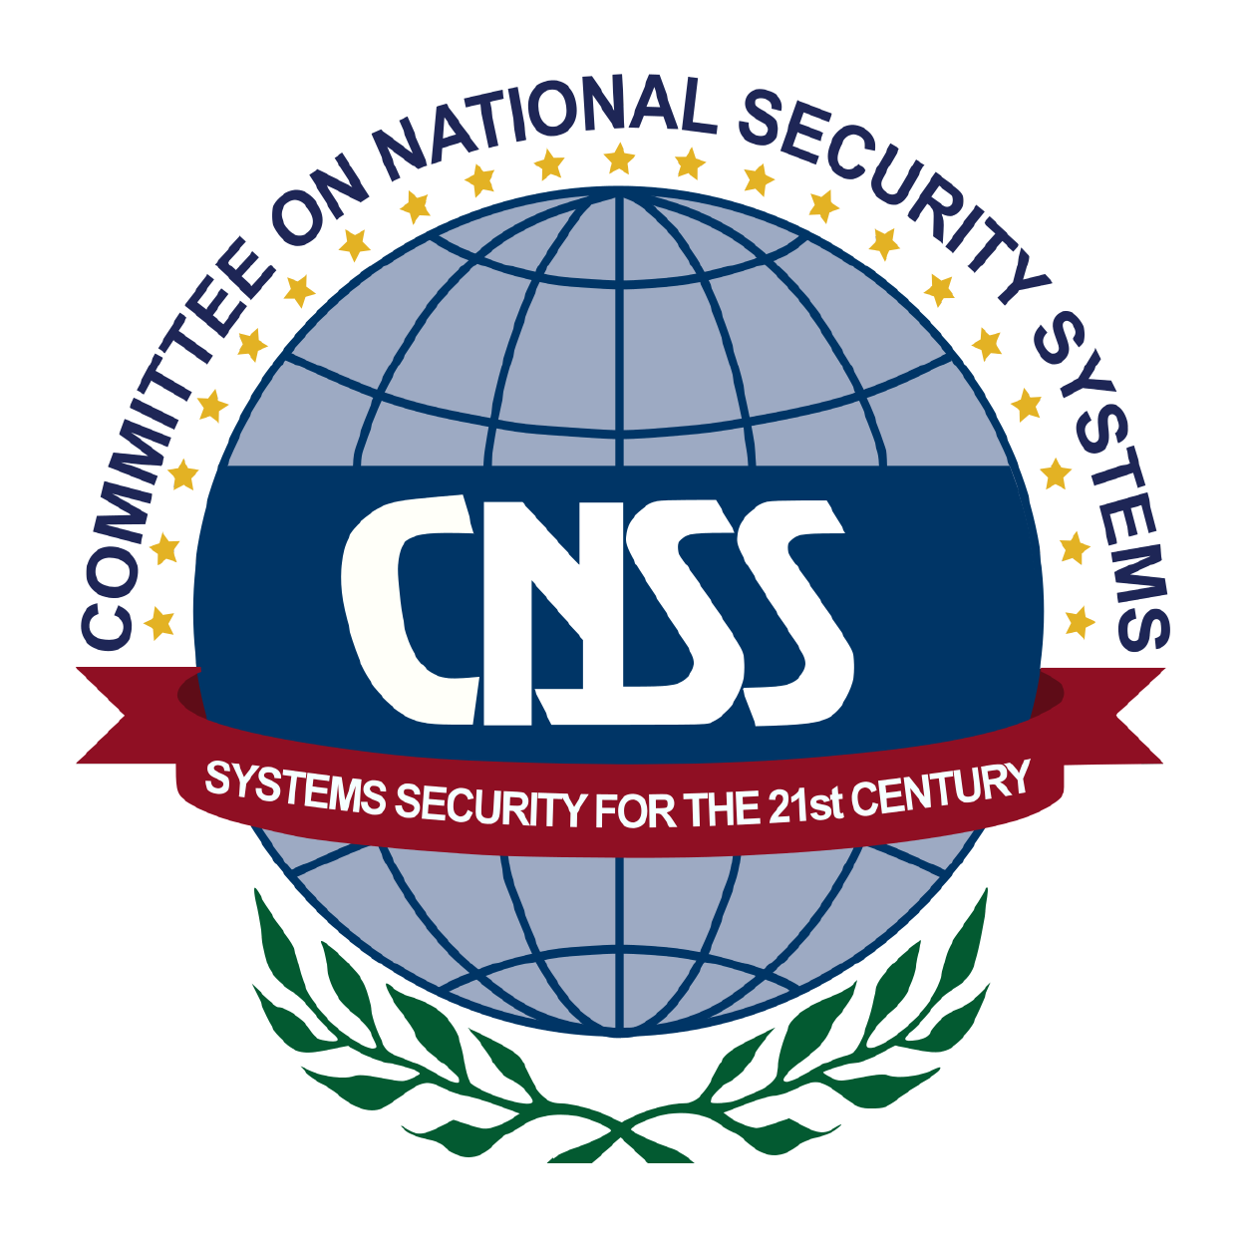

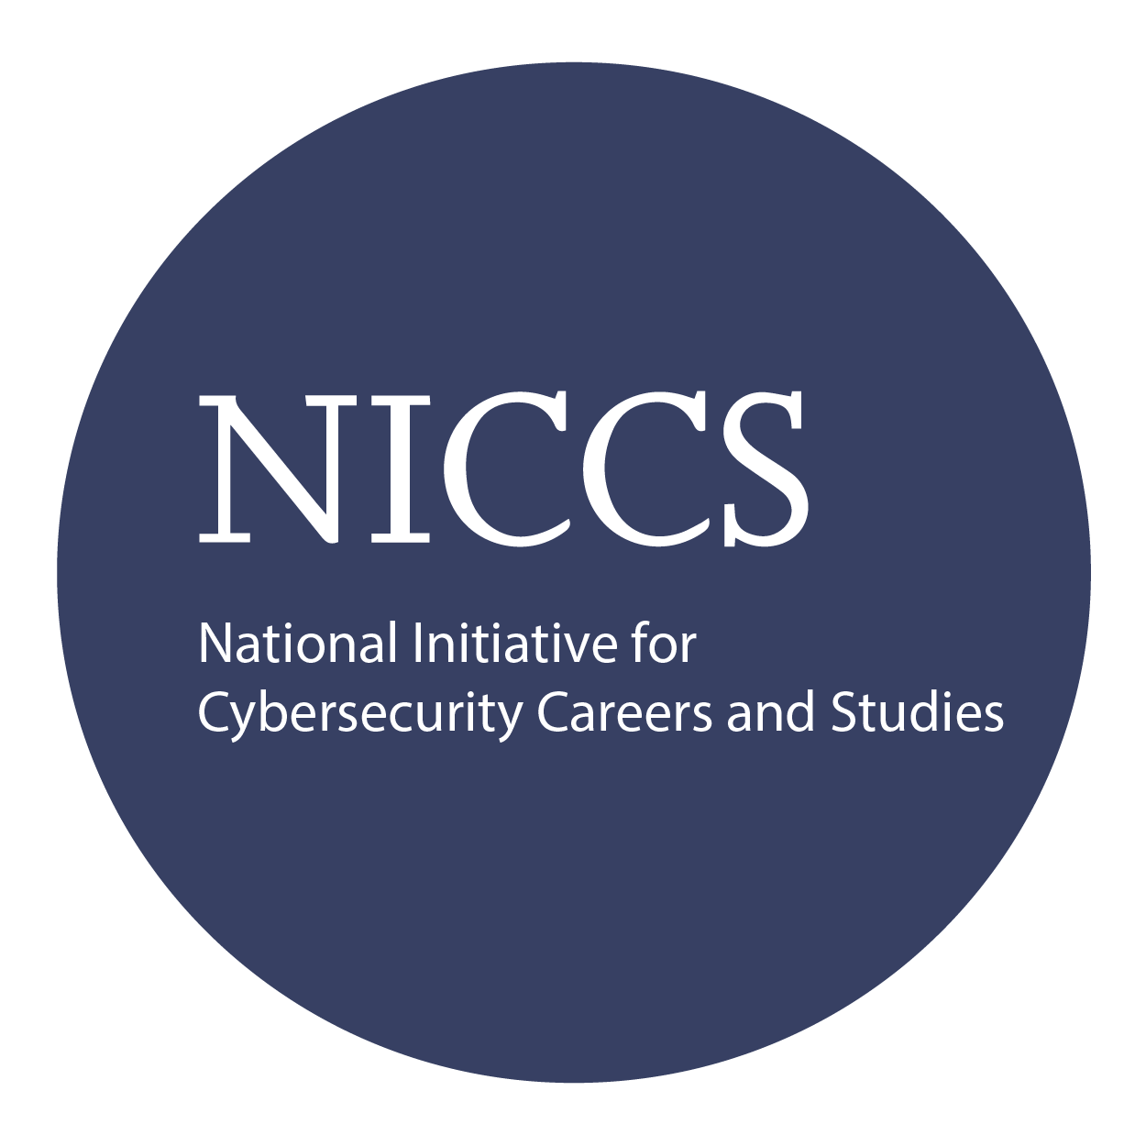

The IS18 exam is taken online through Mile2’s Assessment and Certification System (“MACS”), which is accessible on your mile2.com account. The exam will take 2 hours and consist of 100 multiple-choice questions.
A minimum grade of 70% is required for certification.

All Mile2 certifications will be awarded a 3-year expiration date.

There are two requirements to maintain Mile2 certification:

- Pass the most current version of the exam for your respective existing certification.

- Earn and submit 20 CEUs per year in your Mile2 account.

Upon completion, the IS18 Security Controls candidate will be able to competently take the IS18 Controls exam and understand how to implement the top 18 most critical controls in the workplace.

Question: Do I have to purchase a course to buy a certification exam?
Answer: No

Question: Do all Mile2 courses map to a role-based career path?
Answer: Yes. You can find the career path and other courses associated with it at www.mile2.com.
Question: Are all courses available as self-study courses?
Answer: Yes. There is however 1 exception. The Red Team vs Blue Team course is only available as a live class.
Question: Are Mile2 courses transferable/shareable?
Answer: No. The course materials, videos, and exams are not meant to be shared or transferred.
Upon Completion
Course FAQ’s
Exam Information

Course and Certification Learning Options
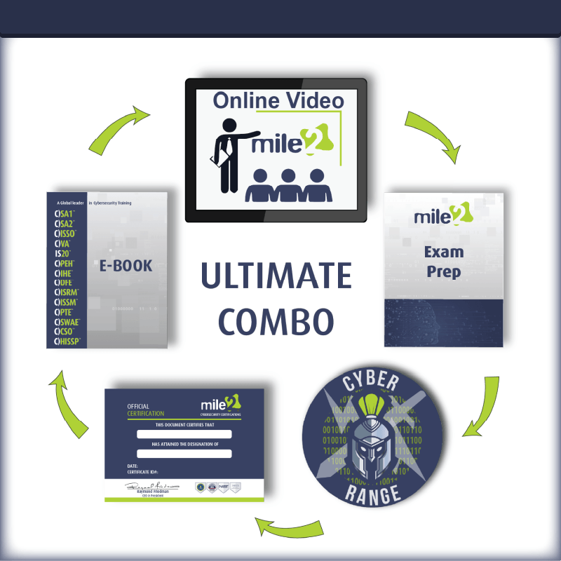
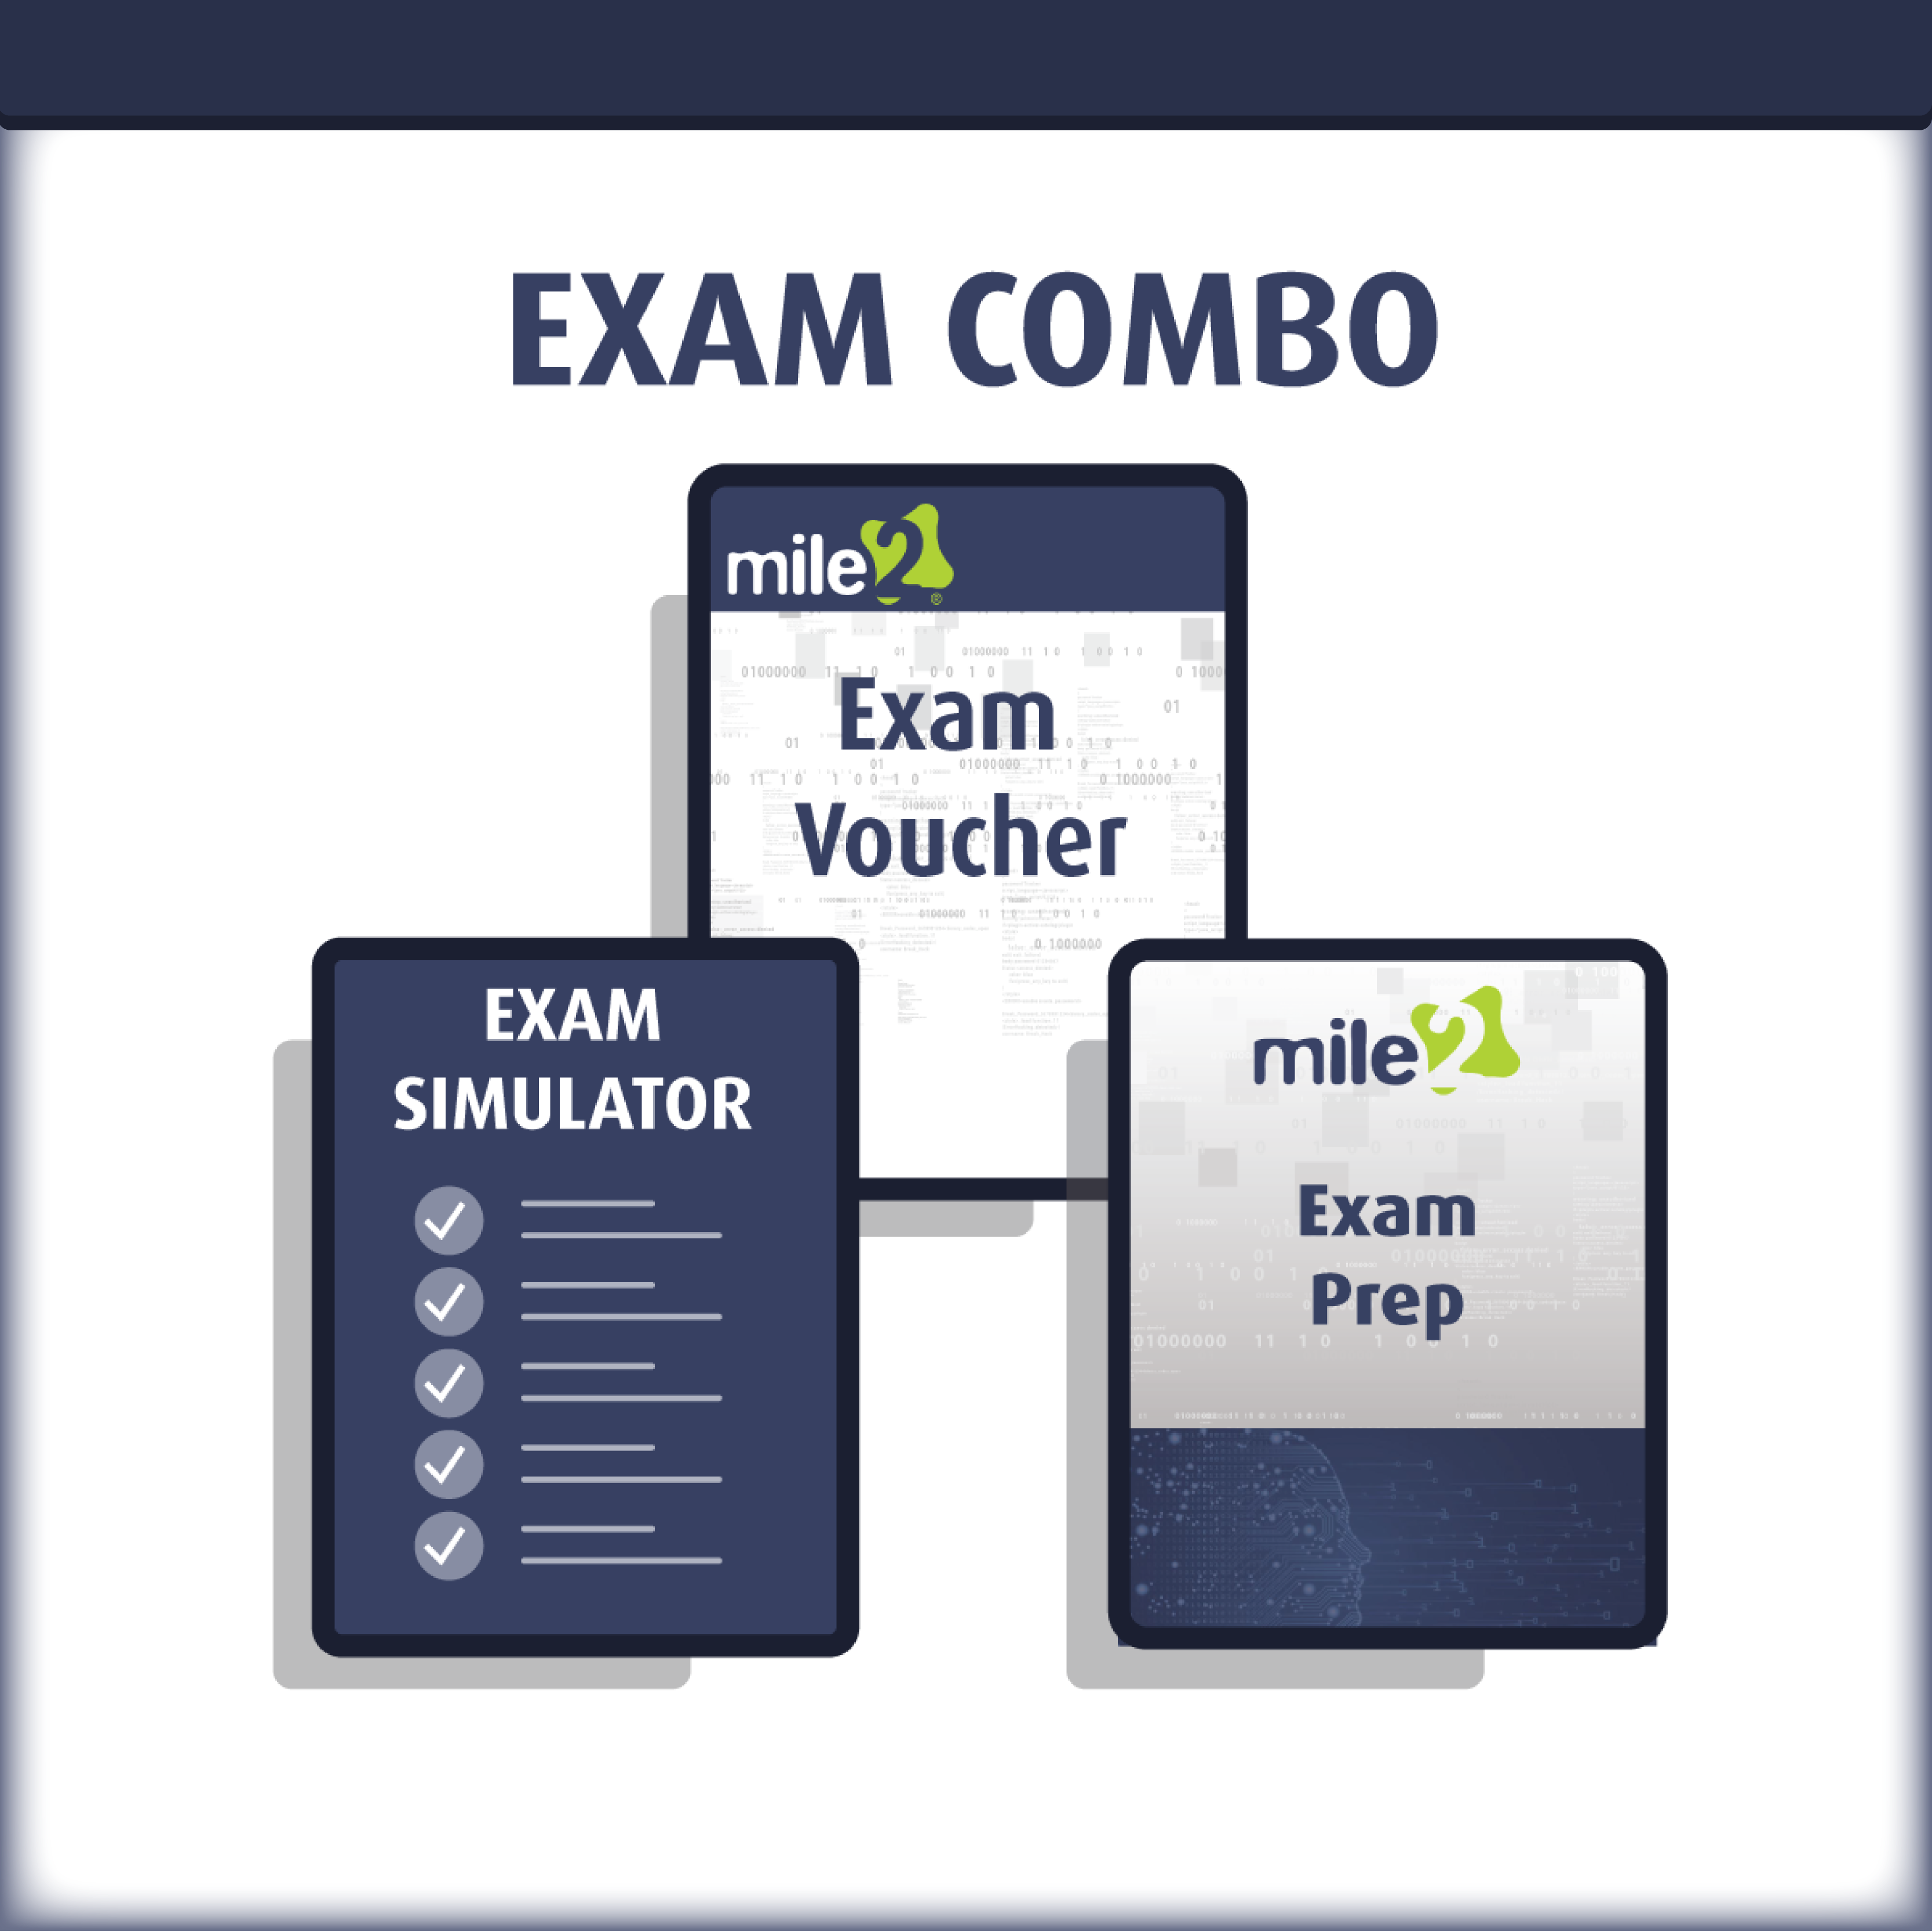
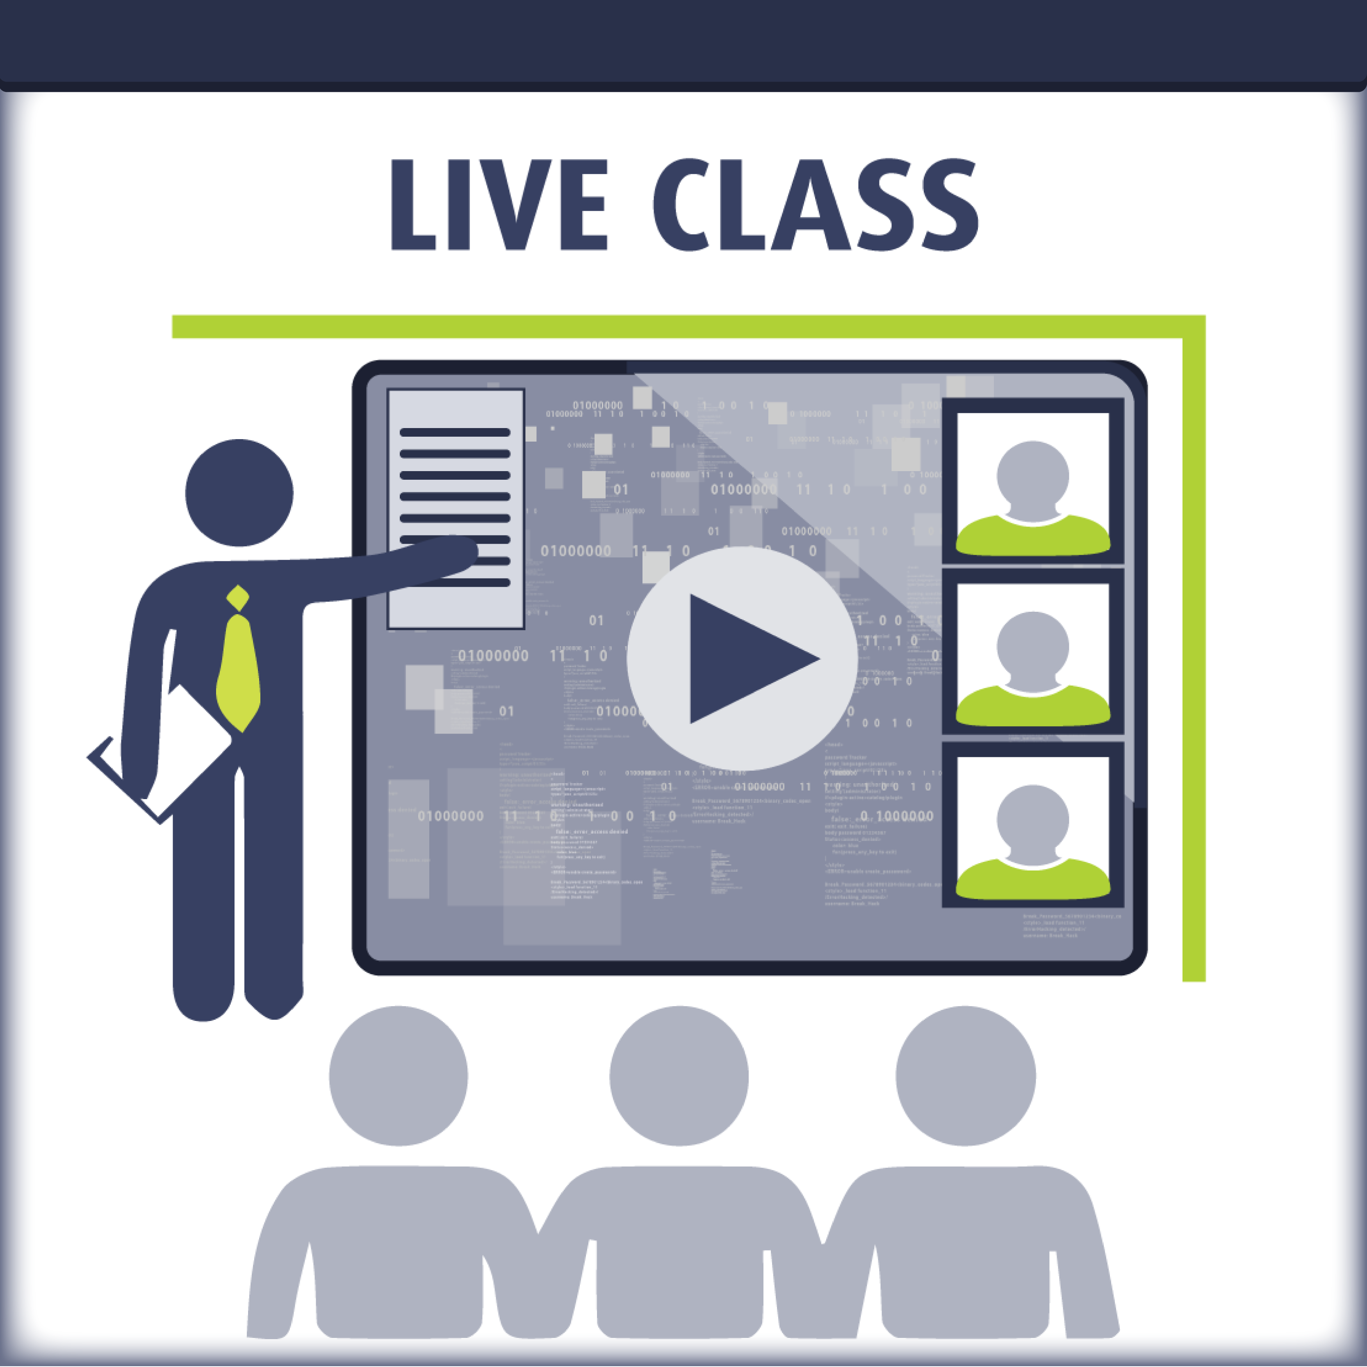

Re-Certification Requirements

Detailed Outline:

Module 01: Introduction
Module 02: Critical Control 01, Inventory and Control of Enterprise Assets
Module 03: Critical Control 02, Inventory and Control of Software Assets
Module 04: Critical Control 03, Data Protection
Module 05: Critical Control 04, Secure Configuration of Enterprise Assets and Software
Module 06: Critical Control 05, Account Management
Module 07: Critical Control 06, Access Control Management
Module 08: Critical Control 07, Continuous Vulnerability Management
Module 09: Critical Control 08, Audit Log Management
Module 10: Critical Control 09, Email and Web Browser Protection
Module 11: Critical Control 10, Malware Defenses
Module 12: Critical Control 11, Data Recovery
Module 13: Critical Control 12, Network Infrastructure Management
Module 14: Critical Control 13, Network Monitoring and Defense
Module 15: Critical Control 14, Security Awareness and Skills Training
Module 16: Critical Control 15, Service Provider Management
Module 17: Critical Control 16, Applications Software Security
Module 18: Critical Control 17, Incident Response Management
Module 19: Critical Control 18: Penetration Testing

