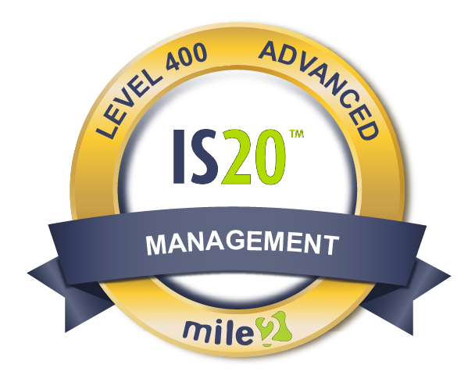
Description:
IS20 controls are the Top Twenty Most Critical Security Controls in Information Technology. This 4 day training course covers proven tools and methodologies needed to execute and analyze the Top Twenty Most Critical Security Controls. Nearly all organizations that maintain sensitive information are adopting these Security Controls
These controls were chosen by leading government and private organizations who are experts on how attacks work and what can be done to prevent them from happening. The controls were selected as the best way to block known attacks as well as help search for and alleviate any damage from the attacks that are successful. This course allows the security professional to see how to implement controls in an existing network through highly effective and economical automation. For management, this training is the best way to distinguish how you will assess whether these security controls are effectively being administered.
,663,6629

Annual Salary Potential $92,662 AVG/year
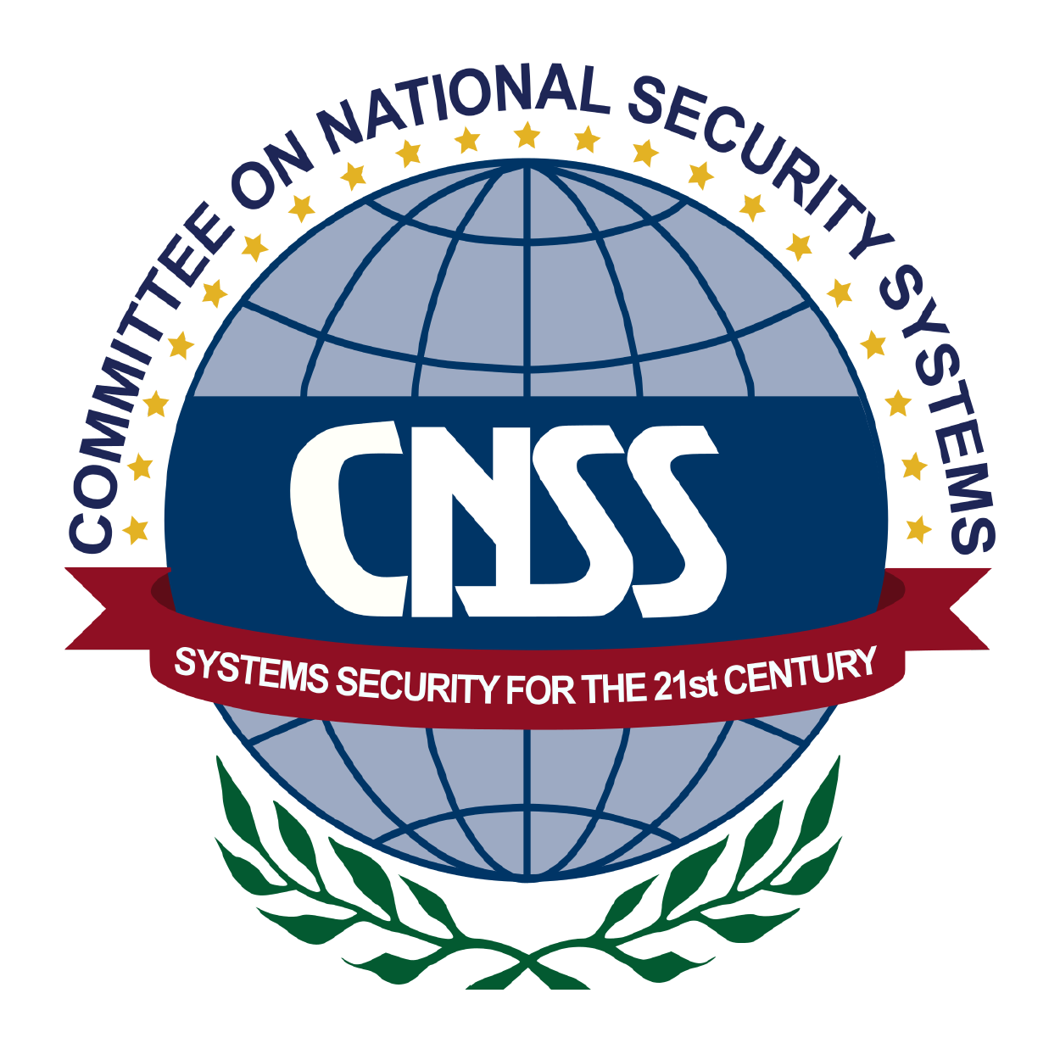

- Information Assurance Managers/Auditors
- System Implementers
- IT Administrators
- Auditors
- Federal Agencies
- Security Vendors and Consulting Groups

Modules/Lessons
Who Should Attend

Live Class Duration: 4 Days
CEUs: 32
Language: English
Class Formats Available:
Instructor Led
Self-Study
Live Virtual Training
Suggested Prerequisites:

- Broad Understanding of Multiple Networking and Security Technologies
Key Course Information
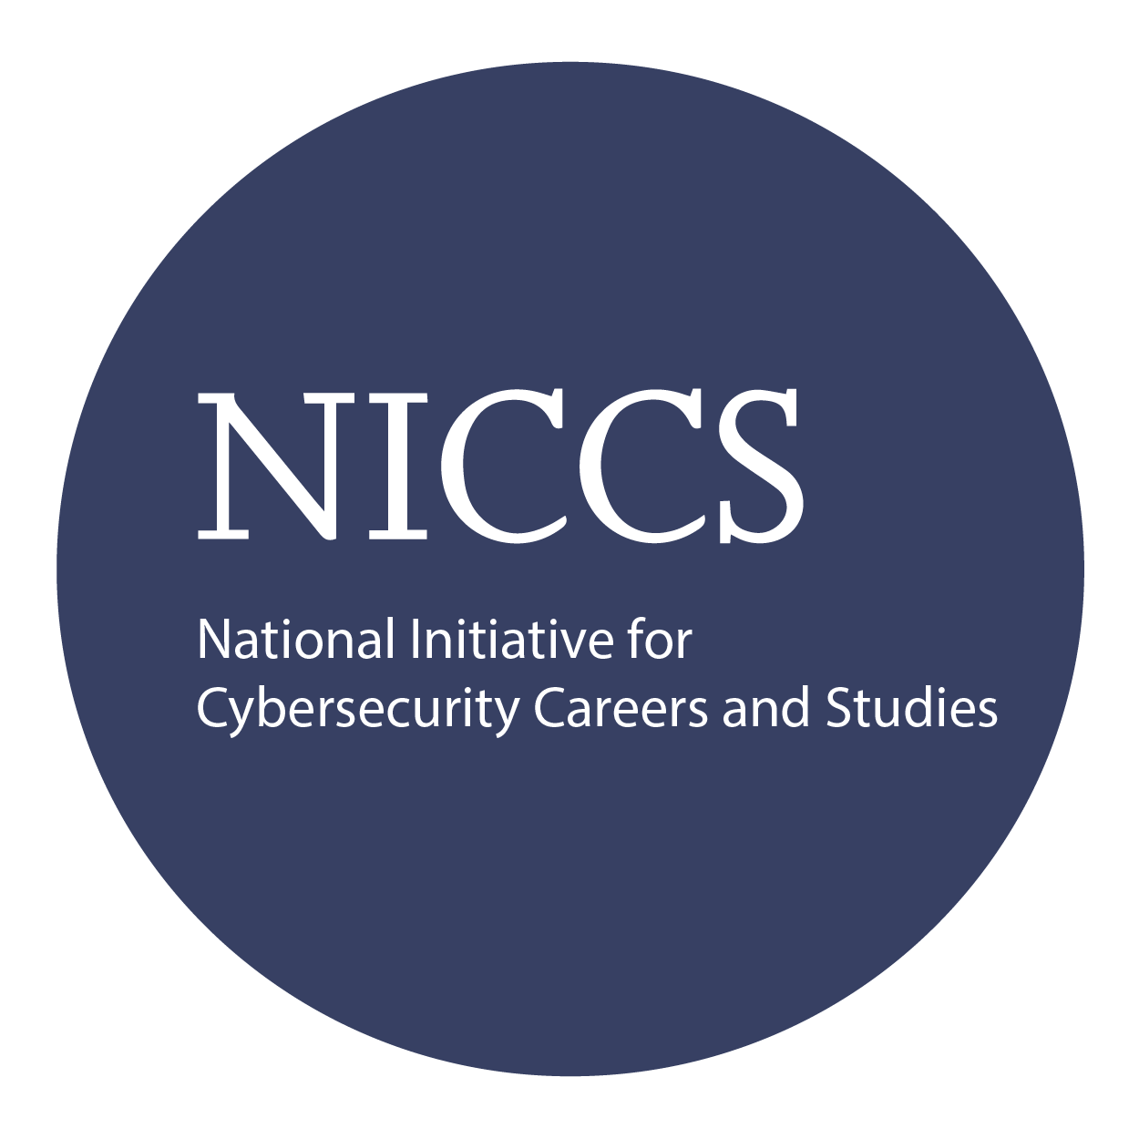

Module 1 - Introduction
Module 2 - Critical Control 1 Module 3 - Critical Control 2 Module 4 - Critical Control 3 Module 5 - Critical Control 4 Module 6 - Critical Control 5 Module 7 - Critical Control 6 Module 8 - Critical Control 7 Module 9 - Critical Control 8 Module 10 - Critical Control 9 Module 11 - Critical Control 10 Module 12 - Critical Control 11 Module 13 - Critical Control 12 Module 14- Critical Control 13 Module 15 - Critical Control 14 Module 16 - Critical Control 15 Module 17- Critical Control 16 Module 18 - Critical Control 17
Module 19 – Critical Control 18
Module 20 – Critical Control 19
Module 21 – Critical Control 20
Key Course Information

Accreditations

Re-Certification Requirements
Upon Completion

The IS20 Controls exam is taken online through Mile2’s Learning Management System and is accessible on you Mile2.com account. The exam will take approximately 2 hours and consist of 100 multiple choice questions.
A minimum grade of 70% is required for certification.

All Mile2 certifications will be awarded a 3-year expiration date.

There are two requirements to maintain Mile2 certification:

- Pass the most current version of the exam for your respective existing certification
- Earn and submit 20 CEUs per year in your Mile2 account.

U pon completion, the IS20 Security Controls candidate will be able to not only competently take the 1S20 Controls exam but will also have an understanding of how to implement the top 20 most critical controls in the work place.

Question: Do I have to purchase a course to buy a certification exam?
Answer: No
Question: Do all Mile2 courses map to a role-based career path?
Answer: Yes. You can find the career path and other courses associated with it at www.mile2.com.
Question: Are all courses available as self-study courses?
Answer: Yes. There is however 1 exception. The Red Team vs Blue Team course is only available as a live class.
Question: Are Mile2 courses transferable/shareable?
Answer: No. The course materials, videos, and exams are not meant to be shared or transferred.
Course FAQ’s
Exam Information

Course and Certification Learning Options

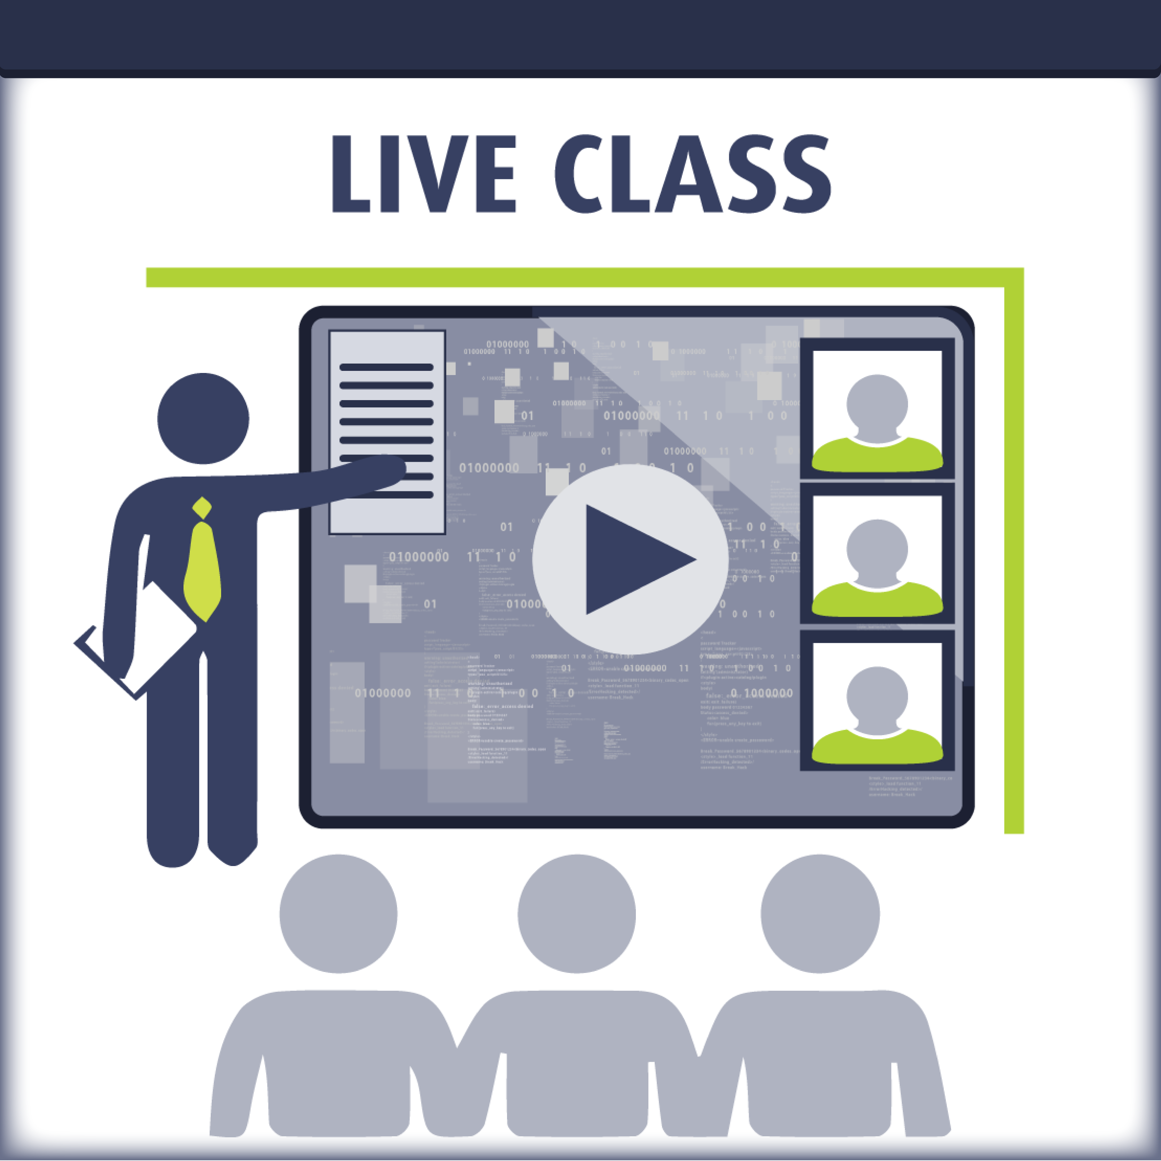
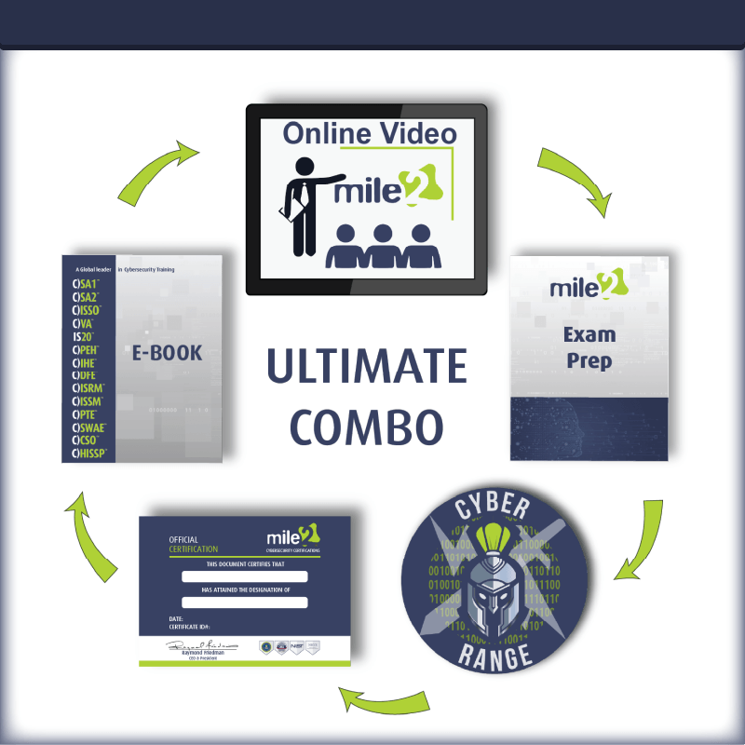
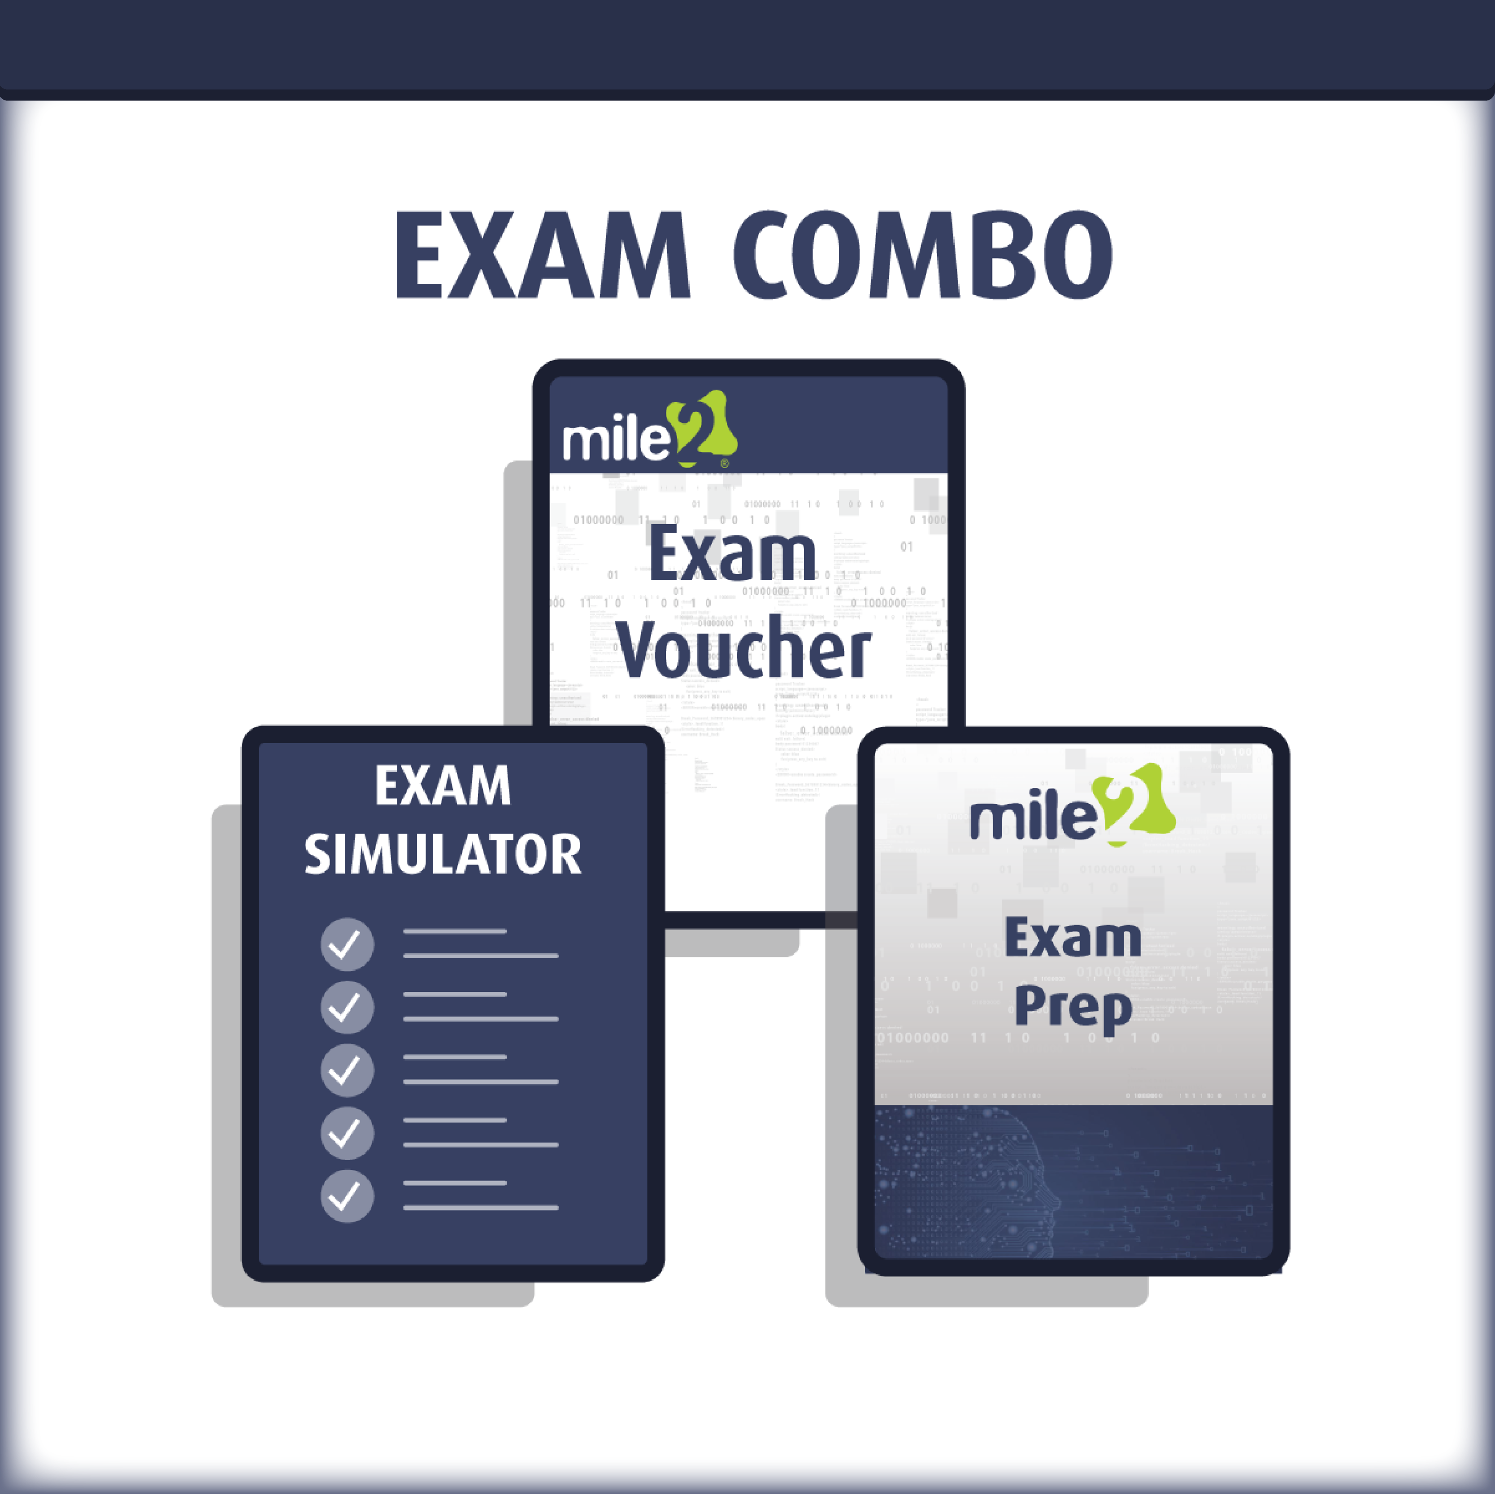

Detailed Outline:
Course Introduction
I. Critical Control 1: Inventory of Authorized and Unauthorized Devices
II. Critical Control 2: Inventory of Authorized and Unauthorized Software
III. Critical Control 3: Secure Configurations for Hardware and Software on Laptops, Workstations, and Servers
IV. Critical Control 4: Secure Configurations for Network Devices such as Firewalls, Routers, and Switches
V. Critical Control 5: Boundary Defence
VI. Critical Control 6: Maintenance, Monitoring, and Analysis of Audit Logs
VII. Critical Control 7: Application Software Security
VIII. Critical Control 8: Controlled Use of Administrative Privileges
IX. Critical Control 9: Controlled Access Based on Need to Know
X. Critical Control 10: Continuous Vulnerability Assessment and Remediation
XI. Critical Control 11: Account Monitoring and Control
XII. Critical Control 12: Malware Defences
XIII. Critical Control 13: Limitation and Control of Network Ports, Protocols, and Services
XIV. Critical Control 14: Wireless Device Control
XV. Critical Control 15: Data Loss Prevention
XVI. Critical Control 16: Secure Network Engineering
XVII. Critical Control 17: Penetration Tests and Red Team Exercises
XVIII. Critical Control 18: Incident Response Capability
XIX. Critical Control 19: Data Recovery Capability
XX. Critical Control 20: Security Skills Assessment and Appropriate Training to Fill Gaps

