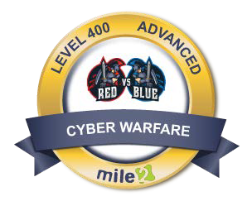

**Ultimate Red vs Blue Team Course**

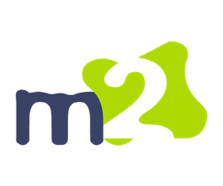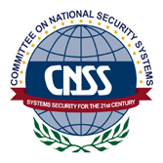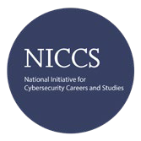

**Description:**

Mile2’s Ultimate Red vs Blue Team Course is built to provide intense hands-on sessions that emulates real-world cyber warfare and defense scenarios. You will implement principles and behaviors you have learned to combat malicious hackers that use advanced threat techniques.

The intent is that the students will have 3 - 4 hours to interact with each

section. In the Day 1 Morning scenario, you will access Proximo and Gracchus. The Day 2 Afternoon work will be in Priscus and Verus. Then, in the Day 2 Morning scenario you will access Maxiums and Quintas. Finally, Day 2 Afternoon work will be in Tetraites and Cummodus.

**Annual Salary Potential**

**$110,000 AVG/year**

pg. 1

[www.mile2.com](http://www.mile2.com/)

10213 Wilsky Blvd, Tampa, FL 33625

813-920-6779

**Key Course Information**

**Live Class Duration:** 2 Days

**CEUs:** 16

**Language:** English

**Class Formats Available:**

Instructor Led Self-Study

Live Virtual Training

**Suggested Prior Knowledge:**

* Networking
* Understanding Scanning and Vulnerabilities
* Network Technologies
* TCP/IP
* Microsoft Packages
* Basic Linux knowledge

**Modules/Lessons Who Should Attend**

**Module 1** - Kali vs Proximo and

Graccus * Penetration Testers

**Module 2**- Kali vs Priscus and * Microsoft Administrators

Verus * Security Administrators

**Module 3** - Kali vs Maximus and * Cybersecurity Engineers

Quintus

**Module 4** - Kali vs Tetraites and Commodus

**Tools & Applications Accreditations**

Participants in Red vs Blue will be using both open source and commercial tools in a controlled virtual cyber range. Some tools/ applications that will be used are nmap, db-exploit, Metasploit through Kali Linux, Empire, and Microsoft PowerShell.

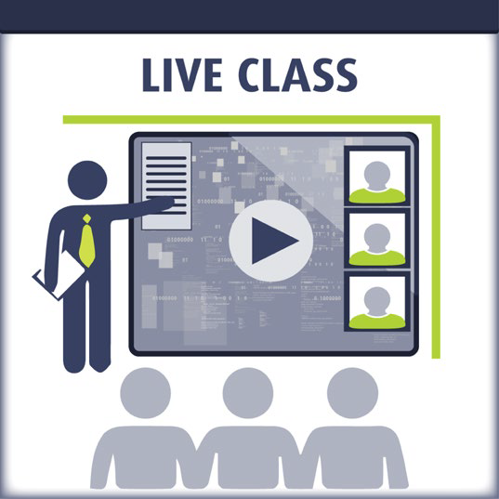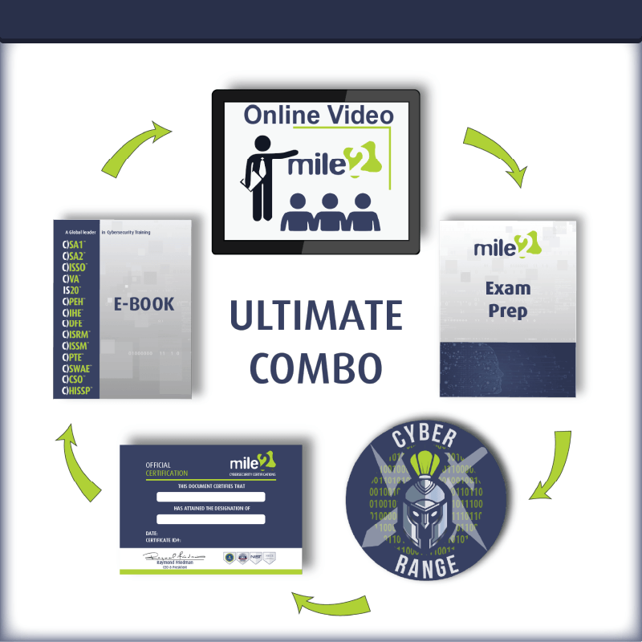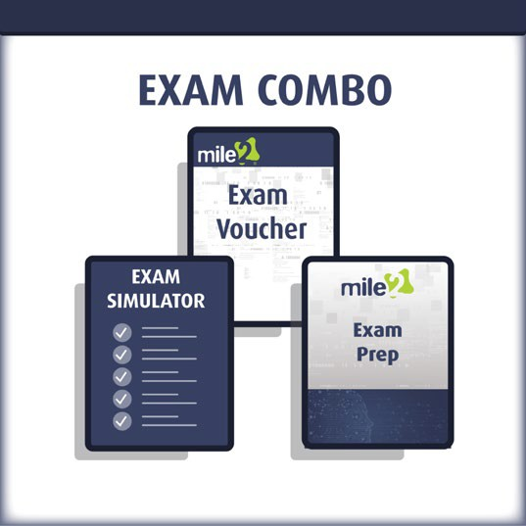

**Ultimate Red vs Blue Team Course**



**Course and Certification Learning Options**

pg. 2

[www.mile2.com](http://www.mile2.com/)

10213 Wilsky Blvd, Tampa, FL 33625

813-920-6779

**Course FAQ’s**

**Question:** Do I have to purchase a course to buy a certification exam?

Answer: No

**Question:** Do all Mile2 courses map to a role-based career path?

Answer: Yes. You can find the career path and other courses associated with it at [www.mile2.com](http://www.mile2.com/).

**Question:** Are all courses available as self-study courses?

Answer: Yes. There is however 1 exception. The Red Team vs Blue Team course is only available as a live class.

**Question:** Are Mile2 courses transferable/shareable?

Answer: No. The course materials, videos, and exams are not meant to be shared or transferred.

**Day Two Format**

**MORNING**

Required VMs:

* Kali-RvB
* Win10-RvB
* Paximus (Linux)
* Quintus (Linux)

Objective: Set defenses in the Blue portion of the Scenario and place your team name in both flag.txt files during the Red portion of the Scenario. If possible, sever access to your systems from other teams if they are connected.

**AFTERNOON**

Required VMs:

* Kali-RvB
* Win10-RvB
* Tetraites (Windows 2K12)
* Commodus (Windows 10) Objective: Set defenses in the Blue portion of the Scenario and place your team name in both flag.txt files during the Red portion of the Scenario. If possible, sever access to your systems from other teams if they are connected.

**Day One Format**

**MORNING**

Required VMs:

* Kali-RvB
* Win10-RvB
* Proximo (Linux)
* Gracchus (Linux)

Objective: Set defenses in the Blue portion of the Scenario and place your team name in both flag.txt files during the Red portion of the Scenario. If possible, sever access to your systems from other teams if they are connected.

**AFTERNOON**

Required VMs:

* Kali-RvB
* Win10-RvB
* Priscus (Windows 7)
* Verus (Windows XP) Objective: Set defenses in the Blue portion of the Scenario and place your team name in both flag.txt files during the Red portion of the Scenario. If possible, sever access to your systems from other teams if they are connected.